Junior
Beef Protégé
Workbook

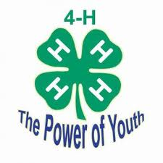

Student: __________________________________________________________________

Teacher: __________________________________________________________________
- What is a heifer?

- What is a bull?

- What is a cow?

- What is a calf?

- What is a steer?

- Name three breeds of beef cattle:
A.
B.
C.
- What does it mean when beef cattle are polled?

- Name three things that beef cattle need to eat:
A.
B.
C.
- In which direction can beef cattle kick?

- Name two things that must be done to show beef cattle:
A.
B.
- What is the proper uniform for showing beef cattle?

Label 10 parts of your choice

