Junior
Dairy Protégé
Workbook

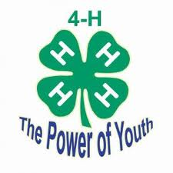

Student: __________________________________________________________________

Teacher: __________________________________________________________________
- Name two breeds of dairy cattle:
A.
B.

- What is a heifer?

- What is a cow?

- What is a bull?

- What is a calf?

- How many teats does a cow have?

- What is the least amount of times you should milk a cow per day?

- Name three products that are made from milk:
A.
B.
C.

- Name 3 things that a dairy cow needs to eat:
A.
B.
C.

- What is the proper uniform for showing a dairy cow?

Label 10 body parts of your choice
