Junior
Goat Protégé
Workbook

Student: __________________________________________________________________

Teacher: __________________________________________________________________
- Name one breed of goat:

- What is a doe?

- What is a buck?

- What is a kid?

- Name at least two products we get from goats:

- How long is the gestation period of a goat?

- Name three things that a goat needs to live:
A.
B.
C.

- What is the proper uniform for showing goats?

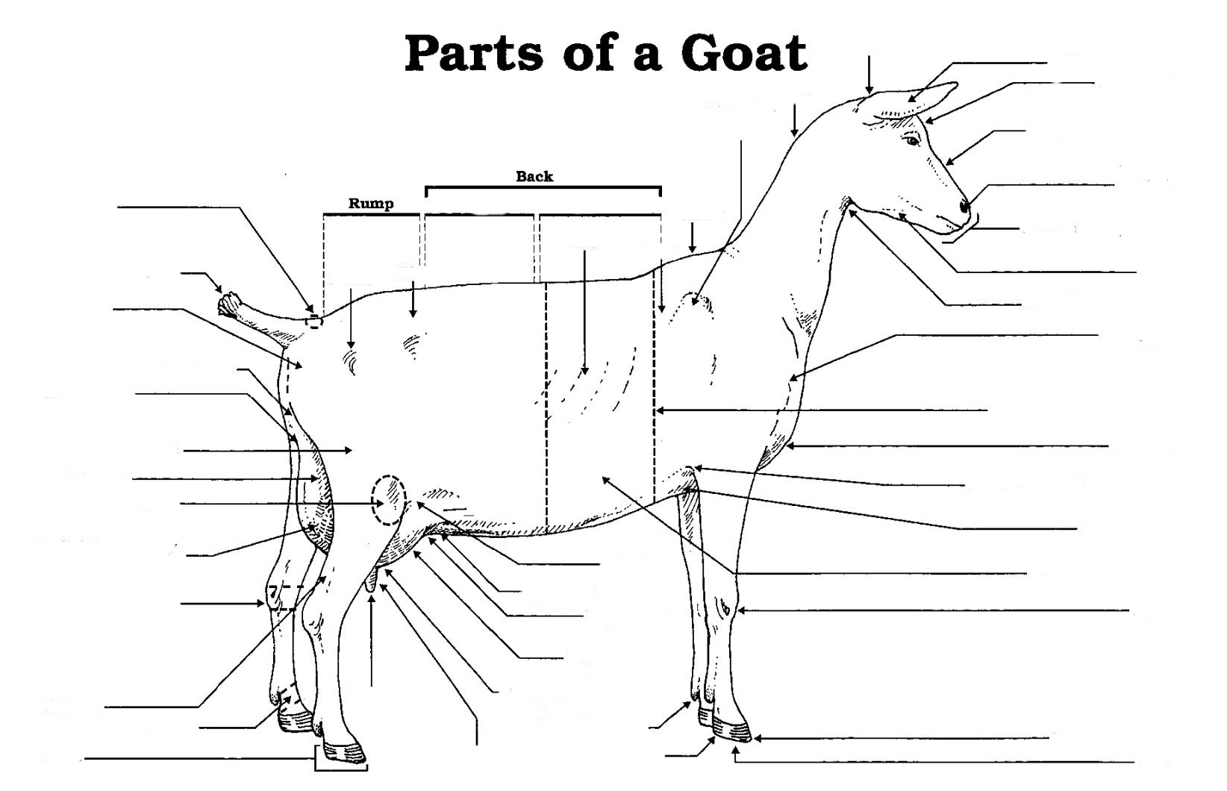
Label 10 parts of your choice

