Junior
Poultry Protégé
Workbook

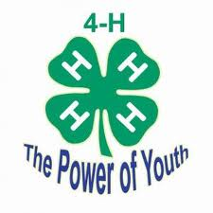

Student: __________________________________________________________________

Teacher: __________________________________________________________________
- Name three breeds of chickens or bantams:
A.
B.
C.

- What is a bantam?

- What is a male chicken called?

- What is a female chicken called?

- What do you call baby chickens?

- What color eggs do chickens lay?

- Name one poultry disease:

- What should you feed chickens?

- What is the proper uniform for showing chickens?

- What breed of chicken or bantam are you showing?

Label the correct body part
Shanks
Vent
Earlobe
Comb
Hocks
Breast
Wattle
Toes
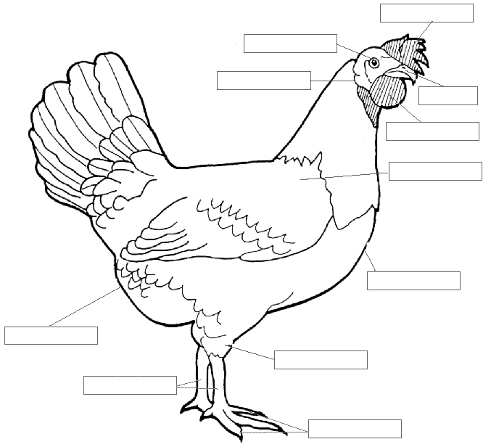
Shoulder
Beak
Eye

