Junior
Rabbit Protégé
Workbook

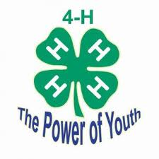

Student: __________________________________________________________________

Teacher: __________________________________________________________________
- What is a buck?

- What is a doe?

- Name two breeds of rabbit:
A.
B.

- Name three things a rabbit needs to have to eat:
A.
B
C.

- Do bunnies have hair when they are born?

- Are bunnies born with their eyes open or closed?

- How long is the gestation period (pregnancy) of a rabbit?

- In what environment should a mother rabbit give birth?

- What is most commonly used for rabbit bedding?

- Name two things for which rabbits are used:
A.
B.

- What is the proper uniform for showing a rabbit?

Label the correct body part
Eyes Mouth
Ears Dewlap (does only)
Nose Toe
Tail Hip
Hock Loin
Foot Chest
Rump Rib
Belly Forequarter
Shoulder Hindquarter
Neck Flank
Cheek
