Junior
Swine Protégé
Workbook

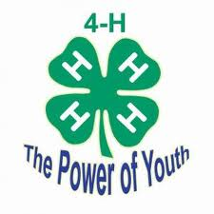

Student: __________________________________________________________________

Teacher: __________________________________________________________________
- Name three breeds of swine:
A.
B.
C.

- What is a boar?

- What is a barrow?

- What is a sow?

- What is a gilt?

- Name one type of parasite:

- Why do we ear-notch piglets?

- What is the breed and weight of the pig you are showing?

- What should you feed pigs?

- What is the proper uniform for showing a swine? What equipment is needed?

Label 10 body parts of your choice

