Poultry
Respiration…………. 15-30 breathes per min
Temperature………. 102-103 F
Pulse rate……chicks- 350-450 beats per min
adults 200-400 beats per min
Gestation Period………….21 days
Male……………………………..cock/rooster
Female………………………….hen
Offspring……………………..chick
straight run- both sexes
pullets- young females
cockerels- young males
Poult …………………..A young turkey
Tom ……………………Adult male turkey
Capon ………………...castrated male chicken
Drake …………………mature male duck
Gander ……………….mature male goose
Selecting your animal
1. Fryer/Roaster Project. This short-term project lasts only five to eight weeks for fryers. Roasters are raised for 8-12 weeks.
2. Egg Production Project. Club member raises a flock of chickens for their eggs. This long-term project generally lasts six months or longer. Hens used for this project may be bought as pullets (young females) or raised from chicks. The eggs produced can be for home use or sold to a local market.
3. Exhibition Birds Project. Club member raises a small flock of chickens to exhibit at poultry shows.. Exhibition birds must be purebred and may be standard bred or bantams. Standard bred are normal-size chickens. Bantams are miniatures. Club member may exhibit both standard and bantam.
Buy chicks from a reliable hatchery. The hatchery you choose should belong to the National Poultry Improvement Plan (NPIP) or should practice a blood-testing program to purchase chicks that are pullorum and typhoid clean. These diseases can be passed from the hen through the egg to the baby chick if the hatchery does not follow a continuous testing program. Chicks purchased for egg production or exhibition should be started in January, February, March or April. Chicks purchased for meat production should be started either 5-8 weeks before fair if you are raising fryers and 8-12 weeks prior to fair if raising roasters.
Housing
The basic requirements of a poultry house are that it provide enough space, protection from weather and predators (dogs, possums, foxes, etc.) and allow for movement of air. Space requirements depend on the type of chicken such as for egg production, exhibition or meat production.
Egg-production birds require about 3 square feet of floor space per bird. Larger breeds grown for exhibition need more space. Space also should be provided for separating males and females for exhibition. Bantams need 2 to 3 square feet of floor space per bird. For both standards and bantams, individual cages are required for the adult males.
Poultry house windows should be covered with 1-inch mesh poultry netting. During cold weather, the windows can be covered with plastic film if needed. Be sure to provide adequate ventilation.
All young chicks require a heat source. Heat can best be supplied by an electric heat lamp. A 125-att lamp is suitable for cool and warm weather and a 250-watt lamp or cold weather.
Chicks will need a trough or tube feeder. A trough 2 feet long is adequate for 12-15 chickens. One tube feeder will provide enough feeder space for 25 chickens. A 1-gallon waterer is adequate for 25 to 30 chicks. Use larger waterers for older chickens.
1. Space - Each chick should be allocated space based on his need at maturity. This amount is different for each type of bird:
Broilers- 1 sq.ft/bird minimum Layers - 2 sq.ft/bird minimum Exhibition- 3 sq.ft/bird minimum
Note: Exhibition birds require separate space for males and females and individual cages for adult males.
2. Ventilation - Air movement through the poultry house is important to provide oxygen, prevent carbon dioxide and ammonia buildup and help regulate temperature. It is also necessary to remove excess moisture,
keep litter dry and reduce disease problems.
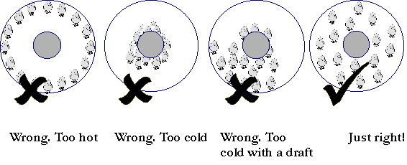
Ventilation is essential even during winter, but it is important to keep birds away from drafts. Younger birds are more sensitive to drafts
than older birds. The best method for providing ventilation in the winter is to close three sides tightly and provide openings high on the south wall of the house. These openings should be covered during severe cold weather. In the summer, cross ventilation becomes important to keep the birds cool, so sides should be open. Even when open, all sides should be covered with mesh or wire to prevent sparrows or predators from entering.
3. Light - Chicks should be given continuous light during the first 48 hours, so they can find the feeders and waterers. A 10 ft X 10 ft house
will need one 25-watt light bulb. Once the chicks have found the feed and water, you can take advantage of natural daylight. Broilers achieve
maximum growth with 23-24 hours of light each day. Laying hens need a minimum of 14-16 hours of light each day for maximum egg production.
4. Temperature - Young chicks cannot maintain their body temperature without supplemental heat. A brooder is a device used to provide heat for young chicks. As the bird ages, its ability to maintain a constant body temperature improves. The adult body temperature of the chicken is
103°F. When the chick hatches, it has a temperature near 100°F. As it ages, the chick’s body temperature slowly increases to that of an adult. During this process an outside heat source must be provided. Once the chick can maintain a constant body temperature on its own (thermoregulate), you can remove the heat source.
The following temperatures are recommended for chicks:
Temperature Age of Chicks
95oF younger than 1 week
90oF 1week to 2 weeks
85oF 2 weeks to 3 weeks
80oF 3 weeks to 4 weeks
75oF 4 weeks to 5 weeks
70oF 5 weeks to 6 weeks
At six weeks, the birds be well-feathered, so
supplemental heat is no longer necessary. Use thermometers to help monitor temperature. Hang one just under the edge of the brooder about two inches from the floor. Place the other one away from the brooder and draft but close
to bird height.

Brooding
Brooding refers to the care of young chicks during the first 2 to 3 weeks of life. Good brooding practices bring out good qualities in chicks.
Use a disinfectant to sanitize the house and equipment before the chicks arrive. A solution of chlorine, iodine or quatenary ammonia can be used. When using any disinfectant, carefully follow the instructions on the label and get an adult to help you. Cleaning and disinfecting help to control diseases and parasites.
Once the brooding area has dried, place 4-6 inches of dry litter on the floor. Materials such as dry pine shavings, rice hulls or chopped straw make good litter.
The brooder lamp should be suspended about 15-18 inches above the litter and turned on the day before the chicks arrive. The lamp should be an infrared lamp, generally a 250-watt lamp bulb. Do not hang it by the electrical cord (see diagram). Secure the lamp at the proper height with a rope or chain. Heat lamps get very hot and are a fire hazard. They should not come near or touch the litter.
Place waterers and feeders inside the brooder area near the heat source. Do not crowd them under the light. The diagram will help you place equipment.
Place feed in shallow, flat pans for the first two or three days. This makes it easy for chicks to find food. After day three, replace the feed pan with a trough or hanging feeder. Hanging tube feeders are best for small flocks. Height of hanging feeders can easily be adjusted as the birds grow. The day before the chicks arrive, turn on the brooder lamp. Fill waterers and feeder pans. Turning the lamp on early allows litter and equipment to warm. This helps make the chicks comfortable.
When the chicks arrive, place them under the heat source. The best guide to adjusting the temperature should be the chicks themselves. Their actions will tell you whether they are comfortable or not.
For the first few days, it will be necessary to watch the birds closely. Adjust the brooding temperature as necessary. The temperature can be increased by lowering the heat lamp. It can be decreased by raising the heat lamp. Supply fresh feed and water daily. Artificial light should be provided 24 hours a day. One 40-watt bulb provides adequate light for pens up to 20 feet square.
The growout period for broilers includes the time after brooding until market size is reached. You must provide the proper conditions, feed and care during the growing period. Keep the house at a comfortable temperature (about 72 degrees). Provide a good supply of fresh air. It is important that the litter remain dry. Remove wet spots and add fresh litter. Wet litter provides an ideal condition for parasites to grow.
Provide fresh feed daily. Do not fill troughs more than two-thirds full, or you’ll waste feed. Chickens must have fresh, clean water at all times. Remove waters daily, wash them and fill with clean water.
Birds need light to locate feed and water. They also need light to grow and develop. Broilers and layers need different light schedules. Chicks grown for broilers should receive light 24 hours a day. This encourages them to eat more feed and grow rapidly. Birds grown for egg production or for exhibition should receive about 12 hours of light a day up to 22 weeks of age. A 40-watt bulb will furnish enough light for 25-50 broilers or pullets. Pullets normally start laying eggs about 22 weeks of age. The average hen lays 260 eggs in one year.
Under natural daylight conditions, chickens lay most of their eggs in the spring as days lengthen. You can use electric lights to make hens think that the days are long. This makes them lay more eggs. A useful rule for lighting laying hens is never to allow day length to decrease. Laying hens require 15 hours of light per day. One 40-watt light bulb provided enough light for up to 100 hens.
Except for controlling day length, hens require about the same management as do broilers and pullets during the growout period. Hens need a comfortable environment, dry litter, fresh feed and water and daily attention.
Laying hens need nests, which can easily be constructed. They should be about 1 foot square and 1 foot high. A small board at the bottom front will help retain nesting material. A perch located below the opening will provide easy access. You should provide one individual nest for every four to five layers.
Nutrition and Feeding
Feeding
Birds require proper nutrition, just like other animals. The health and performance of a
bird depend on the feed or nutrients it eats. The amount and type of feed a bird consumes greatly influences its performance. Special
rations are produced for each type and age of bird. These rations contain many different ingredients to provide specific nutrients.
Chickens have simple stomachs. The nutritional requirements are different for each group of birds. It is important to feed chickens a feed designed specifically for them. Many types of poultry feeds are available from local feed dealers. It is important to select the correct feed. For example, if you are feeding broilers, select a feed designed specifically for growing broilers. Broiler feed should contain 23-24 percent protein. It may be necessary to mix several feeds together to get a 24 percent protein level. A ration that contains no more than 20 percent protein is good for day-old pullets. Pullets do not need to grow as rapidly as broilers. They need less protein. Older pullets (8 to 20 weeks old) need even less protein. A diet containing 16 percent protein is satisfactory. During egg production, a 15 percent protein diet will support a good rate of lay and keep hens healthy. Common mistakes made when feeding chickens include using the wrong type of feed, feeding scratch grain or mixing it with a commercial
feed and feeding table scraps. Cracked corn, for example, is low in protein but high in energy. When it is mixed with a commercial ration, the
protein level of the ration is reduced but the energy is increased. Vitamin and mineral levels of the diet are also reduced. The birds will not grow or produce as well and may even resort to feather picking to compensate for the missing protein. Feather picking often leads to cannibalism. Under-feeding can also be problem. When growing broilers, never let the feed trough be empty. A continuous supply of feed should be provided to broilers to maximize feed consumption and growth. Today’s feed conversion dictates that broilers should consume 12-15 pounds of feed per bird during a six- to seven-week period. When feeding other types of birds, a good guideline is 20 pounds of feed per bird during the first 20 weeks of age.

Nutrients
Six types of nutrients are required by all animals. They are:
1. Water
2. Proteins
3. Carbohydrates
4. Lipids
5. Minerals
6. Vitamins
Water is made up of hydrogen and oxygen, in a two to one (2:1) ratio. This means one oxygen is attached to two hydrogens. You may see it represented as (H2O). Water is one of the cheapest nutrients. Often it is also the one given the least amount of attention. Most of the body fluids are water based, such as blood, sweat, tears, saliva, urine, etc. The bird’s body is 92% water. Birds need a constant, clean source of water. Water is required for many bodily functions, such as
1. Maintenance of body temperature
2. Production of eggs
3. Digestion and absorption of feeds
4. Lubrication of feed by saliva
5. Transport of nutrients via blood
Proteins are used to form many body tissues such as muscle, red blood cells, feathers
and toenails. Proteins are made up of individual building blocks known as amino acids. Amino acids contain carbon, hydrogen, oxygen
and nitrogen. The combination of amino acids, in different ways and amounts, determines the specific protein. More than 1000 proteins
are found within the animal body. For the bird’s body to use these proteins, they must be broken down into amino acids during digestion. The amino acids are absorbed and reformed into proteins within the body cells.
Carbohydrates are made up of carbon, hydrogen and oxygen. The basic unit for most carbohydrates is glucose. Sugars are one common type of carbohydrate. Refined sugar like table sugar is known as sucrose.
Fruits taste sweet because of the carbohydrate fructose. Starches are another type of carbohydrate. Starch is the primary component of corn, milo, potatoes, beans, breads and pasta. Carbohydrates are primarily used
for energy. Energy can be thought of as power or ability to do work. Energy is required for such activities as walking, clucking, producing eggs,
digesting foods, etc. Lipids, also known as fats, are made of carbon, hydrogen and oxygen. The basic unit of all fats or lipids is fatty acids. Just as amino acids are common to all protein, fatty acids are common to all lipids. Lipids contain two and one-half times as much energy as carbohydrates but are more difficult to digest and use. Vitamins are special compounds needed in small amounts for specific bodily activities. Vitamins help regulate many processes. Vitamin D is necessary for bone and shell formation. Vitamin K is required for proper blood clotting. There are two general types of vitamins: those which can be dissolved in water (water-soluble) and those dissolvable only in fat (fat-soluble).
The feeds or diet the bird consumes must contain the basic nutrients. Feeds are chemically analyzed to determine the amount of each nutrient they contain. By knowing the amount of a nutrient in each feed, we can calculate the amount of feed needed to meet the bird’s nutrient requirement. Tables listing the amount of nutrients in a feed are published. These can be used to determine which feeds need to be combined to give the right amount of nutrients. Some feeds used in poultry rations are in Table IV. Most birds today are fed a complete diet containing all of the nutrients required in the proper amounts. These complete diets are made
up of several different feeds in different amounts to meet the nutrient requirements. Poultry rations are prepared by grinding and mixing or
blending the feed ingredients, as you do when making a cake. Each mouthful of diet the bird consumes contains the right amount of nutrients. Nutrient Requirements
The amount of each nutrient needed by a bird is determined by the type of bird and its activities. Several tables of nutrient requirements by
bird and activity have been developed. The National Academy of Science publishes an updated list of nutrient requirements by species based on research conducted at university and private laboratories. Using these tables we can determine how much of a nutrient a particular bird needs. Table III lists nutrient requirements for different birds performing different activities.

Table III. Examples of Nutrient Requirements
Bird Purpose Protein Calcium
(%) (%)
Chicken Meat Production 18-21 .9-1.0
Turkey Meat Production 20-28 1.2-1.3
Chicken Egg Production 16-18 3.0-4.0

Table IV.
Sources of Nutrients Required by Poultry
Nutrient Source

Protein | Soybean meal, corn gluten meal, fish meal, blood meal,meat meal and feather meal
Carbohydrates | Corn, milo, barley, rye, oats and wheat
Fats | Animal tallow, corn oil and other vegetable oils
Minerals | Meat and bone meal, fish meal, limestone, salt
Rations
A ration refers to the combination of feeds or ingredients fed a bird daily. To meet the daily nutrient requirements of a bird, several feeds
must be mixed together. In this ration, eight different ingredients are necessary to meet the nutritional requirements of the broiler.

General Health Management
Health
Prevention is the best way to deal with poultry disease and parasites. Prevention is better than treatment. Good sanitation and good management help prevent disease.
Follow these important sanitation and management practices:
1. Clean and disinfect house before chicks arrive.
2. Wash and clean waterer daily.
3. Keep litter dry. Remove and replace wet litter.
4. Remove and incinerate or bury all dead birds.
5. Provide adequate ventilation.
6. Isolate flock, limit visitors and keep dogs, cats, etc. away.
7. Control rats and mice.
8. If possible, keep birds of only one age on the farm.
Disease Prevention
Good management is essential for poultry health. Raising many birds together in close quarters produces an environment suited
to rapid spread of diseases. Prevention is the key to a healthy bird flock. Sanitation is important to reduce disease. Keeping the litter
dry by removing the wet and adding fresh material will help reduce problems. Removal of wire and sharp or foreign objects will prevent
injuries. Vaccination for specific common diseases is also an effective preventive measure.
Parasite control is also important in poultry flocks. Birds easily contract internal parasites from others by pecking and consuming fecal
material.

Some common internal parasites and their treatment are:

Parasite | Site of Infection | Treatment
Large Roundworm | Intestines | Anthelmintics
Cecal Worm | Ceca | Anthelmintics
Capillaria Worm | Small Intestine | Anthelmintics
Tapeworm | Intestine | Anthelmintics

External parasites are also easily transferred by close contact. Common external parasites and treatments are:

Parasite | Site of Infection | Treatment
Mites | External Surfaces | Sevin Dust
Lice | Body, Feather Shaft | Sevin Dust

Disease | Symptoms | Treatment | Prevention
Pullorum | Acute,white diarrhea  Swollen hock joints | Furazolidone | Blood Testing Breeding Flock
Fowl Pox | Scabs about head & face Sores in mouth &nasal passage | None | Vaccination
Coryza | Nasal discharge  Watery eyes | Sulfonamides | Sanitation
Coccidiosis | Bloody dropping, poor appetite, poor feathers | Coccidiostat | Sanitation
Marek’s Disease | A herpes-virus. Highly contagious. Spreads by bird-to-bird contact, by contact with infected dust and dander, and by darkling beetles and mealworms that live in the chicken house .Morbidity is 10-50% and mortality up to 100%. Mortality in an affected flock typically continues at a moderate or high rate for quite a few weeks. | None. High mortality. | Vaccination of chicks at one day of age. Hygiene is of utmost importance. Please note that Marek’s disease-causing virus particles can survive for months in chicken-house dust and litter.
Newcastle Disease | Caused by a virus. The first symptoms usually consists of respiratory distress and rasping followed in 1 or 2 days by a paralysis of legs and wings and bad down between legs or straight back over shoulders. A twisting of the neck (stargazing) may also be observed.  In adult birds, loss of production along with some respiratory distress and paralysis after 4 to 6 days. | There is currently no treatment | - Strict isolation of outbreaks  - Destruction of all infected and exposed birds  - Thorough cleaning and disinfection of premises  - Proper carcass disposal  - Pest control in flocks  - Depopulation followed by 21 days before restocking  - Avoidance of contact with birds of unknown health status  - Control of human traffic.  - One age group per farm ('all in-all out') breeding is recommended  - Vaccination with live and/or oil emulsion vaccines
Blackhead disease | Blackhead disease (also known simply as blackhead) is a commercially important avian disease that affects chickens, turkeys and other poultry. It is a form of histomoniasis caused by the protozoan parasite Histomonas meleagridis. Blackhead disease affects turkeys more than chickens. The most common symptom of Blackhead disease is yellow watery bird droppings |  | - To reduce the spreading of Blackhead disease, the sick birds must be removed and their litter changed.

Disease | Symptoms | Treatment | Prevention
Campylobacteriosis | in chicks up to four weeks old: depression, diarrhea, slow growth. In growing an mature birds: sudden death of apparently healthy birds, scaly shrunken comb. In hens: loss in egg production. Caused by bacteria; that only affects chickens and is very hard to kill with disinfectant. | none effective. | Transmission: droppings of infected birds. Spread by flies, cockroaches, rodents, contaminated equipment, and shoes. Good management and sanitation. Keep chickens from picking in droppings.
Cholera (acute) | in mature birds and those approaching maturity, you can have sudden death or fever, loss of appetite, increased thirst, depression, drowsiness, ruffled feathers, head pale and drawn back, increased respiratory rate, mucous discharge from mouth and nose, watery white diarrhea, etc.  Cause: bacteria. | none effective. Isolate and dispose of infected flock. | Vaccination is not effective. You must not introduce possibly infected birds into flock and use good sanitation and management practices.
Bumblefoot | occurs in maturing birds, especially males and heavy breeds. Reluctance to walk, inflamed foot, dark black scab on bottom of foot.  Transmitted by contaminated hatching eggs, bacteria enters foot through open injury, sharp roosts, irritation due to improper litter management. | Inject swollen area with penicillin. Open sore by cutting open abscess and squeeze out core, then was with hydrogen peroxide, pack with Neosporin, and wrap foot with bandage. Redress every two or three days. Very difficult to cure. | practice good sanitation, avoid high perches with sharp edges.
Turkey Rhinotracheitis | Turkeys of all ages are susceptible,  but the disease is most severe in  young poults. Chickens are susceptible to the virus. Waterfowl and pigeons are resistant.  Respiratory signs in poults include snicking, rales, sneezing, nasal exudates (often frothy), foamy conjunctivitis, and sinusitis. Drops in egg production can be as much as 70 percent | No drugs are available to combat the virus. Antibiotic therapy is recommended to control secondary bacterial infections | No vaccines are currently available. Prevention is dependent on a comprehensive biosecurity program.
Handling and Training
Selection and Fitting for Show
The objective of the broiler project is to produce top quality market birds. The factors determining quality are:
1. Fleshing
2. Conformation
3. Finish
4. Feathering
5. Freedom from defects
Well-fleshed birds are more attractive. Breast, drumsticks and thighs carry most of the flesh. They should be examined thoroughly. Breast should be long and thick. The breast bones should be completely covered with flesh. Thighs and drumsticks should be thick and meaty. The degree of fleshing can be easily determined by feeling with your hand.

Conformation refers to the overall shape. The ideal shape of a broiler approaches that of a rectangle. This type of bird has good fleshing and fat covering. Some of the common defects
are: (a) breasts which are dented, crooked, v-shaped or slot-sided, (b) backs which are narrow, crooked or hunched, (c) wings that
are deformed and (d) a body that is wedge shaped.

Finish refers to the amount and distribution of fat. Well-finished birds have a uniform layer of fat. The birds will have a creamy or yellowish color. On poorly finished birds, the muscle and blood vessels will show through the skin. This gives the bird a reddish color. To determine finish, examine the underside of the wing. On a well-finished bird, the wing web will appear creamy or yellowish and feel waxy. To determine finish, examine the underside of
the wing. On a well-finished bird, the wing web will appear creamy or yellowish and feel waxy. Examine the skin of the breast, legs and
thighs. Pinching the skin of the abdomen between the thumb and fingers is also a good indication of finish. Color may or may not
correlate with finish. A small amount of fat with dark yellow coloring should not be confused
with good finish.
4. Feathering
The primary concern is the presence of pin feathers, particularly those just coming through the skin, and areas with broken feathers. Ideally,
the birds should be covered with feathers which are sufficiently mature to be removed during processing. In checking for pin feathers, examine these four areas: (1) underside of wing, (2) breast, (3) legs and thighs and (4) back. In checking for pin feathers, ruffle or part the feathers and examine the skin.
5. Freedom from defects
Examine birds thoroughly for broken bones, bruises, cuts and tears. Bruises are a common defect and are usually caused by rough handling. Be particularly careful when boxing or crating the birds for transport.
Breast blisters are a common defect in birds grown on wire or damp packed litter. Eliminate any bird with a watery breast blister or heavy callouses on the breast. Some other common defects are: (a) breasts which do not carry width well back to the end of the keel, (b) breasts which are v-shaped or concave rather than round and full, (c) breasts which are slot-sided, having more fleshing on one side, (d) thighs
and drumsticks which are thin and (e) backs which are not well fleshed around the hip bone.
Although weight itself is not a factor in quality, most shows have minimum and maximum weights. Select birds which meet these requirements. In shows without weight restrictions, a weight of about 4 pounds
should be considered ideal. Broiler strains have been selected for rapid growth, and most birds will be near the ideal weight between 40 and 50
days of age. Larger birds are not necessarily more desirable, and the important characteristics such as fleshing and finish should not be sacrificed for the sake of large birds. Uniformity of size is an important consideration. Birds of approximately the same size and of equal quality should be selected. Birds that stand out because of their larger or smaller size detract from the appearance of an entry. The uniformity of a pen of broilers is a judging consideration. Every bird in the flock should be examined for quality, and birds of
undesirable quality eliminated from consideration. If you are selecting birds for show, examine every bird in the flock for quality. Don’t consider birds of undesirable quality. From the desirable birds, select the most uniform possible.
Then select one or two similar birds as alternates in case something happens to one of the original birds. Handle birds with care. Bruises suffered in selection may not become evident until show day when it is too late to make a substitution.
Birds should be transported to the show in a manner to prevent injury. The best method is in separate crates, but often this is not possible.
Once the broilers have been officially entered in the show, wipe them clean and provide feed and water. Check birds often to replenish feed
and water.
Place birds that you have selected to show in individual cages. Provide plenty of good clean bedding, fresh feed and water. Birds may be washed two or three days before the show. Wash birds in a tub of warm water containing a mild soap (not detergent). Rinse in a tub of warm water. Place birds in a warm place so they can dry properly. A hairdryer may be used to speed drying. At the show, birds may be wiped off and the face, comb and wattles cleaned with a mixture of 50 percent water and 50 percent rubbing alcohol.
Exhibition Birds
The primary goal of selecting exhibition birds is to choose birds which are free from defects and match the standards in the “Standard of Perfection.” Select birds with signs of good
health and vigor. A healthy bird of high vitality has a strong, well proportioned head with full, round, bright eyes. The comb will be bright and of good texture. The plumage is usually glossy and clean. Feathers around the vent are clean and dry. Body feathers fit closely. The bird should show signs of vitality and not be listless.
Birds selected should be placed in individual cages six weeks before the show. This allows for feather replacement and prevents injury. Keep these pens clean, and provide fresh feed and water daily. Birds for exhibition should be washed two or three days before the show. Wash birds in warm water using a mild soap.
Rinse birds in a second tub of warm water. Allow birds to dry properly in a clean area. Birds
may be dried with a hair dryer, but be sure not to blow against the natural lay of the feathers. Immediately before the show, wipe the
birds clean with a damp cloth. The face comb and wattles can be cleaned with a 50:50 mixture of water and rubbing alcohol or glycerine. Taking good care of your birds during a show is also
important. Using these tips will help you be successful at show time.

In 1873, the American Poultry Association (first livestock association in North America) was
organized to establish standards of genetic excellence and develop a system of classifying breeds of chickens. A system of three
categories is used to classify chickens:
1. Class
2. Breed
3. Variety
A class is a grouping of breeds according to the geographic area of their origin or similar
characteristics. The name indicates the region where the breed began, such as English, Mediterranean or American. Most chickens grown by today’s commercial poultry industry are from the American, English or Mediterranean classes.

Breed refers to a group of birds with similar physical characteristics. Birds of the same breed when mated produce offspring with the same characteristics. A variety is a sub-division of a breed. Varieties within a breed have the same physical shape and features but are separated by comb type or feather color. Examples of classes, breeds and varieties are shown in Table I.
Breeds in the American class have yellow skin and unfeathered shanks. They adapt easily to different conditions and are used to produce both meat and eggs. Popular breeds in the American class include the Plymouth Rock, Dominique, Rhode Island Red, New Hampshire, Wyandotte, Jersey Giant and others.
Breeds in the English class excel in producing meat. Popular English breeds include the Cornish, Australorp, Orpington and Dorking.
The Mediterranean class includes breeds that produce eggs, not meat. They are small and lay white eggs. Popular breeds include the Leghorn, Minorca, Blue Andalusian and Ancona.

A variety is a subdivision of a breed. Color patterns, comb type and a beard or muff are used to divide a breed into various varieties. Examples of the varieties of the Plymouth Rock breed are White, Barred, Buff, Columbian, Blue Partridge and Silver Penciled. In each case, the. Feather color is the only body shape is identical difference. The main purpose of growing poultry is to produce meat and eggs. Chicks grown for meat are called broilers. Broilers are crosses of White Plymouth Rock, White Cornish and other breeds. They convert feeds into meat more efficiently than any other type of livestock. With good growing conditions, broilers can convert 1 pounds of feed into 1 pound of weight gain.
Club members beginning an egg production project should select one of the White Leghorn strains. These birds can produce eggs on a small amount of feed.
Any of the purebred breeds can be grown to exhibit. You may also want to consider raising bantams. Bantams are the miniatures of the poultry world. Most large fowl have a miniature likeness called a bantam. They have the same requirements for shape, color and physical features as do large fowl. Bantams are raised for their beauty, as pets or for companion animals. Often they can be kept in areas too small for large fowl. They are excellent birds to grow for exhibition. The term bantam refers to true-breeding miniature chickens. One breed of bantams exists for almost every breed and variety of large chickens. There are also some breeds of bantams with feather color and characteristics not found in larger chickens. Bantam chickens are one-quarter the size of
their larger counterparts. Bantams have a special appeal to many people, especially to those who live in urban areas. These purebreds
are friendly, hardy and are usually raised for exhibition or hobby.

Class Breed Variety Comb Shank Feathers
American Plymouth Rock White Single No
American Plymouth Rock Barred Single No
American Wyandotte Silver-Laced Rose No
Asiatic Cochin Black Single Yes
Asiatic Brahma Buff Pea Yes
English Cornish White-Laced Red Pea No

Anatomy
The chicken has several interesting exterior features (see Fig. 1). The comb and wattles of a
chicken function as a cooling system. Chickens do not sweat like some animals. They lose heat
by circulating blood throughout the comb and wattles. This process is much like the cooling of an engine by the radiator. There are several
different types of combs. Some are shown in Figure 2. The earlobe of the bird does not stand away from the head as in other animals. Just beneath the ear is a flat piece of skin called the earlobe. The earlobe color can tell you what color egg a hen will lay. If the earlobe is
white, her eggshells will be white. A hen with red earlobes will lay brown-shelled eggs. Feathers serve as protective covering for the bird. These
insulate the bird from cold, prevent the skin from getting wet and can be used for flight. Each region of feathers is defined by a special
term (see Fig. 1). Some birds also have
special feathers about the head. These include crest, beards and muffs. Some examples are shown in Figure 3.

Once food is consumed, the bird’s digestive tract must break it down into nutrients the body can absorb. Birds are classified as monogastric or
simple-stomached animals, but their digestive system has several unique features. The mouth of the bird differs from that of other animals. The bird does not have lips or teeth. Birds have a hard beak for grasping food. When food is brought into the mouth, it is moistened by saliva and swallowed. The esophagus of the bird has a special feature, called the crop, where feed can be stored for a short period. The stomach of the bird is divided into two sections: the proventriculus, or true-stomach, and the ventriculus, or gizzard. The proventriculus is a glandular region like the stomach of most
monogastrics. The glands of the
proventriculus produce digestive juices which begin the breakdown of feeds into nutrients. The
ventriculus, or gizzard, is a muscular region where feed material is ground. It was once a
common practice to feed grit to birds to help the gizzard grind feeds. Today we grind the ration
before feeding, so it is not necessary to add grit to the diet. Ground food mixed with saliva and digestive juices called chyme moves from the gizzard into the small intestine. Within the small intestine, juices from the pancreas, liver and wall of the small intestine are added to the chyme for further breakdown of the feed. As this breakdown occurs, individual nutrients move
across the intestinal wall into the blood and body tissue. This process is called absorption.
Following absorption, these individual nutrients are carried by the bloodstream to all body cells. Food and juices not absorbed from the small intestine move into the large intestine. The bird has two special features of the large intestine called ceca. These are long narrow pouches where special bacteria use the undigested material. Some of the by-products of this bacterial activity can be absorbed by the bird.
Most of the water in the digestive system is absorbed in the large intestine. The remaining material in the large intestine is released from the body as manure.
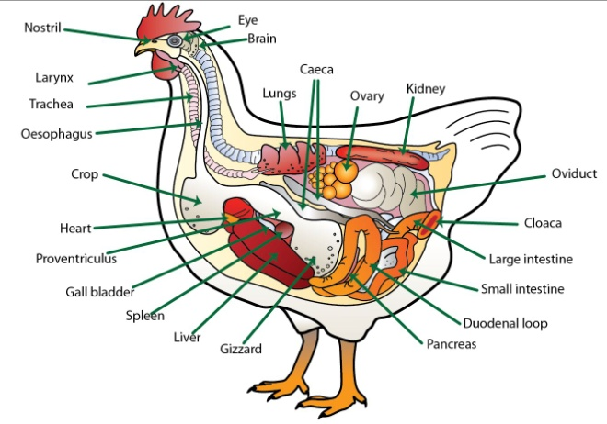
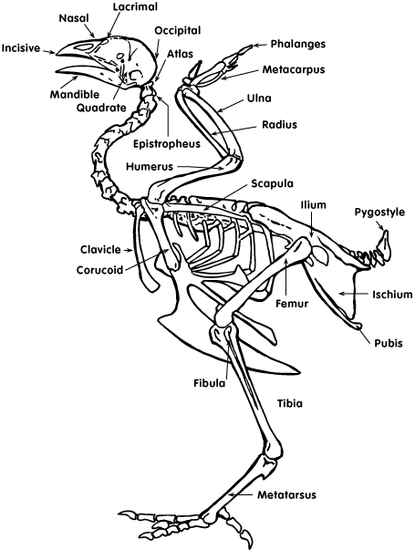

EGGS
Eggs are a biological structure intended by nature for reproduction of birds. They protect the developing chick embryo and provide food for the first few days of the chick’s life. The egg is also one of the most nutritious and versatile of human foods. Eggs of domestic chickens may be white, many shades of brown, or yellow. One breed lays blue green eggs. Sometimes very small, dark flecks are present on the eggshell, especially if it is brown. Egg color often assumes economic importance, as there are numerous local prejudices in favor of shell tints. Colored eggs occur because pigment is deposited in the shell as it is formed in the uterus. The structure of an egg is shown (illustration #7) with the various parts labeled in their normal position.
The protective covering known as the shell is composed primarily of calcium carbonate, with 6,000 to 8,000 microscopic pores permitting transfer of volatile compounds. The air cell is located in the large end of the egg, and is formed when the cooling egg contracts and pulls the inner and outer shell membranes apart. The chordlike chalazae holds the yolk in position in the center of the egg. As shown, a membrane surrounds the yolk, known as the vitelline membrane. The germinal disc, a normal part of every egg, is located on the surface of the yolk. Embryo formation begins here only
in fertilized eggs.

The albumen, or egg white, is secreted around the yolk. Four distinct layers of albumen can be
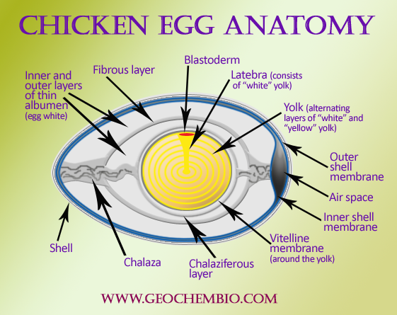
recognized in an egg: the chalaziferous layer, attached to the yolk; the inner thin albumen; the thick albumen; and the outer thin albumen. Three-fourths of the albumen is made up of the thick and outer thin albumen. The twisting of the egg during formation appears responsible for the separation of the albumen into the four layers.
Two shell membranes are formed, an inner and an outer shell membrane. These are rather loose fitting membranes when first formed. Water is added to the egg to “plump out” the egg into its final shape. The outer shell membrane is about three times as thick as the inner membrane. The membranes normally adhere to each other except at the large end of the egg, where they are separated to form the air cell.
The eggshell is made up almost entirely of calcium carbonate deposited on the outer shell membrane. The process of forming the shell requires 19 to 20 hours. About two grams of calcium is deposited in each eggshell. Strong eggshells are essential for eggs to be handled as they progress from farm to market. Hens are usually fed a laying ration to obtain the majority of the eggshell calcium directly from the feed, but they also withdraw some calcium from their bones, especially at night when they are not eating.
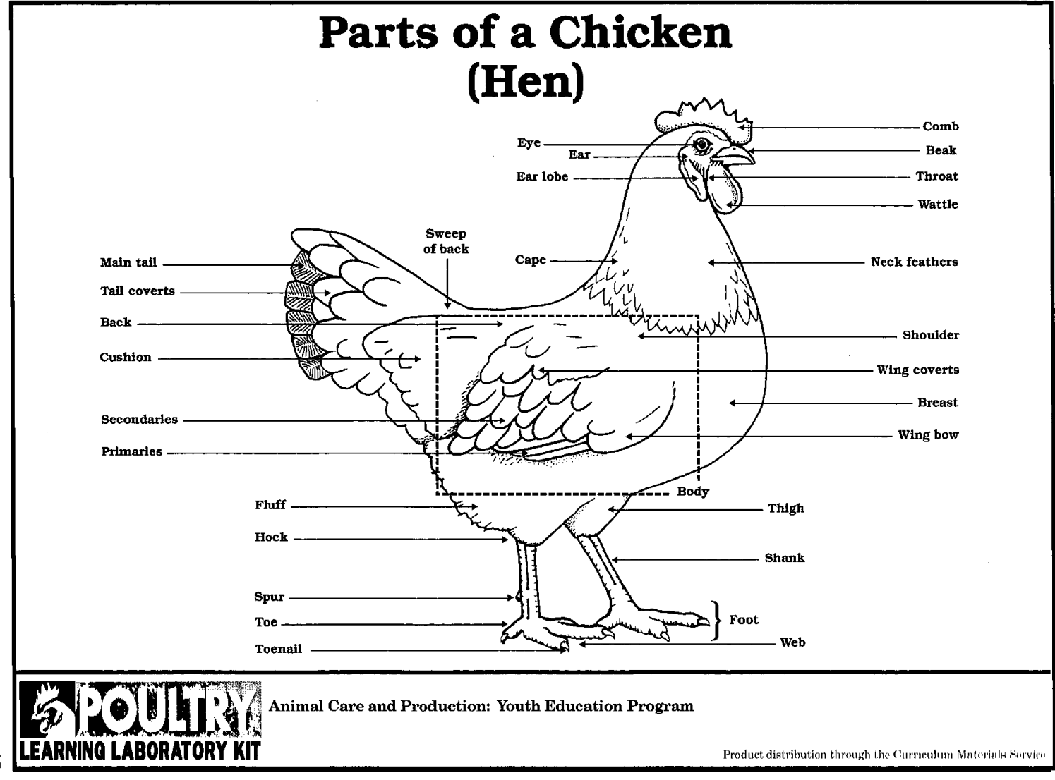
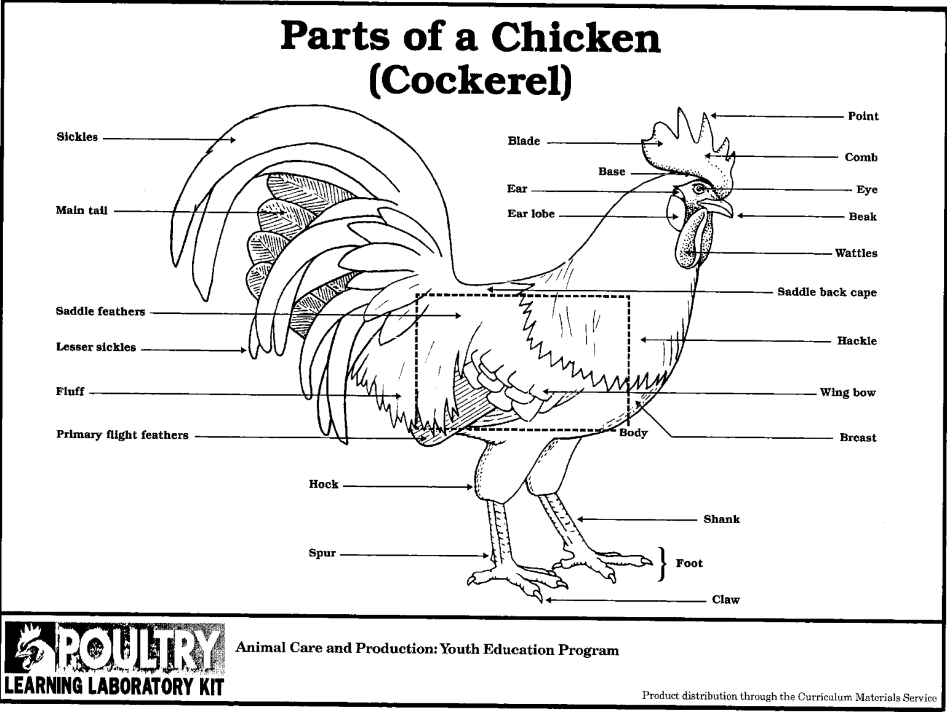
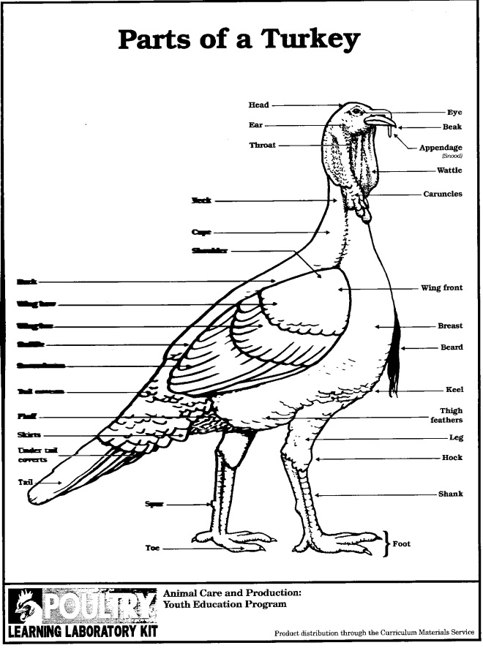
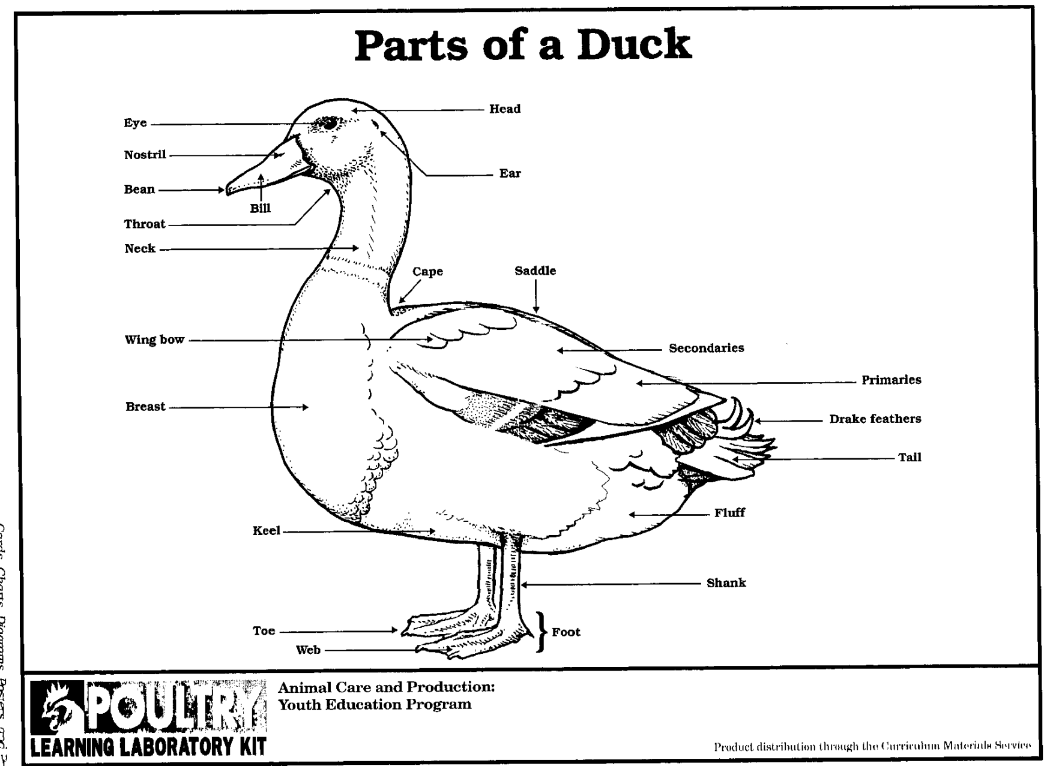

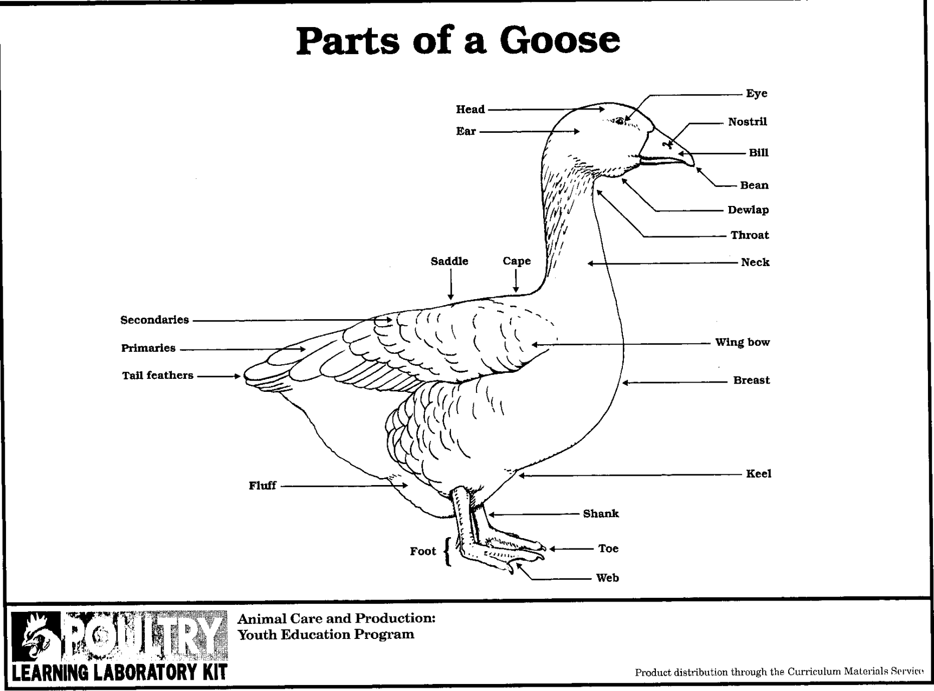

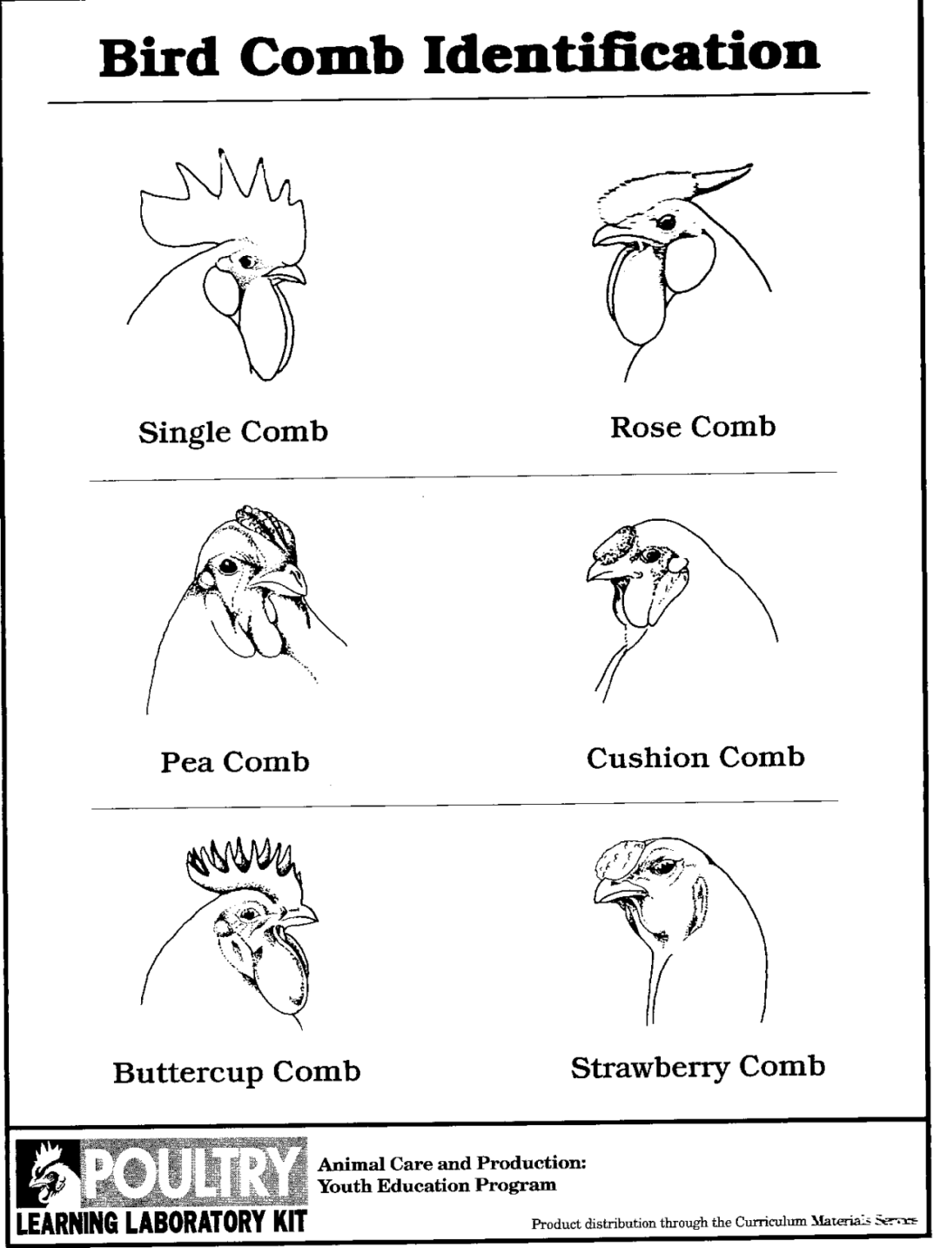
There are different types of combs that are inherited characteristics of breeds and varieties. The single
comb (illustration #3) is most familiar, having its base of attachment to the skull. Its posterior edge is the blade, and the spaces defined by its points are serrations. The pea comb has three rows of bumps. The rose comb has many very small bumps and may not have a spike projecting back. The strawberry comb has a pitted texture, is relatively small, and sets well forward on the head with its larger end forward. The v-shaped comb is associated with chickens that have a crest of feathers on the head, is very small, and sets well forward on the head. These chickens may or may not also have muffs or a beard of feathers. The buttercup comb,starting at the base of the beak forms a cup-shaped circle of points defining a deep cavity. It has a smooth, fine texture. The cushion comb is relatively small and smooth in texture, setting low and well forward on the head. The observable differences in secondary sex characteristics between the male and female chicken are referred to as sexual dimorphism. The male has a larger body, comb, and wattles. In single-comb birds the male’s comb will be turgid and stand erect, whereas the female’s comb may flop over on one side. In multicolored varieties, the male will have more variety of coloring in his plumage than the female. The male has longer and more pointed hackle feathers than the female. The male and female both have main tail feathers. However, in the male only, the tail feathers are covered by sickle feathers. Also, only the male has saddle feathers. The male has a larger, more developed spur than does the female.
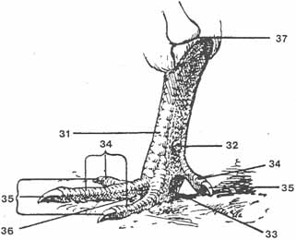
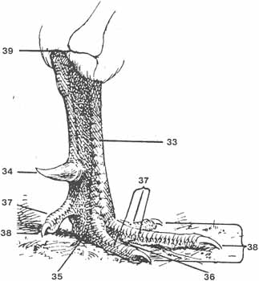

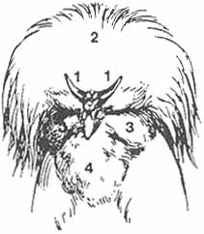
Sultans Head (ideal)
1-1, V-shaped Comb; 2, Crest; 3, Muffs; 4, Beard.

FEMALE
35-35. Toe-Nails
36. Web
37. Middle of Hock Joint
31. Shank
32. Spur
33. Foot
34-34. Toes
MALE
37-37. Toes
38-38. Toe-Nails
39. Middle of Hock Joint
33. Shank
34. Spur
35. Foot
36. Web
A young chicken from hatch to five weeks of age is called a chick. A male chicken less than one
year of age is a cockerel; a female through her first laying year may be referred to as a pullet. A
mature male chicken greater than one year of age is referred to as a cock or rooster; a mature female greater than one year old may be called a hen.

The turkey has nomenclature similar to the chicken but with a few notable differences (illustration #5). It has no comb on its head, but does have a fleshy growth from the base of its beak that is known as a snood, which is very long on males and hangs down over the beak. It has a wattle, but also bumpy, red, fleshy tissue
covering the head and neck called caruncles. Male turkeys have a tuft of long, bristly, black, coarse fibers attached to the breast, known as the beard. A young turkey is called poult. A male turkey of any age may be referred to as tom; female turkey, a hen.

Ducks have nomenclature similar to that of the chicken, with the following notable differences (illustration #6). There is no comb or other head covering. The duck’s bill is flatter than the chicken’s beak and has a protrusion on the upper tip known as a bean. The duck has webbed toes used for swimming. Male ducks
have curled feathers at the base of the tail distinguishing them from females. Male ducks emit only a hiss, whereas the female will also emit a squawk when handled.
A young duck is called a duckling. An adult male is a drake; and an adult female, a duck.

Geese have a few additional distinguishing #features (appendix illustration 6). Some breeds will have a horny knob at the base of the bill. Some geese also have dewlap, which is a loosely suspended growth of skin extending from the base of the lower bill along the upper throat. A young goose is called a gosling. An adult male is a gander; and an adult female, a goose.

Pigeons, guineas, and various ornamental and game birds are frequently raised for pleasure. Also, a limited number of producers raise them for profit, on a full-time or part-time basis. Game birds are raised for sale to game preserves or for shooting preserves. Also, there is a limited market for the sale of ornamental birds. The domestic guinea fowl is descended from one of the wild species of Africa. Guineas might be
more popular were it not for their harsh and seemingly never-ending cry, and their bad disposition. Guinea chicks are known as baby keets. Usually, sex can be distinguished by the cry and by the larger helmet and wattles and coarser head of the male.

The peafowl belongs to the same family as pheasants and chickens, differing in no important characteristic other than plumage. Peafowl have a very raucous voice, which may annoy neighbors.

Pheasants are similar to chickens structurally and may be produced in a similar manner. Pheasants are generally raised for the purpose of stocking farms reserved for hunting by sportsmen. Pheasants originated in the orient and were first brought to America by Benjamin Franklin’s son-in-law. Pheasants are classified as (1) game breeds, or (2) ornamental breeds.

Pigeons are a versatile bird with four distinct uses: (1) the sport of racing pigeons; (2) flyers and performers; (3) showing fancy pigeons; and (4) meat production. There are about 200 different breeds of pigeons, each distinct from the other in behavior, size, shape, stance, feather form, colors, markings, and ornamentation. Pigeons are the most rapid growing of all poultry.
.
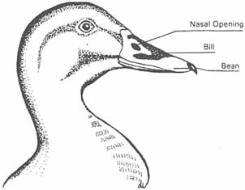

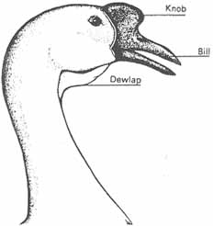
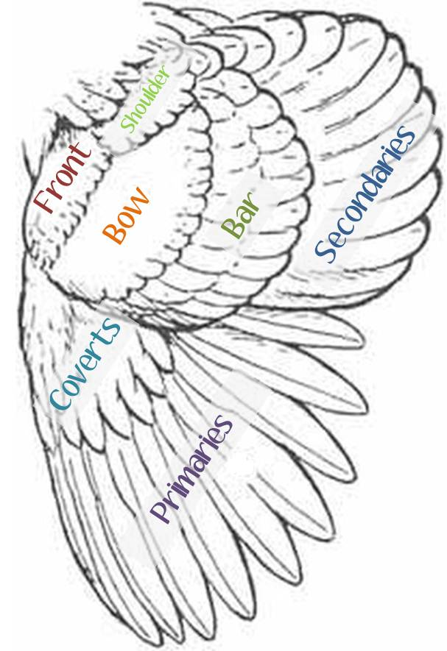
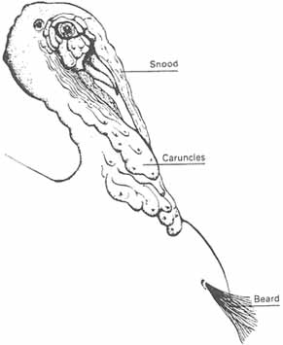
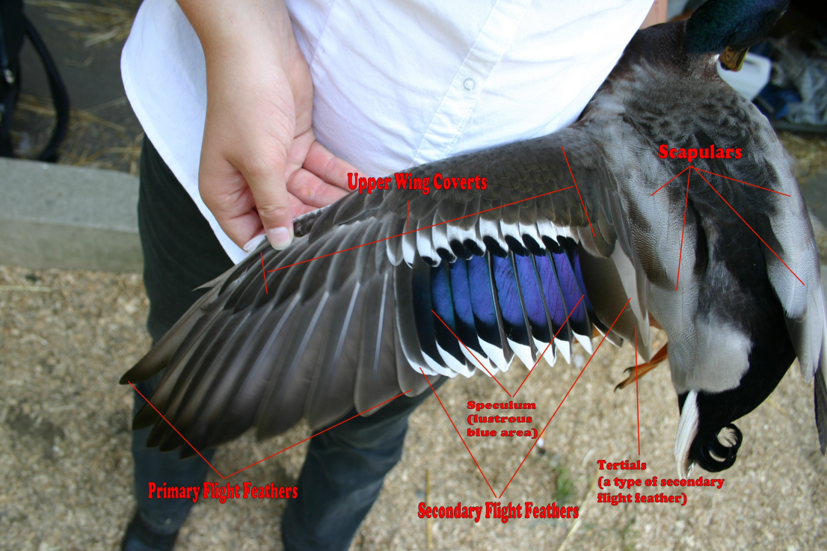
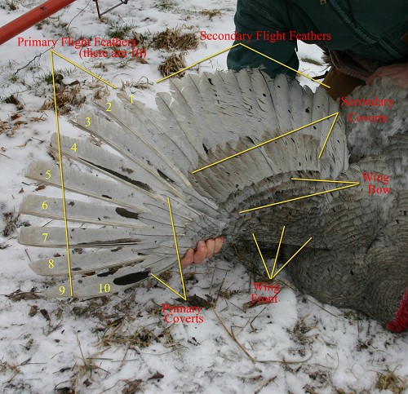
Duck Wing
Turkey Wing

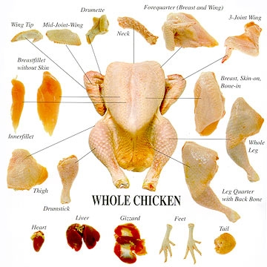
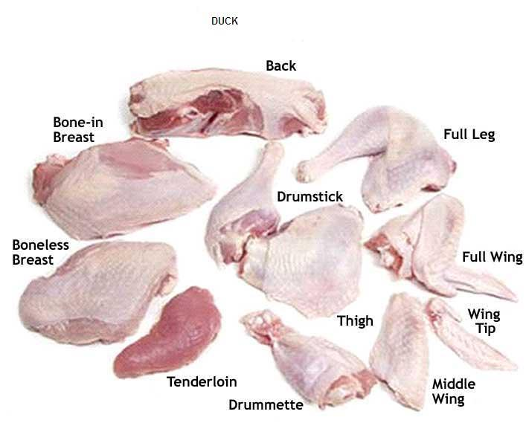
Duck, Goose, Turkey all have the same meat cuts
Broiler – a chicken less than eight weeks old, which will cook tender by broiling or frying.
Flock – three or more birds kept in one place.
Hen – a female chicken over 1 year of age for exhibition purposes.
Pullet – a female chicken under 1 year of age for exhibition purposes.
Cockerel – a male chicken under 1 year of age for exhibition purposes.
Cock – a male chicken over 1 year of age for exhibition purposes.
Exhibition – birds shown for their outward genetic expression (color patterns, body type and other characteristics).
Standard bred – large fowl that weigh more than 3 lb at maturity.
Bantam – small fowl (or miniature) that weigh less than 2 lb at maturity.
Crossbred – the offspring of parent stock of different genetic makeup.
Fowl – refers to chickens mostly, but also refers to most avian species.
Nutrients – the individual components of a feed or ingredients required by an animal.
Protein – any of a large group of complete organic components essential for tissue growth and repair.
Ration – a combination of ingredients (feed stuffs) that supply all of an animal’s dietary needs.

BREEDS

There are over 20 pages of recognized breeds on the American Poultry Associations website. (www.amerpoultryassn.com)
We have only highlighted a few common breeds. Every breed usually has a bantam variety also.
For more information about breeds, varieties and characteristics of chickens, search the local library for “The American Standard of Perfection.” This book contains descriptions and photos of all recognized breeds of domestic chickens.

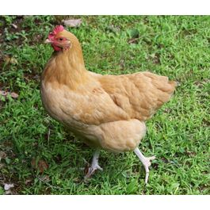
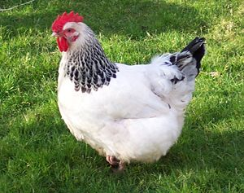
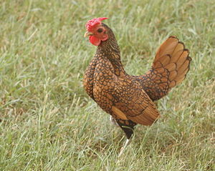
ORPINGTON  Chicken Breed Info:  Breed Purpose: Dual Purpose  Comb: Single  Broodiness: Frequent  Climate Tolerance: All Climates | General Egg Info:  Egg Productivity: Medium  Egg Size: Large  Egg Color: Light Brown
Breed Temperament:  Friendly, easily handled, Calm, Bears confinement well, Quiet, Docile | Breed Colors / Varieties:  USA APA: Buff, Black, White, Blue Splash in not recognized at this time. Also there are a few other colors of Orpington Projects under way in the USA as of today.

The Sussex chicken is a dual purpose breed that is a popular backyard chicken in many countries. They come in eight colors (with a couple more being developed) and have a bantam version at 1/4 size; the bantams may be any of the seven colors.

Sebrights -The first poultry breed to have its own specialist club for enthusiasts, Sebrights were admitted to poultry exhibition standards not long after their establishment. Today, they are among the most popular of bantam breeds. Despite their popularity, Sebrights are often difficult to breed, and the inheritance of certain unique characteristics the breed carries has been studied scientifically. As a largely ornamental chicken, they lay tiny, white eggs and are not kept for meat production.

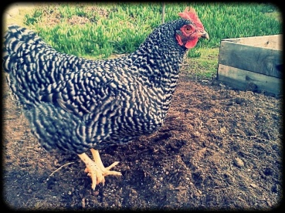

Plymouth Rock  Chicken Breed Info:  Breed Purpose: Dual Purpose  Comb: Single  Broodiness: Seldom  Climate Tolerance: All Climates | General Egg Info:  Egg Productivity: High  Egg Size: Large  Egg Color: Light Brown
Breed Temperament:  Friendly, Easily handled, Bears confinement well, Docile, Curious | Breed Colors / Varieties:  White, Partridge, Buff, Barred (most popular color), Blue, Columbian, Silver Penciled, Black.

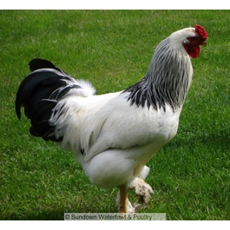
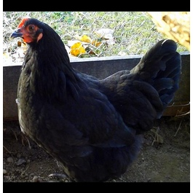

Brahma  Chicken Breed Info:  Breed Purpose: Dual Purpose  Comb: Pea  Broodiness: Average  Climate Tolerance: All Climates | General Egg Info:  Egg Productivity: Medium  Egg Size: Large  Egg Color: Light Brown
Breed Temperament:  Friendly,Easily handled,Calm,Bears confinement well,Docile | Breed Colors / Varieties:  Light, Buff, Dark, Gold, Black, White, Blue, Buff Columbian,and Blue Columbian.

Australorp  Chicken Breed Info:  Breed Purpose: Dual Purpose  Comb: Single  Broodiness: Average  Climate Tolerance: All Climates | General Egg Info:  Egg Productivity: High  Egg Size: Large  Egg Color: Brown
Breed Temperament:  Friendly, Easily Handled, Calm, Bears confinement well, Quiet, Shy, Docile | Breed Colors / Varieties:  Black

The Plymouth Rock is one of the foundation breeds of the modern broiler industry.
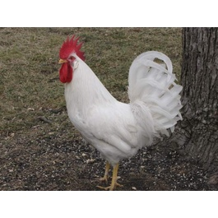

Leghorn  Chicken Breed Info:  Breed Purpose: Egg Layer  Comb: Single  Broodiness: Seldom  Climate Tolerance: All Climates | General Egg Info:  Egg Productivity: High  Egg Size: Large  Egg Color: White
Breed Temperament:  Flighty, Calm, Bears confinement well, Noisy, Shy | Breed Colors / Varieties:  white, light brown, dark brown, black, blue, buff, Columbian, buff Columbian, barred, exchequer and silver

White Leghorn is the most popular
commercial egg production breed

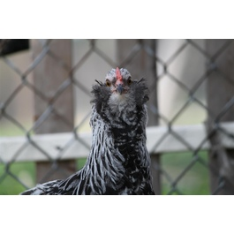

Ameraucana  Chicken Breed Info:  Breed Purpose: Dual Purpose  Comb: Pea  Broodiness: Average  Climate Tolerance: All Climates | General Egg Info:  Egg Productivity: Medium  Egg Size: Medium  Egg Color: Blueish Green
Breed Temperament:  Aggressive, Friendly ,Flighty, Easily handled, Calm, Bears confinement well, Quiet, Docile | Breed Colors / Varieties:  Black, Blue, Blue Wheaten, Brown Red, Buff, Silver Duckwing, Wheaten and White. Colors being worked on include Lavender, Splash, Splash Wheaten, Mottled, Salmon, Red Pyle and Black Gold.

Polish  Chicken Breed Info:  Breed Purpose: Ornamental  Comb: V-Shaped  Broodiness: Seldom  Climate Tolerance: All Climates | General Egg Info:  Egg Productivity: Medium  Egg Size: Medium  Egg Color: White
Breed Temperament:  Flighty, Noisy, Shy | Breed Colors / Varieties:  White Crested : Black, Blue, Cuckoo, Choc. Solid : Black, Blue, White, Cuckoo Laced : Silver, Golden, Buff Other : Tolbunt, Crele

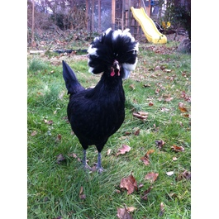

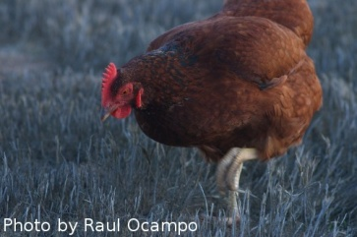
Rhode Island Reds are a good choice for the small flock owner. A dual-purpose medium heavy fowl; used more for egg production than meat production because of its dark colored pin feathers and its good rate of lay. Relatively hardy, they are probably the best egg layers of the dual-purpose breeds. This breed lays brown eggs.

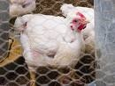

Cornish Cross  Chicken Breed Info:  Breed Purpose: Meat Bird  Comb: Pea  Broodiness: Seldom  Climate Tolerance: All Climates | General Egg Info:  Egg Productivity: Low  Egg Size: Medium  Egg Color: Brown
Breed Temperament:  Calm, Bears confinement well | Breed Colors / Varieties:  White

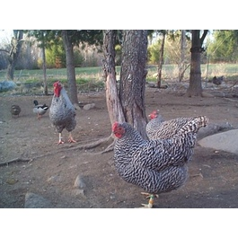
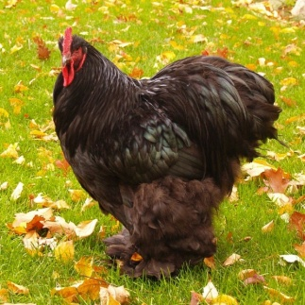

Dominique  Chicken Breed Info:  Breed Purpose: Dual Purpose  Comb: Rose  Broodiness: Average  Climate Tolerance: All Climates | General Egg Info:  Egg Productivity: High  Egg Size: Medium  Egg Color: Brown
Breed Temperament:  Friendly, Easily handled, Calm, Bears confinement well, Quiet, Docile | Breed Colors / Varieties:  Correct Dominique barring is not quite black on not quite white, and the bars are staggered, rather than the parallel and sharply contrasting black and white barring of the Barred Rock.

Cochin  Chicken Breed Info:  Breed Purpose: Ornamental  Comb: Single  Broodiness: Frequent  Climate Tolerance: Cold | General Egg Info:  Egg Productivity: Medium  Egg Size: Small  Egg Color: Light Brown
Breed Temperament:  Friendly, Easily handled, Calm, Bears confinement well, Quiet, Docile | Breed Colors / Varieties:  White, Blue, Black, Buff, Red, Partridge and various other newer colors, Splash

A Cornish X will weigh about 3 times that of a Buff Orpington (dual purpose breed) at 5 weeks! From hatch to slaughter weight in 6 to 8 weeks.! Processing is much easier with Cornish X's than a dual-purpose bird because they have very little feathering at slaughter age. Probably the only other reason why this bird is used so much by the processing/packing industry. Cornish X's are not self-sufficient. The best results after brooding seem to come from those who raise in a chicken tractor, moved daily (sometimes more), and a ration of high protein feed. Rationing the feed 12 on, 12 off, seems to encourage the Cornish X to forage and get some exercise. If not, they tend to stay right by the feeder making a very concentrated mess. Some problems that may occur if pushed (or even just because of their genetics) are heart attacks and broken legs.
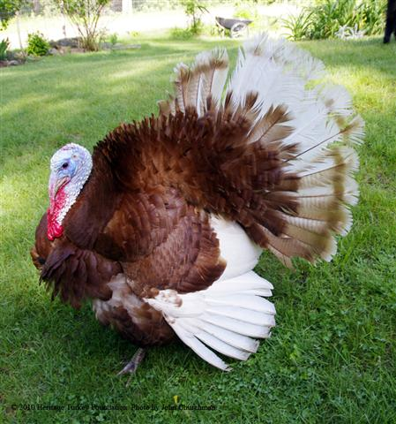
Turkeys may vary in color from white to bronze with mottled shades of black. The mottled shades are not as common as white or bronze.
White turkeys are the most popular turkeys
for the production of meat.

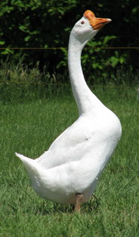

The White Chinese goose has a distinctive knob on its head. Chinese geese can be colored brown in addition to the white color.

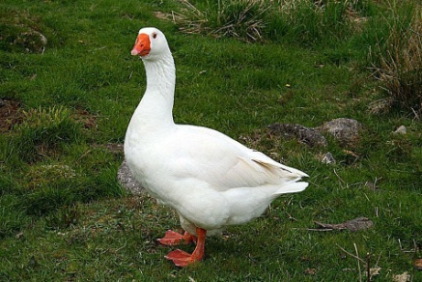

The Embden was one of the first breeds of geese introduced to the United States. It originated in Germany.

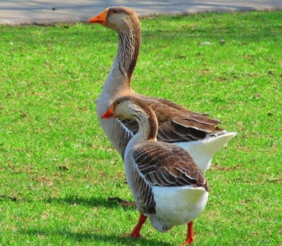

The Toulouse goose originates from the Toulouse area of southern France. The plumage is dark gray on the back, gradually shading to light gray edged with white on the breast and to white on the abdomen.

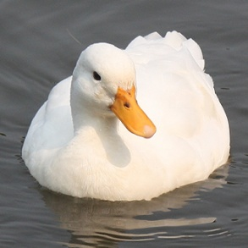
White Pekin ducks are the most popular meat duck in the United States reaching a market weight at 7 pounds in 8 weeks. The breed originated in China and was brought to the United States in the 1870s.
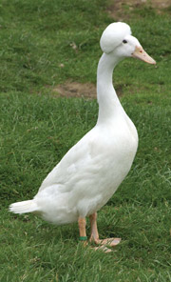
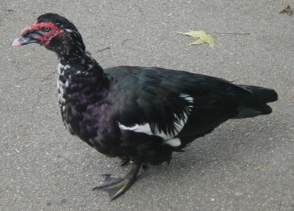
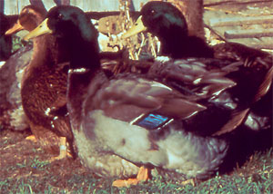
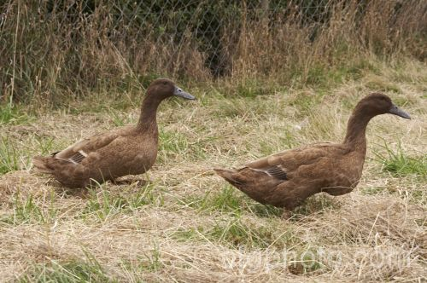
Bali
Originally imported from Malaysia in 1925, these ducks take their name from Bali, an island east of Java where they were indigenous. Originally standardized in 1930, the breed has recently been re-created in Britain (in the 1990s) by crossing crested ducks with Indian Runners.

Khaki Campbell-The Campbell is a medium-sized duck that typically weighs ~4 to 4 1/2 pounds. It has a modestly long head, bill, neck and body. The body should be full yet compact. Its carriage is held slightly upright - although should be no more than 35 degrees (variations range from 20 to 40 degrees above horizontal), with the head held high. The plumage should be tight and sleek.
Head & Neck: slender; neat and refined with medium proportions Wings: carried close and fairly high
Tail: short and slightly elevated
Legs: medium length, set well apart and not too far back

Muscovy ducks originated in South America. Numerous varieties of Muscovies exist; the white variety is the most desirable for market purposes. Mucsovies are an excellent meat bird but
their low egg production makes them unsuitable for commercial duck farms.
Rouen ducks are excellent meat producers but poor egg production and colored plumage make them unsuitable for mass
commercial production. White plumage is preferred for commercial feather processing.
Resources

http://www.lsuagcenter.com/mcms/images/departments/4hteens/project_books/pub2390 %20Intro%20Poultry%20Project%20(4th-6th).pdf

http://www.geauga4h.org/poultry/chicken_breeds.htm

http://edis.ifas.ufl.edu/ps044
www.amerpoultryassn.com

