Senior
Dairy Protégé
Workbook

Student: __________________________________________________________________

Teacher: __________________________________________________________________

**Please write and/or draw examples of your protégé experience. You may also include photographs.**

- Name two breeds of dairy cattle:
A. B.
- What is a heifer?

- What is a cow?

- What is a bull?

- What is a steer?

- What is a ruminant system in dairy cattle?

- How many parts are there to the ruminant system?

- What is mastitis?

- Name two items that are needed to show dairy cattle:
- B.
- Name three things that a dairy cow needs to eat:
A.
B.
C.
- What is the gestation period of a cow?

- Where should cows that are being milked, be clipped?

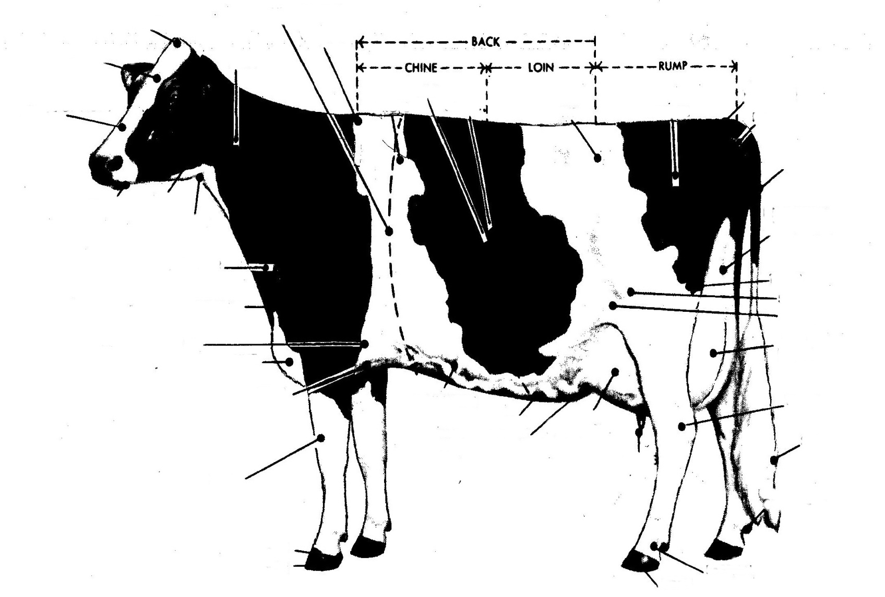
Label 20 body parts of your choice

