Senior
Llama Protégé
Workbook

Student: __________________________________________________________________

Teacher: __________________________________________________________________

**Please write and/or draw examples of your protégé experience. You may also include photographs.**
- Name and properly spell four species of South American Camelids
1. ___________________________________
2. ____________________________________
3. ____________________________________
4. ____________________________________
2. Define the following terms:
Gelding: _____________________________________________ __________
Intact male: ___________________________________________
Desensitization: ________________________________________
Conformation: _________________________________________
Ruminant: ____________________________________________
Guard hair: ____________________________________________
3. Explain the difference between an IM and Sub-Q injection_______________________________
____________________________________________________________________________
4. List three ways llama/alpacas communicate:
1 __________________2. ___________________3. ________________
5. How many compartments are in a llamas or alpaca’s stomach?____________________
6. How many days is the average gestation period for a female llama?__________ ________
for a female alpaca?________
7. The normal body temperature of a llama is ________ degrees Fahrenheit.
The body temperature of an alpaca is ___________degrees Fahrenheit.
8. Name a common internal parasite of llamas.____________________
9. If you spell llama it means____________________________
If you spell lama it means__________________________________
10. Why would a llama spit?_____________________________________________
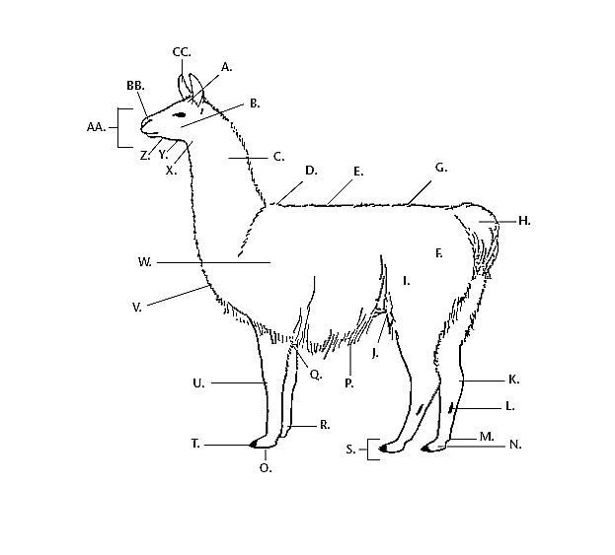
LABEL 15 BODY PARTS
Body Part Letter Body Part
______________ ______________________________
______________ ______________________________
______________ ______________________________
______________ ______________________________
______________ ______________________________
______________ ______________________________
______________ ______________________________
______________ ______________________________
______________ ______________________________
______________ ______________________________
______________ ______________________________
______________ _____________________________
______________ ______________________________
______________ ______________________________
______________ ______________________________

