Senior
Swine Protégé
Workbook

Student: __________________________________________________________________

Teacher: __________________________________________________________________

**Please write and/or draw examples of your protégé experience. You may also include photographs.**

- Name and describe (color and ears) three breeds of swine:
A.
B.
C.

- Name a common parasite (internal or external) and its treatment:

- Why and when do pigs get ear notched?

- What do the ear-notches represent?

- Name two wholesale cuts of pork:
A.
B.

- What should you feed pigs?

- What is the breed and weight of the pig you are showing?

- What is the proper uniform for showing a swine? What equipment is needed?

- Why is it “bad” to tap a pig on its ham or loin?

- Name an indication that your pig may be sick:

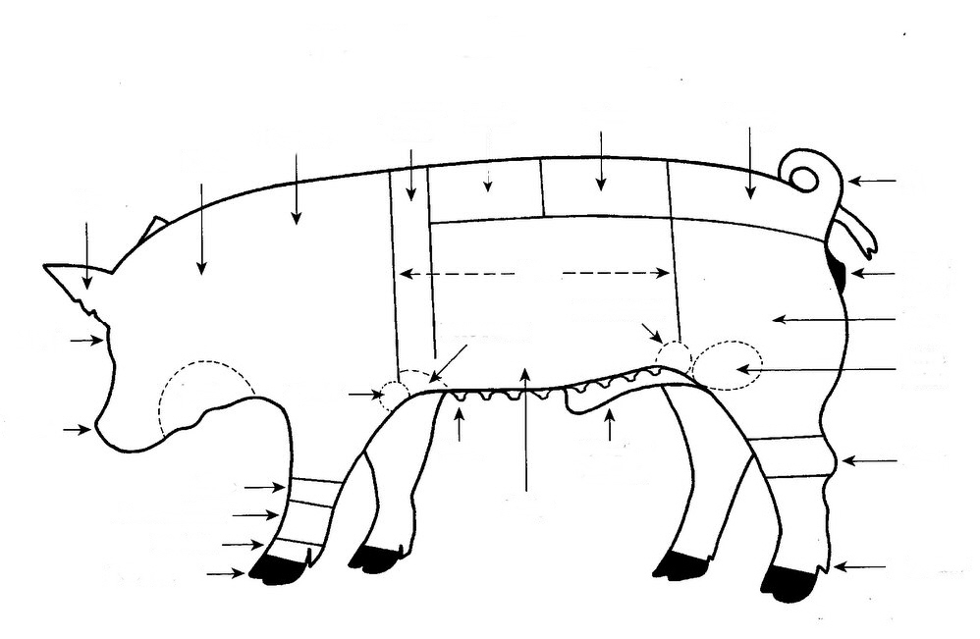
Label 20 body parts of your choice

