***Questions? Please contact Anita Sampson at anitasampson56@yahoo.com***



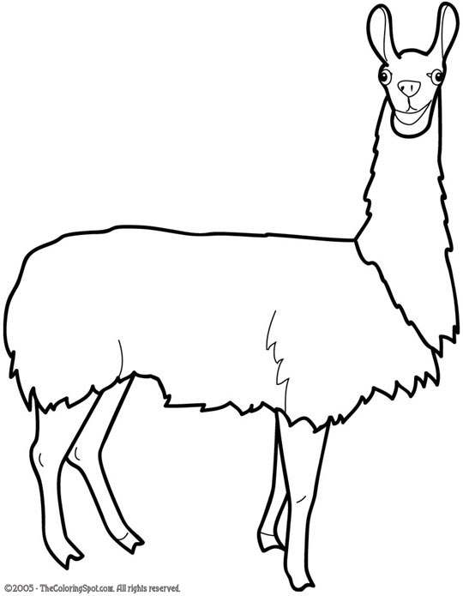

There is a $10 registration/participation cost for the Protégé Program.

The Protégé Meeting is the first Tuesday in May (May 3, 2016) at 6pm at the Wayne County Fairgrounds in Belleville.

The Wayne County 4-H Protégé Program allows youth, 5 years old and up, to:

* Learn about an animal of interest
* Learn what it eats and how to care for it
* Work with a protégé teacher (an older 4-H member who mentors protégé youth)
* Work with an animal provided by protégé teacher (no animal is necessary to participate)
* Come to the Wayne County Fair to help take care of the animal during the week and gain opportunity to show the animal with protégé teacher supervision
* Receive a packet of information with animal facts and worksheets to learn about the species
* Receive recognition at the end of the Wayne County Fair for participation in the program



