**Goat**

**Respiration…………** 12-20 breathes per minute  
**Temperature…….…..**103.8 (100.9- 104 F ) **Pulse rate…………….**70-80 beats per minute **Gestation Period……**150 days (5 months) **Estrus cycle …………**18-22 days **Male…………………….**Buck **Female………………...**Doe **Offspring……………...**Kid **Castrated Male………**Wether **Disbudding…………...**Removing horns **Caprine………………..**Goat

**All goats moved within Michigan or interstate shall be identified with official USDA scrapie program identification prior to movement off the farm. Official ID is:**

**a. A USDA approved scrapie tag. Tags are available free of charge by calling 1-866-USDATAG (866-873-2824).**

**b. The premises ID, obtained by calling the above number, and a unique alpha-numeric individual animal ID, legibly tattooed in the ear (right ear-premises ID; left ear-individual ID) or flank. Tattoos in the tail web are permissible for earless goats.**

**c. A tattoo of the registration number from an approved breed registry, only if the number is printed on the registration certificate, and the registration certificate is with the animal. USDA must be contacted to link the registration preface with the premises ID.**

**d. Electronic ID implants only in registered animals from an approved breed registry where the ID number is printed on the registration certificate. The owner must present the registration certificate and have a reader present with the animal.**

**Do not remove tags prior to weigh-in or showing. It is illegal to remove official USDA individual animal identification.**

**Selecting your animal**

Consider the following when selecting a goat: structural correctness, muscle, volume and capacity, style and balance, and growth

potential.

**Structural correctness**

Structural correctness refers to the skeletal system or bone structure of an animal. A goat should hold its head erect, and the neck

should extend out the top of the shoulders.

A goat should travel and stand wide and straight on both front and rear legs, and the legs should

be placed squarely under the body. A goat should have a strong, level top and a long rump with a slight slope from hooks to pins. Your goat should be heavy boned and strong on its pasterns. Avoid goats with open shoulders,

weak tops, weak pasterns, or steep rumps.

**Muscle**

Generally, a goat that walks and stands wide is going to be heavier muscled. The goat should have a deep, heavily muscled leg and rump. When viewed from behind, the widest part of the leg should be the stifle area. The goat should have a broad, thick back and loin that is naturally firm and hard handling. A good goat should be wide through its chest floor, with bold shoulders and a prominent forearm muscle.

The forearm is the best indicator of muscling in thin goats.

**Volume and capacity**

This refers to the relationship of body length to body depth and body width. Goats should be long bodied, with adequate depth and spring of rib. Avoid selecting goats that are short bodied, shallow bodied, narrow based, and flat ribbed.

**Style and balance**

Style and balance refer to the way all body parts blend together, how the neck blends into the

shoulder, the shoulder into the rib cage, the rib cage into the loin, the loin into the rump, or the “eye appeal” of the goat. When viewed from the side, a goat should have a smooth shoulder, level top, trim middle, and straight legs.

**Growth potential**

An animal’s ability to grow rapidly is very important. Generally, a larger framed goat that shows a long head, neck, cannon bone, and

body will grow faster, be larger, and be more competitive in the show ring.

Most shows also have weight limit requirements. Usually goats will gain approximately 2 to 3

pounds per week. Not all goats can be fed to the same final weight because of differences in

frame size. Large-frame goats may be correctly finished at 120 pounds, while small-frame goats

may be correctly finished at 80 pounds. You must learn to look at indicators of frame size and

growth (length of head, neck, cannon bone, and body) to determine at what weight a goat will be correctly finished. If you know the approximate weight of a goat at the time of purchase and the

length of time until the show, you can calculate feed requirements (light, moderate, or heavy) needed to let that goat enter the show at its correct weight. Remember that size does not make a good goat. There are good small goats and good big goats. Your management

program is the key.

**Here are some questions to ask yourself when looking to buy a goat:**

Are his back knees (hocks) extremely straight so that when viewed from the side he looks as if his back legs are fence posts? This is called “posty legged”.

Are his ankles (pasterns) weak and long so that his dewclaws almost rest on the ground?

Are his front knees and pasterns crooked (toe in or out) when viewed from the front?

Are his hocks and pasterns crooked (toe in or out) when viewed from the rear?

When you open his mouth, are the teeth on his lower jaw way in front of (overshot, monkey jawed) or behind (undershot or parrot mouthed) the dental pad of his upper jaw?

Do the toes of his hooves spread far apart from each other when he walks?

Hopefully, you answered **NO** to all these questions.

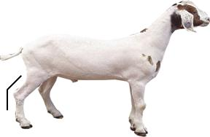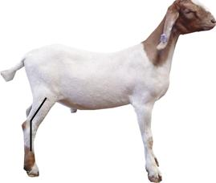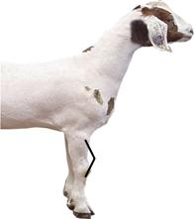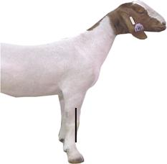

Too much set to hocks  
Bad

Buck-Kneed   
Bad

Nice set to hocks  
Good

Straight Knee  
Good

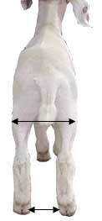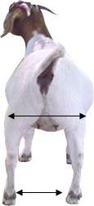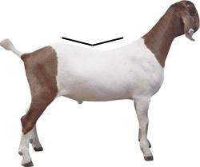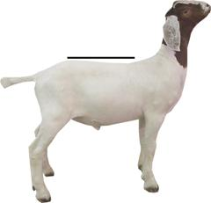

|  |
| --- |
| Weak Topped **Bad** |

Narrow/  
Thin Muscled  
**Bad**

Wide/Thick Muscled  
Good

Level Topped  
**Good**

|  |
| --- |
|  |

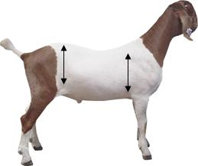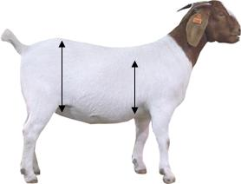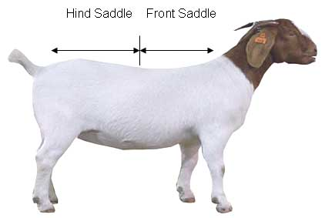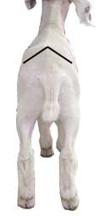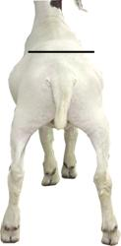

Deep Bodied  
**Good**

Shallow Bodied  
**Bad**

Hind saddle should be at least as long as front saddle.

|  |
| --- |
| Narrow and  Steep Over Top **Bad** |

Wide and Flat Over Top  
**Good**

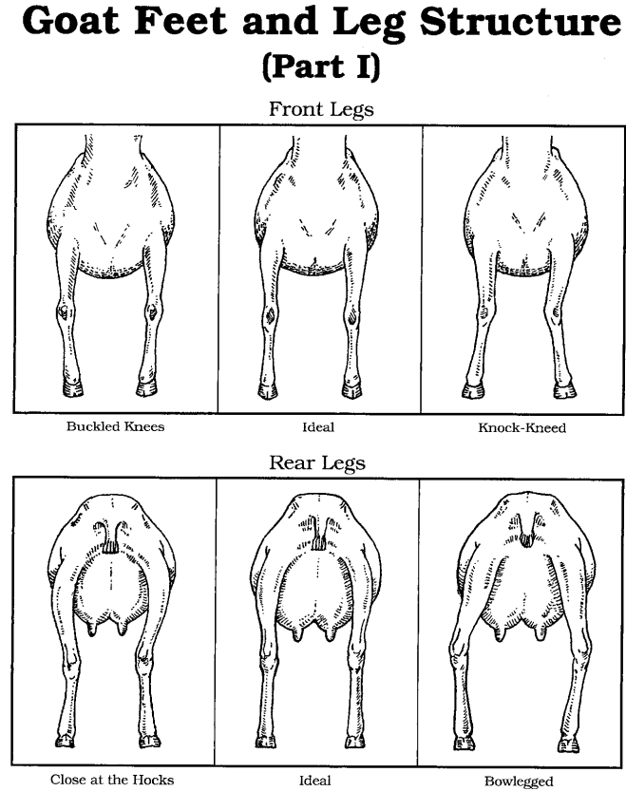

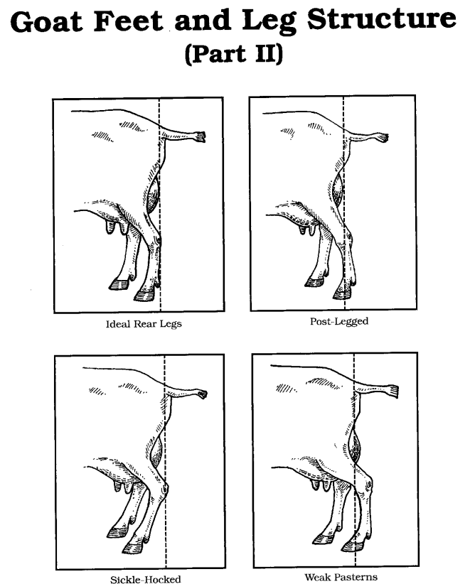

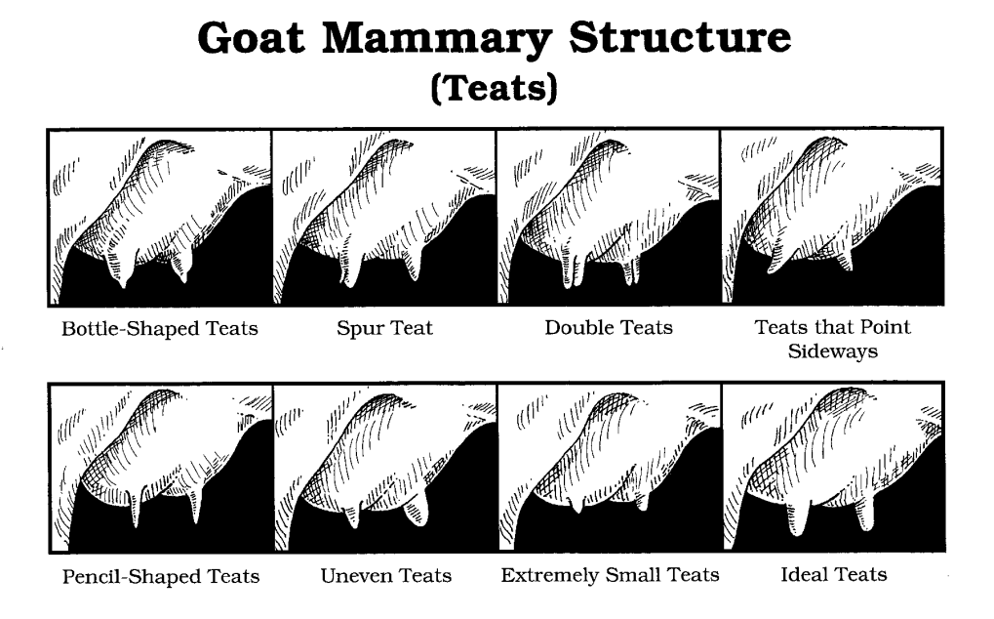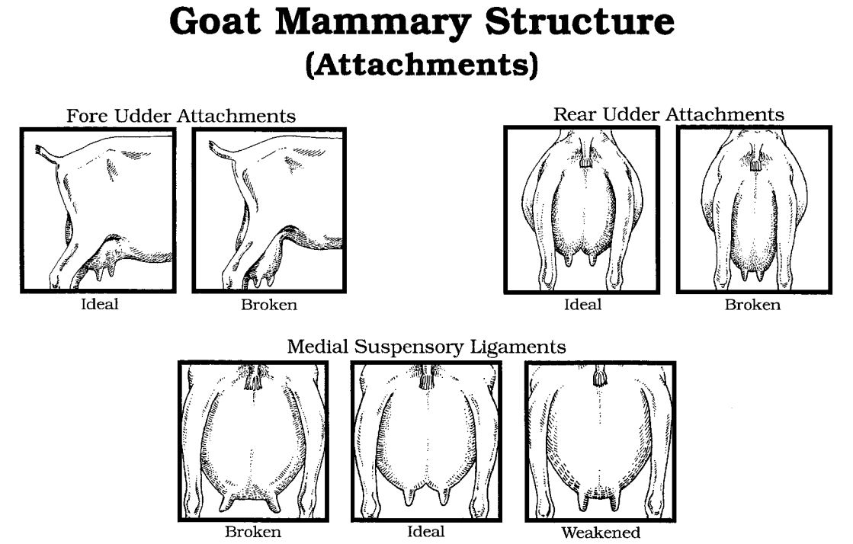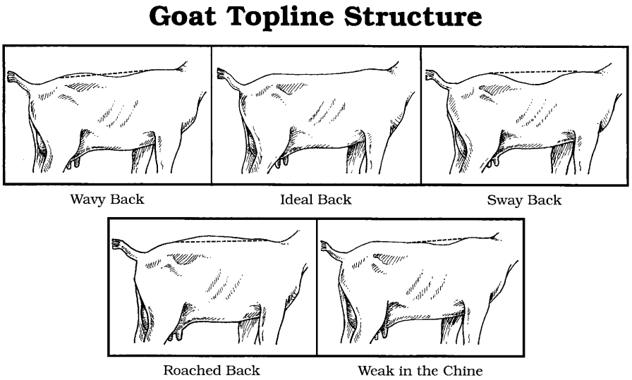

***Facilities and Equipment***

One of the major advantages of a club goat project is that you do not need expensive facilities. A barn or shed where goats can get

away from cold, wet, or drafty conditions and a pen with outside exposure are essential. Adequate fencing, a feeder, and a water container are required. Other equipment

is optional.

**Barns/sheds**

Goats need a shed or barn and an area where they can get outside in the sunshine. Ideally the shed area has at least 15 square feet of space for each goat. The outside pen needs to be as large as possible to let the goats exercise. The

shed should be well drained and open to the east or south. Barn temperature is critical. Structures should be well-ventilated so goats

can stay cool and continue to grow in the summer months. However, if club goats are slick shorn for shows, you should change the barns in winter to keep goats as warm as possible. You can do this by closing the front with a tarp or

plastic sheet and by using heat lamps.

**Fences**

The fence should be at least 42 inches high to keep goats from trying to jump. Fences should be predator proof. Net wire fences should be 12-inch mesh rather than 6-inch mesh to keep goats from hanging their heads in the wire. The most desirable pens are galvanized livestock panels 5 feet tall with 4-inch squares.

**Feeders**

Self-feeders are preferred for feeding goats. Self-feeders should be at least 6 inches off the ground. If you hand-feed goats, use movable

troughs that hang on the fence. Hang troughs at the same height as the top of the shoulder of

the goat you are feeding. You should take down these movable troughs and clean them regularly. Hay and mineral feeders also need

to be raised off the ground. This will help reduce the spread of disease. It also is important to make sure goats cannot stand in their feed troughs because they will urinate or defecate on the feed.

**Water containers**

Fresh water is the most important nutrient for club goats. Water containers should be small so you can empty and clean them regularly. Put containers in the shade to keep water cool.

In the hot summer months, some goats tend to drink too much water and will appear “full.”

Water should never be totally removed from the goat. However, rationing water before a show will help remove the “fill” and improve the goat’s appearance in the show ring. Remember, maintaining the proper amount of fluids is vital to the feel and condition of your goat.

**Equipment**

To feed and exhibit a club goat properly, you should have the following extra equipment:

•stiff brush to clean water troughs

•shovel to clean pens

•trimming table

•small animal grooming clippers

•syringes and needles

•goat blankets and/or socks

•halters, collars, and/or show chains

•hoof trimmers

•small portable feed troughs

•soft brush for grooming

•water bucket

•extension cords

You may want this equipment if you are exhibiting several goats at major shows:

•show box to hold equipment

•hot air blower or dryer

•portable livestock scales

•muzzles

•electric fans

**Nutrition and Feeding**

**When you get your goat home**

* Keep your goat in a warm, dry, and well-bedded area (especially if it has been clipped).
* Watch your goat for a runny nose or watery eyes, and treat accordingly by consulting your vet.
* Feed a 16% or 18% protein, well-balanced GOAT feed. Make sure that ammonium chloride is present in the feed to prevent urinary calculi.
* Provide fresh water daily (be sure to clean out water bucket periodically)
* De-worm your goat every 3-4 weeks and rotate the de-wormer

**1 – 2 months before a show**

* Feed a 16% to 18% GOAT feed (goats need less copper than cattle, and more copper than sheep).
* Feed 2 pounds of feed per day along with a small handful of hay to each goat.
* Provide free-choice GOAT mineral at all stages
* It is important to keep the feet trimmed
* Feeding individually is best
  + Allows you to monitor amount being eaten and watch for loss of appetite
  + Allows you to individualize amount of feed and amount/type of top dress for each goat.
* For best results you need a regular EXERCISE program for your goat. This allows for muscle growth and development.

**In the weeks right before the show**

* Adjust feed according to amount of fat cover/condition you goat is showing.
  + This can be determined by handling the goat over his ribs, right behind the front legs, and in the rear flanks.
* Hay may be limited to get rid of unwanted belly.
* Exercise program should be showing results by now (muscle development and expression).

**Two days before the show**

* Adjust feed according to weight and condition.
* Hay can be withheld to minimize belly.
* Can limit water while adding electrolytes to the water that is provided. This will help achieve the look that is needed but still keep your goat hydrated.

**If your goat is too heavy or over-conditioned**

* Back down feed consumption accordingly.
* Add a top dress such as “Star-Glo” to the feed.
* Increase exercise

**If your goat is gaining slowly**

* Increase quantity of feed and be sure you are feeding a **QUALITY** feed.
* Top dress with steam flaked corn.
* Have you de-wormed your goat lately?

Contrary to popular belief, there is no such thing as a “magic” ration to make your goat a champion. Implement a good feeding program and analyze the goat to know when to make feed changes. Since goats do not deposit external fat as rapidly as other species

of livestock, a self-feeding program is most effective. However, sometimes goats can become too fat during the feeding period and

should be hand fed to control the amount of feed consumed. All livestock require five basic

nutrients: water, protein, fats and carbohydrates (or energy), minerals, and vitamins.

The feeds that are fed to goats can be broken up into two different groups. Basically, these two groups are roughages and concentrates.

Roughages are high in fiber (18% crude fiber or more). Fiber adds bulk to the goat’s diet and keeps his digestive tract working well. Fiber has a laxative effect. It can also influence the butterfat content of a mother goat’s milk.

Diets that are high in fiber tend to increase butterfat content resulting in creamy milk, while low fiber diets decrease butterfat content. Most roughages are forages, that is, they come from the green vegetative parts of the plant, for

example, blades of grass. Forages tend to be low in energy. In contrast, concentrates are low in fiber and high in either energy or protein. They often come from the seeds of a plant. Examples of concentrates include corn, oats, brewers’ grains and soybeans.

Feed groups

1) Dry forages - these feeds are cut and cured, usually in the sun. This way they can be stored for later use. Hay is forage that is cut before or at maturity. It is either cut before it has formed seeds or while the seeds are still on it. Straw is forage that is cut after it is past maturity and the seeds have already dropped or been harvested from it.

2) Green forage and browse - examples of these are pastures or shrubs that your goat grazes fresh. As well as grazing, goats can browse like deer and giraffes. They can take a woody plant like a raspberry bush and use their mobile upper lip to select the tender, highly digestible new leaves from it and leave behind the less digestible branches and thorns. Because of this ability to select and reject different parts of the plant, goats are called **selective eaters**. Sheep and cows do not have mobile upper lips and thus, have less ability to pick and choose the parts of a plant they want to eat. Goats can get sick if they get too much green forage too suddenly. Always introduce your goat to fresh pasture and cuttings gradually. Do not feed her yew clippings, rhododendron clippings or prunings from cherry, apricot or peach trees (these fruit tree leaves are toxic when they wilt). All of these plants are very deadly to her but she will eagerly eat them. Before you cut and carry any fresh feed to her make sure it is not

poisonous.

3) Silages - these forages have been cut and then “pickled” rather than dried to store them. They are cut and then stored without air. In the absence of oxygen, certain bacteria are able to ferment the forage and preserve it this way.

Silage can be made from grasses and legumes and also from corn plants. Goats that have not grown up on silage take a little while to develop a taste for it. If improperly fermented or stored, the silage can develop molds that are deadly to goats.

4) Energy concentrates - as the name suggests, these feeds are high in energy. They include feeds that have less than 20% protein and less than 18% crude fiber. Energy concentrates include grains, flour mill by-products and

certain root crops.

5) Protein concentrates - these concentrates contain at least 20% crude protein. They are often also high in energy. They can be of plant or animal origin. Examples include soybean meal, buckwheat midlings, dried whey,

cottonseed meal and soybean meal.

6) Mineral supplements - come in various chemical forms depending on what mineral is being added to the diet. A mineral supplement that many of us humans use is table salt. Minerals should be added carefully to the feed as excesses can be toxic (poisonous) to your goat. Some minerals, for example, Selenium, Copper, Magnesium, and Cobalt are best fed as salt blocks or mixed into the grain ration or complete diet as the goat may eat too much of

them if fed free choice in the form of loose salt.

7) Urea - is a source of nitrogen just as proteins are. However, it is not a dietary protein and can be highly toxic if used to substitute for too much protein. Always introduce goats to it gradually. It should not make up more than 1% of the complete ration or 3% of a concentrate fed separately. Commercial dairy concentrates that contain 1 to 2% urea are safe for goats.

**Understanding a Feed Tag**

**A commercial feed in the United States is required to carry the following information:**

**Product name** and brand name, if any.

**Medication information**, if used. There are many different medications available depending upon the class of animal being fed.

**Purpose Statement:** Since some product names are ambiguous on what animals the feed may be fed to, a purpose statement states what animal and what feeding situation the feed is designed for (i.e., For Holsteins fed in confinement for slaughter).

**Guaranteed Analysis:** There are three basic nutrients that must be on all labels: a) If the product is intended to supply protein, minimum crude protein. If a source of non-protein nitrogen is used, the maximum amount of "equivalent protein from non-protein nitrogen" needs to appear. b) minimum crude fat, and c) maximum crude fiber. If the total minerals added to the feed exceed 6.5%, additional guarantees are required for beef cattle labels. These guarantees are minimum and maximum calcium, minimum phosphorus, minimum Vitamin A if added, and if salt is added, minimum and maximum salt. Other minerals and vitamins may be guaranteed. Mineral supplements must state (when these nutrients are added) minimum/maximum calcium (Ca), minimum phosphorus (P), minimum/maximum added salt (NaCl), minimum magnesium (Mg), minimum potassium (K), minimum zinc (Zn), minimum copper (Cu), minimum selenium (Se), and minimum Vitamin A.

**Non-protein nitrogen** (NPN) sources generally found in commercial feeds are urea, monoammonium phosphate, ammonium sulfate and ammonium chloride. Non-protein nitrogen is highly soluble, converts rapidly to ammonia in the rumen and is utilized by ruminal microbes to produce microbial protein which the animal then uses. To convert NPN to "crude protein" multiply the amount of nitrogen by 6.25. Different sources of NPN may be used in feeds for a variety of reasons. Urea is used as a low cost source of crude protein. Urea containing feeds have a lower price than feeds containing "all natural" proteins. Monoammonium phosphate is a source of phosphorus often found in mineral supplements. Ammonium sulfate and ammonium chloride are used to help prevent urinary calculi (water belly) in wethers and steers. Ammonium sulfate is also used as a source of sulfur for high urea diets.

**Ingredient Statement:** The major ingredients of the feed may be listed specifically (i.e., corn, soybean meal, alfalfa) or may be represented by collective terms (grain products, plant protein products, forage products, etc.) Collective terms refer to a group of ingredients used for a common purpose. Collective terms make it easier to "best-cost" formulations (using the best combination of ingredients to meet a specific nutrient profile for the feed at the lowest possible cost) without reprinting labels each time an ingredient is changed. An abbreviated list of collective terms is in Table 1. The order in which ingredients appear is not regulated, but generally is from the greatest amount to the least amount.

Since August 1997, United States feed companies have been prohibited from feeding ruminant derived meat and bone meal back to ruminants, including cattle and sheep. This rule was put in place to prevent any chance of introducing Bovine Spongiform Encephalopathy (BSE) into the United States. Any feed containing ruminant meat and bone meal must be labeled "do not feed to cattle or other ruminants." If "animal protein products" appears on the tag of the commercial feed you are using, don't panic. Ask your feed company to explain the source of "animal protein products." This term includes porcine meat and bone meal (legal to feed to ruminants), hydrolyzed feather meal, fish meal and blood meal (no BSE concern). Animal fat poses no threat from BSE.

**Cautions, Warnings:** This section gives any precautionary warnings such as with medicated feeds like Lasalocid (Bovatec): "The safety of lasalocid in unapproved species has not been established." Another commonly seen warning is "Caution: Do Not Feed to Sheep" found on feeds with high levels of supplementary copper and "Caution: Use as Directed" seen on feeds with high levels of urea. Feeding or Mixing Directions: Directions are expected to be fully explanatory. This section should indicate minimum and maximum amounts to feed. Amounts may be in absolute weights (i.e., feed 0.1 to 2 lb.), expressed as the amount of feed on a body weight basis (i.e., 1 to 1.5% body weight would be 10 to 15 lb. for a 1000 lb. bull) or the amount an animal is expected to consume when the product is fed free choice (i.e., optimum intake is 2-4 oz/head/day). It should also indicate if other feeds should be used in conjunction with this feed. If special care should be used in mixing this product, the directions would indicate for instance "mix thoroughly with grain and/or roughage prior to use.

**Net Weight of Unit:** Net weight refers to bag weight (50 lb) or bulk amount (2000 LB).

**Manufacturers or Distributors Name:** The name and address of the company selling the feed must be on the tag.

|  |  |
| --- | --- |
| **The exercise on this page uses a feed tag for sheep feed as an example.** However, for learning purposes, it is applicable to other animals such as poultry, swine, dairy, beef, goats, rabbits, etc.  Identify the parts of a feed tag.  **Product name  Medication information  Purpose Statement  Guaranteed Analysis  Ingredient Statement  Cautions, Warnings  Net Weight of Unit  Manufacturers or Distributors Name**  What is the main ingredient of this feed? Top of Form  Crude protein Calcium Vitamin A Crude fat What is the active drug ingredient? Top of Form  Vitamin A Tylenol Lasalocid Selenium  What is the minimum crude protein level? Top of Form  10.00% 2.50% 0.55% 20%  What is the minimum crude fat level of this diet?  Top of Form  0.30 PPM 0.75% 2.50% 0.55% Is this a medicated feed? Top of Form  Yes No  Is there a withdrawal time for this feed?  Top of Form  Yes No  Bottom of Form  Top of Form  Bottom of Form | **Lamb Starter  Medicated**  Starter for growing lambs  FOR THE PREVENTION OF coccidiosis CAUSED BY *Eimeria ovinodalis*, *Eimeria crandalis*, *Eimeria ovinoidali*, *Eimeria ahsata*, AND *Eimeria* IN SHEEP KEPT IN CONFINMENT.  ACTIVE DRUG INGREDIENT LASALOCID (AS LASALOCID DOSIUM) 90 g/ton  GUARANTTED ANALYSIS  CRUDE PROTEIN …........…MIN 20.00%  CRUDE FAT …… …………MIN 2.50%  CRUDE FIBER …. …...……MAX 10.00%  CALCIUM …………….…… MIN 0.75%  CALCIUM …………….…….MAX 1.25%  PHOSPHORUS ……..……. MIN 0.55%  SALT …………… . ……….. MIN 0.40%  SALT …………… . ……….. MAX 0.90%  SELENIUM ……… . ……… MIN 0.30 PPM  VITAMIN A ……………….... MIN 2,000.000 iu/LB  INGREDIENT USAGE  Processed Grass by Products, Grain Products, Plant Protein Products, Roughage Products, Molasses Products, Ground Limestone, Salt, Lignin , Sulfonse, Potassium Sulfate, Magnesium Sulfate, Magnesium Oxide, Sodium Selenite, Calcium Propionate, Vitamin E Supplement, Vitamin A Acetate, Vitamin D-Supplement, Zinc Sulfate, Zinc Oxide, Sodium Molybdate, Manganese Oxide, Calcium Iodate, Colbalt Carbonate, Ferrous Sulfate.  FEEDING DIRECTIONS  Lamb Starter contains 45 mgs lasalocid per pound. Feed continuously as the sole ration to growing lambs from 1 to 6 weeks of age at the rate of 0.33-1.55 pounds per head per day to provide not less than 15 mgs. And not more that 70 mgs of lasalocid per head per day. Provide clean, fresh water at all times.  CAUTION  The safety of lasalocid in unapproved species has not been established; do not allow horses or other equines access to lasalacid as ingestion may be lethal, feeding undiluted or mixing errors resulting in excessive concentrations of lasalacid could be fatal to sheep.  MANUFACTURED BY SKILLATHON FEEDS  NET WEIGHT 50 POUNDS (22.7 KILOGRAMS) OR AS SHOWN ON SHIPPING DOCUMENT    Bottom of Form  Top of Form  Bottom of Form  Bottom of Form  Top of Form  Bottom of Form |

**General Health Management**

***Health***

The key to a healthy goat is the development of a preventive health program. Most goats purchased for club projects should be on a health maintenance program and have had a variety of vaccinations. However, as you develop your preventive program, assume

the goat you have purchased has had no treatments. You should include in your program vaccinations and treatments for certain

common problems. Find out what vaccination, worming, and Selenium supplementation programs are recommended in your area. Find out how soon before slaughter various vaccines and wormers must be given in order not to leave

drug residues in the goat’s meat. Give vaccines just under the skin (SQ) and not directly into the muscle (IM) to avoid bruising your goat’s meat. Generally, Vaccines - **Enterotoxemia and tetanus** are two very common diseases of goats caused by soil borne bacteria. Vaccinating your goat for these diseases will greatly reduce his chances of getting them. Goat kids are vaccinated for Clostridium C, D and tetanus at about 4 weeks of age and then again 3 to 4 weeks later. If they are in a feed lot situation, the vaccine is often repeated every 4 months to optimize protection. In most herds, adult animals are only vaccinated once per year after they receive their two initial kid boosters. The yearly vaccine is given to does 4 to 8 weeks before they are due to kid so that their newborn kids will be protected against these diseases until they are old enough to effectively vaccinate. When you buy a goat make sure he has had both of the boosters for these diseases. If in doubt, vaccinate him again.

**Enterotoxemia**

A major cause of death in club goats is enterotoxemia, or overeating disease. Afflicted animals seldom show symptoms, and rapid

death is usually the result. This disease is caused by a clostridial organism normally present in the intestine of most goats. Goats that

have their feeding schedules abruptly changed or take in large amounts of grain are subject to

enterotoxemia types C and D. Feeding changes can cause the clostridial organism to grow rapidly and produce a powerful toxin that causes death in a few hours. All club goats should be vaccinated with a combination (types C

and D) vaccine immediately after purchase. The vaccine usually comes with tetanus also (C,D and T). At least one booster vaccination is recommended.

**Internal parasites**

Internal parasites are a continual problem. Newly purchased goats should be dewormed immediately for internal parasites and a

second treatment should follow about 3 weeks later. Few dewormers are approved to treat goats for internal parasites. Your veterinarian will have the best information on the most

effective treatments. Because internal parasites develop resistance to a dewormer over time, it

may be more effective to rotate products.

**Urinary calculi**

Urinary calculi is a metabolic disease of male goats characterized by the formation of calculi, or stones, in the urinary tract. The first sign of calculi is a goat’s inability to pass urine. The goat will be restless, kick at its belly, stretch, and attempt to urinate. Because grains are high in

phosphorus and low in calcium, high concentrate rations may cause urinary calculi. Use a ration that contains ammonium chloride

and provide plenty of clean, fresh drinking water at all times.

**Coccidiosis**

Coccidiosis causes weight loss and continued inefficiency in goats. Bloody diarrhea, dehydration, weight loss, and weakness

characterize the disease. Separate sick goats and treat them individually as prescribed by

a veterinarian. Most commercial show goat

rations are medicated with a coccidiostat

that will help control coccidiosis.

**Soremouth**

Soremouth is a contagious viral disease that causes scabs on the lips and around the goat’s mouth. This virus can affect humans, so

be careful when handling goats with soremouth. You can rub iodine into lesions after the scabs

are removed, and this will help dry the area and reduce the infection. Vaccines are available to help prevent this problem.

**Pinkeye**

This contagious disease is characterized

by excessive watering of the eye and clouding over of the pupil. Goats are especially susceptible to pinkeye when stressed or

after they have been transported to a new location. Dry, dusty pens and constant exposure to sunlight can be contributing factors. Several medications are on the market for pinkeye. If you do not notice improvement within a few

days after treatment, contact your veterinarian.

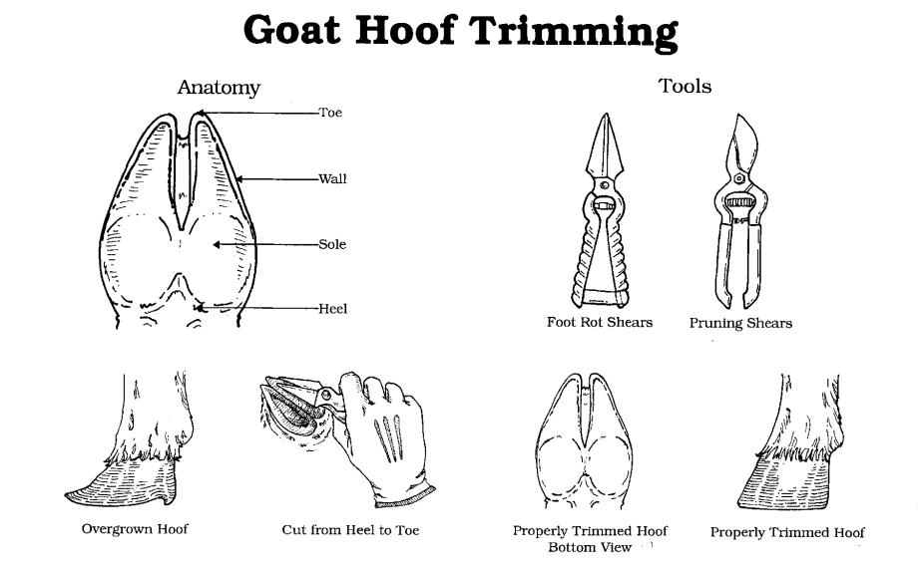**Scrapie**  
Scrapie is a fatal degenerative disease of the central nervous system of sheep and goats. Although Scrapie doesn't cross species, it is a member of the family of diseases known as Transmissible Spongiform Encephalopathies (TSE's) that includes "Mad Cow Disease" in cattle and Chronic Wasting Disease in deer and elk. Over a period of years, infected and/or susceptible herds become economically unviable as younger and younger animals succumb to the disease. Animals sold from infected herds spread this incurable illness. The existence of Scrapie in the United States prevents the export of breeding stock, semen, and embryos to other countries from herds with known or suspected exposure to scrapie.

**Lice**Lice can become a problem in early spring as goats start to shed their winter coats. Always look for lice if you notice flaky or itchy coats and treat as necessary.

**Hoof trimming**

A goat’s hooves will grow long if they are not naturally worn down by traveling over rough terrain. You should trim long hooves about every 6 weeks. Always trim hooves 1 to 2 weeks before a show in case you accidentally cut

into the quick. This will allow the goat time to heal before the show. If foot rot develops, trim the hoof closely, treat with an external product, and give an antibiotic.

**To Trim Hooves:**

1) with the point of your shears, clean out any dirt that has gotten stuck between his walls and soles;

2) carefully cut off the wall at the tip of his toe so that it is even with his sole;

3) cut away any bent over or excess wall until it is level to the sole all the way around;

4) trim away any rotted out areas between the sole and hoof wall;

5) trim the tissue on his heels until the floor of his hoof is level to his hairline (this also stimulates the heels to grow and helps prevent contracted heels)

**Dehorning or tipping**

Some shows require that goats be dehorned. If you plan to dehorn, it is preferred to “disbud”

goats at 10 to 14 days of age. The older the goat is and the larger the horn, the more stressful it will be on the goat. Dehorning rules are made strictly for the safety of the exhibitors.

**Exercise**

Exercise can be very good for your goat and toward your success in the show ring. Goats are very active animals, and if given enough room will exercise themselves. Have objects like big rocks or wooden spools in your pen for the goat to climb and jump. This will give your goat an excellent chance to exercise. A goat that

exercises will handle harder and firmer and will give you an advantage in the show ring.

.





Third year (2-3 year-old)

The teeth next to the middle pair are replaced by permanent teeth when the goat is about 24 months old.

Fifth year (4 year-old and over)

The set of 8 front teeth is complete. The age of the goat beyond 5 years must be guessed at from the amount of wear on the teeth. This is very variable, and diet has a big effect. Goats on a rough, coarse diet will grind their teeth away faster than does on an easily eaten diet. Does grazing on rough pasture will show considerable wear sooner than barn-fed does on a better quality ration. Teeth spread, loosen and finally drop out as the goat ages.

Fourth year (4 year-old)

The goat now has six permanent teeth, with only one pair of kid teeth remaining.

Second year (yearling)

The goat loses the two middle front teeth when it is around 12 months old, and they are replaced by larger, permanent teeth.

First year (kid)

All teeth are small and sharp. They will gradually be replaced by larger, permanent teeth, and this process is used to help determine the age of the goat.

**Disease Prevention**

**A yes answer to any of these questions often indicates a sick goat.**

Do his eyes look dull or cloudy?

Does he have diarrhea?

Is he standing hunched up with his tail drooping down?

Are his eyes or nose very runny?

Is he coughing or breathing hard without having just done hard exercise?

Is his coat rough and flaky or does he have any bald spots?

Are his gums and insides of his eyelids very pale?

Does he have any unusual lumps or swellings on his body or legs?

Is he lame or stiff moving?

Does he have a fever?

Is his appetite poor?

Does he seem depressed or weak and uninterested in his surroundings? Is he having trouble urinating?

**REPRODUCTIVE PROBLEMS OF THE DOE**

A variety of health problems may be associated with reproduction in the doe.

1) ketosis

2) retained placenta

3) milk fever

4) genetic infertility

5) metritis

**Ketosis** (acetonemia, pregnancy toxemia). This is a metabolic disease, which means that it is a disturbance in the normal body processes, not something "catching". It is most likely to occur just before kidding or within the two to four weeks after. Does that are extremely overweight or underweight, carrying several kids, or lacking exercise are all susceptible to developing ketosis. A correctly balanced diet during

pregnancy and in early lactation, exercise, and no stressful situations are all ways to avoid ketosis in does. Never diet a doe in late pregnancy. Good management can largely control metabolic diseases. The doe with ketosis loses her appetite, becomes weak and may have muscle spasms. Advanced ketosis

results in rapid breathing, frequent urination, coma, and death. Treatment is with oral propylene glycol to raise blood sugar levels. Be sure not to overdose her with propylene glycol as this can cause acidosis.

**Milk fever** is another metabolic disease. It is poorly named as the doe often has a lower (92-96°F) than normal temperature. Good management can also largely control milk fever. It generally occurs shortly after kidding, and is the result of a calcium imbalance as lactation begins. First signs are listlessness and lack of appetite. Then the doe becomes uncoordinated and goes down. Death can happen quickly after this, so the doe needs help fast. The veterinarian will treat her with intravenous (into the veins) calcium solutions, to raise her blood calcium quickly. The best control for milk fever is to limit calcium in the feed during pregnancy, then to increase it once lactation begins. The doe needs lots of calcium as soon as she starts producing milk, but not before. High calcium feeds to avoid in late pregnancy are legume hays and soybean and linseed meals. These dietary rules do not apply to yearling does. Yearling does rarely if ever get milk fever. This is because their bodies have a high requirement for calcium throughout their pregnancy due to the fact that they are still growing themselves. To prevent milk fever, it is also best to wait until 24 hours after kidding to milk a heavy producing doe out completely. Instead, milk her just enough to release the pressure on her udder.

**Retained placenta** can occur after kidding. The afterbirth is not delivered, but remains in the uterus, or partially inside. Do not pull at the exposed parts. Simply clip them off or tie them in a knot and wait. The doe should be started on antibiotics to combat any infections from the afterbirth rotting inside her. You can also get hormone injections from your vet to help her push.

**Metritis** is a uterine infection that may occur after kidding. The temperature will be high (106-108°F), and immediate and severe antibiotic treatment will be needed. Does with retained placenta or dead kids, or one you had to put your hands in to, are most likely to develop metritis. This is because disease organisms will

have had a chance to gain entry in to the uterus. Do not neglect metritis. Serious uterine infections can be fatal or make your doe permanently sterile.

**Infertility** can have many causes. Goats that never seem to conceive should have their vagina examined with a speculum to make sure it is not abnormally small (infantile) or that the cervix opening does not look infected. Does that come into heat constantly with very short cycles may have cystic ovaries and require hormone treatment.

**Handling and Training  
*Fitting***

Some shows may enforce a shearing rule for goats. Since differences in hair length are allowed at shows, it is important to read the show rules before clipping your goat for a particular show. It is necessary to wash your goat before clipping, as clean hair will

cut smoother. Use a mild soap sparingly, rinse the animal thoroughly, and dry the goat completely. Regularly brush your goat with

a stiff brush, because brushing removes dead hair and dirt. Shear your goat according to

show rules at least 1 week to 10 days before the show. While shearing, run the clippers parallel

to the length of the body rather than vertically. Do not shear hair below the knees and hocks. Bob the hair on the end of the tail. Blend in leg hair with the body, and clip legs to mirror structural correctness. Small animal clippers

are preferred to clip closely around the eyes, ears, pasterns, or delicate areas on the goat.

**Showmanship**Showmanship can play a major role in your success in the show ring. Showmanship is the working relationship between you and your goat. If this relationship is lacking, it will result in a goat that is not being exhibited at its full potential.

### Cardinal Sins

* Going behind the goat when switching sides in order to keep the goat between you and the judge.
* Letting the goat get loose.
* Letting the goat lay down.
* Lack of eye contact or an excessive amount of eye contact. This should be split evenly between your goat, surroundings, and the judge.
* Having a dirty goat.
* Having wild and crazy goat this is a good example of how much you have worked with your goat before the show.

**Practice!**No substitute can be made for hard work.

* Work at the barn will result in goats that are more show ready.
* Winning means practicing
* Practice makes perfect!!

**Presentation**

* Attention should be divided equally between the goat and the judge.
* When the goat looks good you're doing well.
* Drawing attention away from the goat takes away from the presentation and is referred to as over showing.
* Neglecting the goat or the judge will result is a lower placing.

**Moving**

* Goat head up to the point of allowing for level top line.
* Speed is one step at a time that makes the goat appear comfortable.
* Spacing at least enough room between goats for one more.
* Stay in line.

**Setting Up**

* Feet out on the corners giving as wide a look as is comfortable for the goat.
* Set the end closest to judge first.
* Set and leave (if the fix is little, leave it, because the process of a reset gives the impression that you're struggling).
* Head up stay in line.

**The Show Person**

* Every movement is done slowly and with purpose.
* Looking effortless is the ultimate compliment.
* Give the appearance of being relaxed and enjoying the trip.
* A smile never hurts.
* A confident look convinces judges.

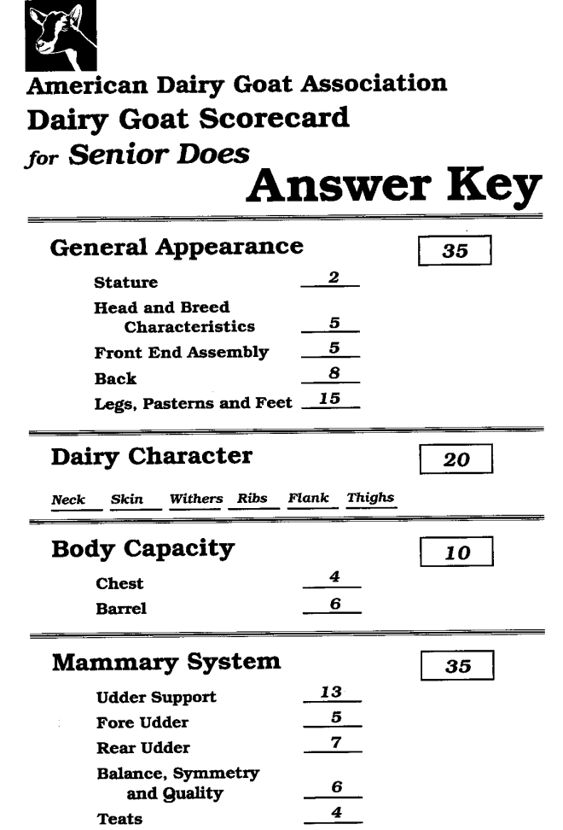**Shifting and Handling**

* Majority of the time showing is spent on the left shoulder of the goat.
* Shifting to accommodate the judge's view should be done from left shoulder to right shoulder and back slowly maintaining consistent pressure on chain to maintain the setup.
* During handling move in front of goat without bracing, holding the chain and the head if necessary.
* Never kneel on the ground. You can squat.

As with any time that you try something new, it just takes time, practice, and hard work to reach your goal and to be successful. However, the best way to learn is by asking questions and finding someone that can help you get a good start and lead you in the right path. Breeders or older exhibitors would make good helpers.

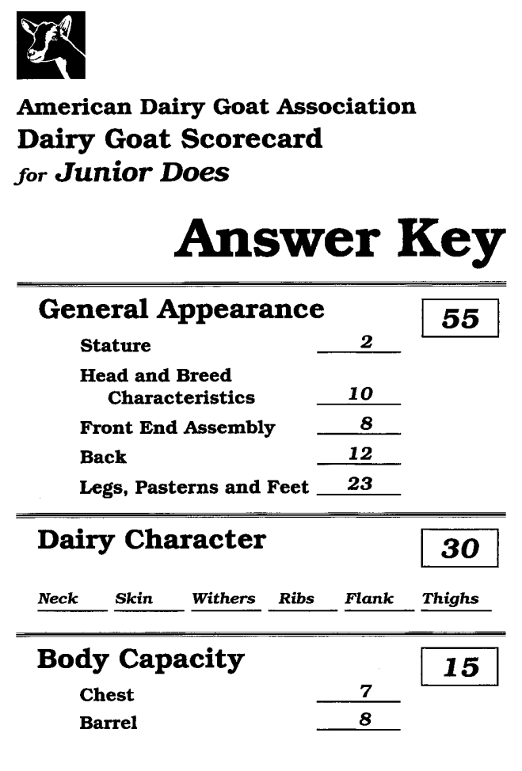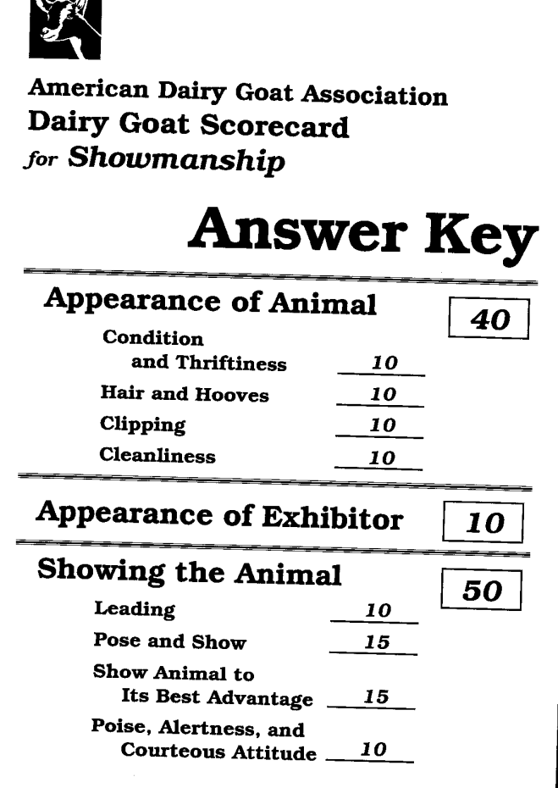

**THE DIGESTIVE SYSTEM OF THE GOAT**

The goat is a member of a class of animals called ruminants. These animals ruminate (chew their cud). Unlike us, they have special four-compartment stomachs especially designed to digest roughage (food high in fiber) such as grass, hay and silage. The goat’s stomach has four chambers: 1) the rumen, 2) the honey-combed reticulum, 3) the omasum, and 4) the abomasum or true stomach. The size relationship of the four chambers changes as the animal grows up. The abomasum gets proportionally smaller. To understand why this happens, let’s consider the function of each compartment and then review the goat’s diet.

1) The rumen acts as a big fermentation vat. Bacteria and protozoa in the rumen supply enzymes to break down the fiber in the goat’s feed. This is similar to how bacteria can ferment the sugars in grape juice to make wine in big wine barrels. The tiny organisms in the rumen also help to build proteins from the feed and manufacture all of the B vitamins needed by the goat. Many nutrients that help provide the goat with energy are also absorbed here. The

fermentation process produces heat that helps to keep the goat warm. When roughage is eaten by the adult goat, it is chewed on, soaked with saliva, and then swallowed. This bolus of food

is called “the cud”. It goes down into the rumen to be attacked and broken down or digested by the micro-organisms. At regular intervals the cud is brought back up to the goat’s mouth to be chewed on some more and then swallowed

again. This entire process is called rumination. If you watch the goat’s neck carefully, you can see him swallow and later regurgitate his cud. The goat will often burp to get rid of the gas produced by all the fermentation going on in his

rumen. You can really smell the fermentation process on his breath. If something causes the goat to stop being able to burp up the gases, the gas will build up and bloat or swell up his rumen and he may become very sick with “bloat”.

2) Once the food particles of cud become small enough, they pass to the second compartment or reticulum. Here any foreign objects that may have been accidentally swallowed with the feed settle out in the honeycomb structure of the

reticulum’s walls. Another name for the reticulum is the “hardware stomach”.

3) The fermenting particles then pass on to the omasum. The omasum removes the water from them and also absorbs more nutrients called volatile fatty acids that help supply the goat with energy.

1- rumen, 2 - reticulum, 3 - omasum, 4 - abomasum

4) The particles are then forced into the abomasum or true stomach. Here, the particles are digested by the stomach acid, hydrochloric acid (HCl). This form of digestion is the same as what occurs in our stomachs. The remaining particles are then passed on to the small intestine where most of the nutrients are absorbed by the body and made available to the goat. When a goat kid is born, its rumen, reticulum and omasum are very tiny and not useful. The goat kid depends on a liquid, milk, not roughage for its feed source. When the kid swallows milk, the milk goes directly to the abomasum through the esophageal groove. Everytime the kid swallows, a flap of skin at the entrance to the rumen folds over to form a groove that bypasses the rumen and sends the milk straight to the abomasum to be digested by stomach acid. As the kid gets older, he starts trying to consume roughage. The rumen becomes active and starts to enlarge. Its

population of micro-organisms increases. The reticulum and omasum also respond to the changes in diet by getting bigger. By the time the kid is an adult goat, roughage is his main source of food and his rumen is far larger than his abomasum.

**KID**

**ADULT**





**DISHED**

**ROMAN**

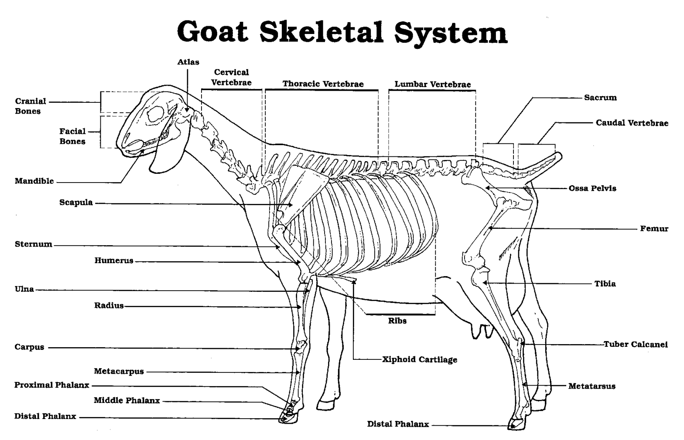**Anatomy**

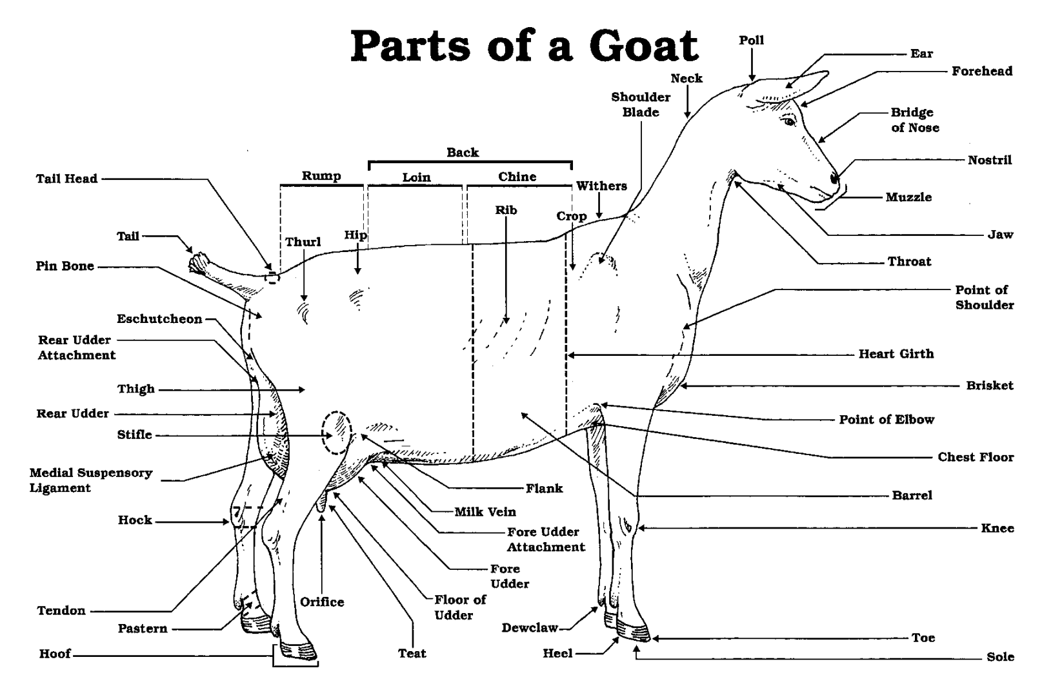 **Meat Science**

* The normal dressing percent for goats is 45-48%.

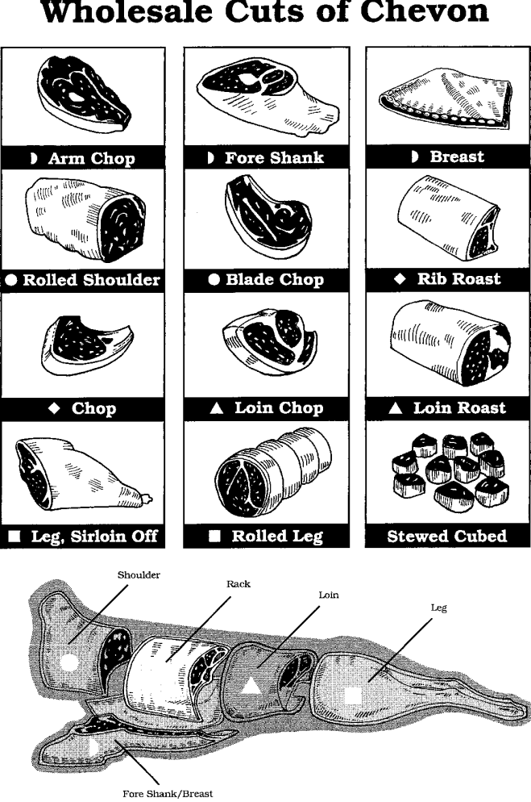

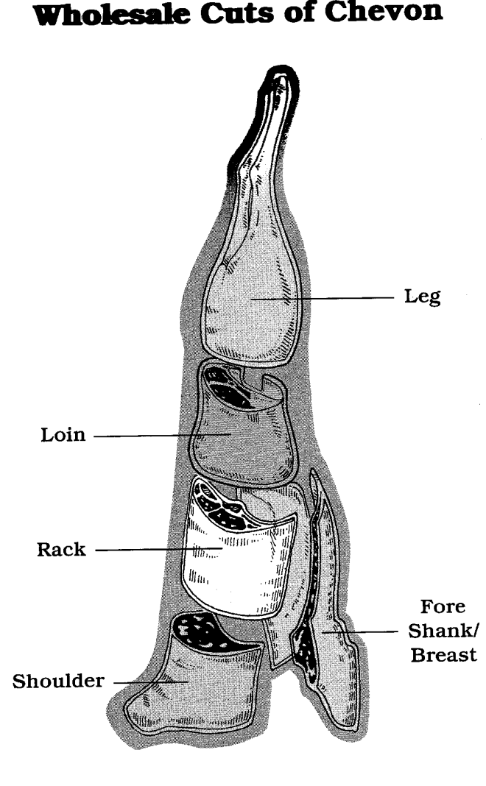

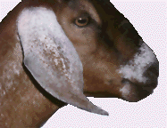

**Anglo-Nubians** were developed in England by crossing British goats with bucks of African and Indian origin. The Anglo Nubian is an all-purpose goat, useful for meat, milk and hide production. It is not a heavy milk producer but has a high average butter fat content (between four and five percent). The Anglo Nubian breeding season is much longer than that of the Swiss breeds so it is possible to produce milk year round. The udder of the Anglo-Nubian is capacious but is sometimes more pendulous than that of the Swiss breeds. A mature doe should stand at least 30 inches at the withers and weigh 135 pounds or over, while the males should stand at least 35 inches at the withers and weigh at least 175 pounds. The Anglo-Nubian usually gives less milk than the Swiss breeds, but produces a milk of higher butterfat content. Nubians have very long, floppy ears and they can be any color. They have a convex nose and are one of the larger breeds of goats.

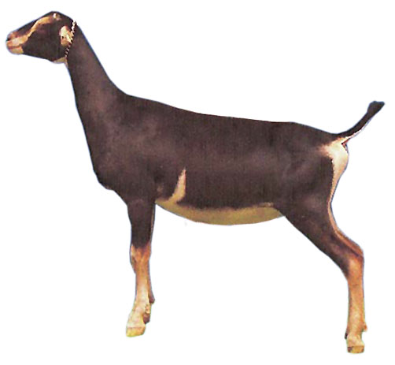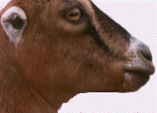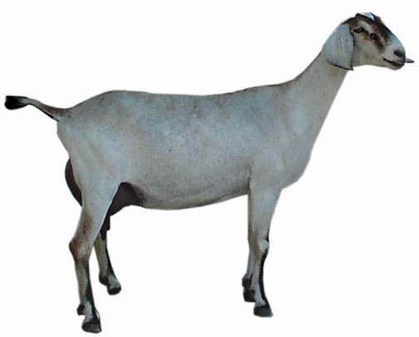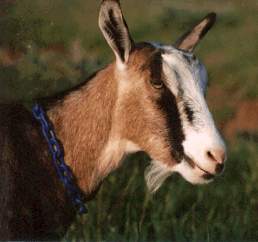

The **LaMancha** goat originated in Oregon by Mrs. Eula Frey from short-eared goats of a type found not only in LaMancha, but throughout spain. It has excellent dairy temperament and is an all-around sturdy animal that can withstand a great deal of hardship and still produce. Through official testing this breed has established itself in milk production with high butterfat. The LaMancha face is straight with the ears being the distinctive breed characteristic.   
  
There are two types of LaMancha ears. In does one type of ear has no advantage over the other. The "gopher ear" is described as follows: an approximate maximum length of one inch but preferably non-existent and with very little or no cartilage. The end of the ear must be turned up or down. This is the only type of ear which will make buck eligible for registration. The "elf ear" is described as follows: an approximate maximum length of two inches is allowed, the end of the ear must be turned up or turned down and cartilage shaping the small ear is allowed.  
  
 Any color or combination of colors is acceptable with no preferences. The hair is short, fine and glossy.

The **French-Alpine** is a breed of goat that originated in the Alps. Alpines can be almost any color except solid white and light brown with white markings (toggenburg color); their face should be dished or straight. They have erect ears and are a medium-large breed. They are popular with dairies due the amount of milk they produce. The French-Alpine is a larger and more rangy goat and more variable in size than are the Swiss breeds. Mature females should stand not less than 30 inches at the withers and should weigh not less than 135 pounds. Males should stand from 34 to 40 inches at the withers and should weigh not less than 170 pounds. French-Alpine females are excellent milkers and usually have large, well-shaped udders with well-placed teats of desirable shape.

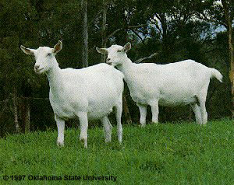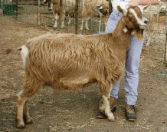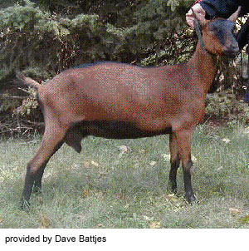

The **Toggenburg** is a Swiss dairy goat from Toggenburg Valley of Switzerland at Obertoggenburg. They are also credited as being the oldest known dairy goat breed.   
  
This breed is medium size, sturdy, vigorous, and alert in appearance. Slightly smaller than the other Alpine breeds, the does weight at least 120lb/55kg. The hair is short or medium in length, soft, fine, and lying flat. Its color is solid varying from light fawn to dark chocolate with no preference for any shade. Distinct white markings are as follows: white ears with dark spot in middle; two white stripes down the face from above each eye to the muzzle; hind legs white from hocks to hooves; forelegs white from knees downward with a dark lien (band) below knee acceptable; a white triangle on either side of the tail; white spot may be present at root of wattles or in that area if no wattles are present. Varying degrees of cream markings instead of pure white acceptable, but not desirable.   
  
The ears are erect and carried forward. Facial lines may be dished or straight, never roman. Toggenburgs perform best in cooler conditions. They are noted for their excellent udder development and high milk production, and have an average fat test of 3.7 percent.

The **Saanen** dairy goat originated in Switzerland,in the Saanen Valley. Saanen does are heavy milk producers and usually yield 3-4 percent milk fat. It is medium to large in size (weighing approximately 145 lbs/65kg) with rugged bone and plenty of vigor.

Does should be feminine, and not coarse. Saanens are white or light cream in color, with white preferred. Spots on the skin are not discriminated against. Small spots of color on the hair are allowable, but not desirable. The hair should be short and fine, although a fringe over the spine and thighs is often present. Ears should be erect and alertly carried, preferably pointing forward. The face should be straight or dished. A tendency toward a roman nose is discriminated against.

The breed is sensitive to excessive sunlight and performs best in cooler conditions. The provision of shade is essential and tan skin is preferable.

The Oberhasli is a Swiss dairy goat. This breed is of medium size, vigorous and alert in appearance. Its color is chamois. Does may be black but chamois is preferred. Chamois is described as: Bay - ranging from light to a deep red bay with the later most desirable. A few white hairs through the coat and about the ears are permitted. Markings are to be: two black stripes down the face from above each eye to a black muzzle; forehead nearly all black, black stripes from the base of each ear coming to a point just back of the poll and continuing along the neck and back as a dorsal stripe to the tail; a black belly and udder; black legs below the knees and hocks; ears black inside and bay outside; bucks often have more black on the head than does, black whiskers, and black hair along the shoulders and lower chest with a mantle of black along the back; bucks frequently have more white hairs through the coat than does. The face is straight. A Roman nose is discriminated against.

**South African Boer Goat** - This South African breed probably resulted from crossbreeding of native goats raised by Bantu tribes and various European and Asian goats brought in by Dutch immigrants. In the 1800s, SA goat farmers started selecting for compact, muscular, short-haired goats. They were able to produce a strain of goat that bred true for high growth rate, muscular carcasses, good fertility, and short hair combined with a very distinct color pattern (white body and red head). In 1959, breed standards were adopted and they became a recognized breed. Boer goats were introduced into the US in the early 1990s. Under good nutritional conditions, Boer goat crossbreds produce outstanding weight gains and carcasses.

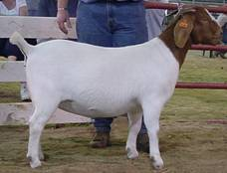

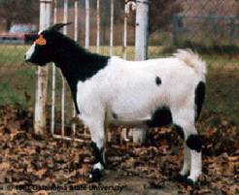

**Tennessee Meat Goat** - in 1880 a flock of myotonic goats was identified on a farm in Tennessee. Myotonic means that they have a condition that caused their muscles to lock up whenever they were startled. Sometimes their muscles lock up so suddenly that they fall over. This was the origin of the Tennesee Stiff-Leg or Fainting Goat population. These goats come in many color combinations and have airplane ears (shaped like Alpine ears but not erect, instead they jut out sideways). Texas ranchers at Onion Creek Farm chose from this population, goats with the largest frames and heaviest muscles to keep for breeding purposes. Gradually they produced a goat that is larger and heavier than the original strain. These selected goats are known as Tennessee Meat Goats. The constant stiffening and relaxing of the muscles of myotonic goats may result in heavy rear leg muscling, tender meat, and a high meat to bone ratio.

**New Zealand Kiko Goat** - The Kiko goat was produced in New Zealand by taking feral does that exhibited good meat conformation and breeding them with Saanen and Nubian bucks to increase their milk yield and butterfat content. Those bucks and does whose offspring grew best (as measured by weight gain) under rugged conditions were chosen to produce the future generations. Kikos have similar ears to Spanish goats but are usually larger framed. They are often white like their Saanen ancestors.

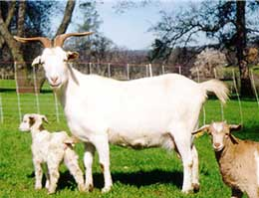

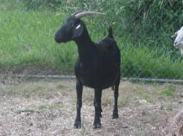

**Spanish Meat Goat** - Spanish goats are the descendants of goats brought to the U.S. by early New England settlers. They migrated south and probably interbred with goats brought into Texas and Mexico by early Spanish settlers. Their ancestry is as mixed up as that of a mongrel dog. Their rugged environment shaped them into very tough, rather small goats. Specific ranchers have genetically selected Spanish goats for better meat production by keeping only the biggest or meatiest bucks for breeding to females. Nubian bucks have sometimes been crossed with them to improve size, milk production of dams, and fleshiness of the kids. These meatier goats are known as Spanish Meat goats. They come in almost any color and are usually left horned. Their ears are somewhat pendulous but shorter than a Nubian’s. Many of them produce a cashmere undercoat in winter

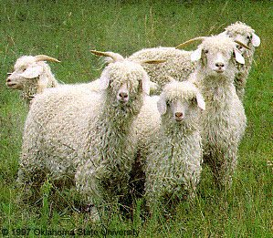

The **Angora goat** originated in the district of Angora in Asia Minor. The Angora dates back prior to early biblical history. The most valuable characteristic of the Angora as compared to other goats is the value of the mohair that is clipped. The average goat in the U.S. shears approximately 5.3 pounds of mohair per shearing and are usually sheared twice a year. They produce a fiber with a staple length of between 12 and 15cm. The mohair is very similar to wool in chemical composition but differs from wool in that it is has a much smoother surface and very thin, smooth scale. Consequently, mohair lacks the felting properties of wool. Mohair is very similar to coarse wool in the size of fiber. It is a strong fiber that is elastic, has considerable luster, and takes dye very well. Mohair has been considered very valuable as an upholstering material for the making of plushes and other covering materials where strength, beauty, and durability are desired.

The Angora is very picturesque animal in which both sexes are horned. The bucks usually have a pronounced spiral to the horn, which comes back and away from the head; the horns of mature bucks sometimes reach two or more feet in length. In contrast, the horn of the female is comparatively short, much smaller, and has only a very slight tendency to spiral. The horn of the female seldom exceeds nine or ten inches. The ears are heavy and drooping.

The Angora goat is a small animal as compared to sheep, common goats, or milk goats. There is considerable variation in the size of goats, but mature bucks will usually fall in a weight range of from 180 to 225 pounds but do not reach their maximum weight until after five years of age. Does will fall in a weight range of from 70 to 110 pounds when mature.

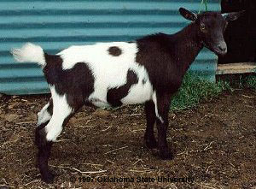

The **Nigerian** **Dwarf** is a miniature goat of West African Origin. It's conformation is similar to that of the larger dairy goat breeds. The parts of the body are in balanced proportion. The nose is straight. The ears are upright. The coat is soft with short to medium hair. Any color or combination of colors is acceptable, though silver agouti (roan) is considered a moderate fault.

**Height of the Nigerian Dwarf Goat**

|  |  |  |
| --- | --- | --- |
|  | Ideal | Maximum |
| Does | 17" to 19" | 22.6" |
| Bucks | 19" to 20" | 23.6" |

Ideal weight is suggested to be about 75 pounds. The most commonly asked question about Dwarf goats is: What is the difference between these and Pygmy goats? Although they have similar origins, they are separate and distinct breeds. Pygmies are bred to be "cobby" and heavy boned. (The best pygmies look like beer kegs with legs.) Dwarves are bred to have the length of body and structure, in proportion, of a dairy goat.

Dwarf goats come in many colors. Main color families are black, chocolate and gold. Random white markings are common, as are spots and other color combinations such as red, white, gold and black.

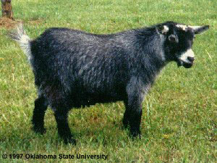

The **Pygmy Goat** was originally called the Cameroon Dwarf Goat. The goat is mostly restricted to the West African countries. A full coat of straight, medium-long hair which varies in density with seasons and climates. On females, beards may be non-existent, sparse, or trimmed. On adult males, abundant hair growth is desirable; the beard should be full, long and flowing, the copious mane draping cape-like across the shoulders.

All body colors are acceptable, the predominate coloration is a grizzled (agouti) pattern produced by the intermingling of light and dark hairs, of any color.

Breed-specific markings are required: muzzle, forehead, eyes, and ears are accented in tones lighter than the dark portion of the body in goats of all colors, except goats that are solid black. Front and rear hoofs and cannons are darker than main body coat, as are the crown, dorsal stripe, and martingale; except in goats that are solid black. On all caramel goats, light vertical stripes on front sides of darker socks are required.

The fall of 1985 found the Showalters of Zederkamm Farm, Snohomish, Washington in a bind. Their old Nubian buck had died and left their two Nubian does without a mate. True, they had other goats including several Pygmies and the Pygmy buck was eager to be of help. So they bred the Nubians to the little fellow and in the spring of 1986 three little doe kids were born, the first Kinders. One, called Liberty, stayed at Zederkamm Farm, one was placed with a 4-H girl and the other went to live with Teresa Hill, a nearby goat enthusiast. More crosses were made, this time in a deliberate attempt to produce more of these moderate sized, highly efficient dairy goats. An organization was established to register and promote this new, dual-purpose breed of goats. Initial publicity found a ready interest among goat fanciers around the country and now over 50 herd names and many hundreds of goats are registered with the Kinder Goat Breeders Association. **The Kinder goat**, as it has evolved, is a joy to milk and an ideal small homestead milk producer. Though smaller, Kinder goats are required to meet the same standards of production to be eligible for star milker awards as their larger counterparts registered by the American Dairy Goat Association. With a base production of 1,500 pounds of milk and/or 52.5 pounds of butterfat in 305 days or less, freshening at 2 years or less in age, these hard working little animals stand up well in comparison.

Since the breed is being developed as a dual purpose breed, it is also important to note that the wethers (does as well) make extremely desirable meat animals. Usually born weighing 4 or 5 pounds, they grow rapidly at a rate of about 7 pounds per month. Recently some 6-month-old wethers were slaughtered weighing about 50 pounds and dressing out at 30 pounds. This makes the dressing percentage a very favorable 60 percent. Older wethers have an even higher dressing percentage with some 14-month-old wethers having a live weight of 80 pounds and a carcass weight of 50 pounds - a dressing percentage of nearly 63 percent.

It is easily possible for a Kinder doe weighing about 115 pounds to produce five kids who in 14 months can weigh 80 pounds each and dress out at 50 pounds thereby producing 250 pounds of meat each year.

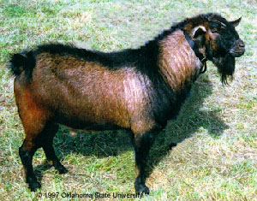

GOAT BOWL Sample Questions

What is a baby goat called?

Kid

What is an adult female goat called?

Doe

What is an adult male goat called?

Buck

What is a castrated male goat called?

Wether

The mother of a goat is called?

A dam

The father of a goat is called?

A sire

What is the "first milk" of a doe that is secreted after kidding called?

Colostrum

Why do kids need colostrum?

Antibodies and laxative

What is the technical term for the afterbirth?

Placenta

Name the two parts of a goat's body where it can be tattooed.

Ears and tail web

What does the word rumination refer to?

Bringing up cud and chewing it.

What is the most common reason for a doe to stop coming into heat during the breeding season?

She is pregnant.

What is the average length between heats?

21 days

What is a French word that often used to mean goat meat?

Chevon

What is a Spanish word that is often used to mean goat meat?

Cabrito

What is the description of a goat's ancestry called?

Pedigree

Tell why a stainless steel container is the best for milking.

Easy to sanitize

Define bloat.

Excess gas in the rumen

Which has more protein: a pound of cheese or a pound of milk?

A pound of cheese

When should you disbud a kid?

4-7 days or as soon as you can feel the horn buds on top of the head

Why should you remove the water bucket from a kidding pen?

So a kid will not be born into the water and drown

In which direction are goats led in the show ring?

Clockwise

What is the most normal presentation of a kid at birth?

Front feet and nose first.

Which dairy breed of goat is characterized by long pendulous ears?

Nubian

Name one meat breed of goat characterized by long pendulous ears rather than “airplane” ears?

Boer (another rarer breed would be Savanna)

Which goat breed is characterized by tiny ears?

LaMancha

Where are LaMancha goats tattooed?

In the tail web

After milking, should milk be cooled quickly or slowly?

Quickly

What dairy breed of goat is characterized by a white or cream color?

Saanen

What two breeds of goats have Roman noses?

Nubians and Boers (another rarer breed would be Savanna)

A doe bred in November should kid in which month?

April

A doe bred in August should kid in which month?

January

What is the main problem for a kid with scours?

Loss of fluid from the body (dehydration)

Washing the doe's udder stimulates what?

Milk letdown

What breed is characterized by a light fawn to dark chocolate color with white ears, facial stripes and lower legs?

Toggenburg

In what order are dairy goats shown?

Alphabetically by breed. (Alpine, LaMancha, Nigerian, Nubian, Oberhasli, Saanen, Sables, Toggenburg, Recorded Grade)

The first dairy goat importation came to the US from what country?

Switzerland

The first importation of Boer goat genetics into the US came primarily in what two forms?

Semen and embryos

The first Boer goat importation of semen and embryos came to the US from what country?

New Zealand

The Boer goat originated in what country?

South Africa

Which breed of dairy goat originated in the US?

LaMancha

Name three products made from goat milk.

Cheese, ice cream, yogurt, fudge, butter, soap

Which breed of dairy goat produces the most milk?

Saanen

What do we call an animal who is born without horns?

Polled

What is the normal temperature of a goat?

101.5-104 degrees Fahrenheit

Give two reasons why a goat’s temperature might be elevated?

Fever, very hot day, she has been racing around

Why is it a good idea to compare a sick goat’s temperature to a healthy herdmate’s temperature when trying to decide if she has a fever?

Other things besides a fever can make her temperature temporarily elevated

What is an Experimental dairy goat?

The result of mating two different Purebred breeds.

What is the average weight of a newborn dairy doe kid?

5-7 pounds

Tell two things to do when fitting a dairy goat for show.

Trim hooves, break to lead with a collar, clip all hair except a tuft at the end of the tail, bathe

Tell two things to be sure to do to kids at birth regardless of whether they are meat or dairy goats.

Make sure noses are cleaned off and they are breathing, dip cords, make sure they get colostrum, check for abnormalities, make sure they are warm enough

What do we call the act of a doe giving birth?

Kidding, freshening, parturition

When showing dairy goats, what kind of clothing should the exhibitor wear?

Clean, white

When showing meat goats, what kind of clothing should the exhibitor wear?

Clean clothes, dark pants

Kids' living quarters should be what?

Clean, dry, draft free

What part of the doe produces milk?

Udder

Are dairy goats typically seasonal or year round breeders?

Seasonal

Name the two types of LaMancha ears.

Gopher and elf

Tell two reasons why goats should not be tied.

Could get tangled, dogs could have easy access to them, being browsers, they need to walk around to find food.

During what season of the year are both dairy and meat does most likely to get pregnant?

Fall

When reproducing, the doe provides the egg cell. What does the buck provide?

Sperm

When reproducing, the buck provides the sperm cell, what does the doe provide?

Egg

What is the largest breed of dairy goat?

Saanen

What is the solid part of cheese called?

Curd

What is the liquid part left after curds are removed in cheesemaking called?

Whey

What do the letters ADGA stand for?

American Dairy Goat Association

What do the letters ABGA stand for?

American Boer Goat Association

Name the eight breeds of dairy goat recognized by ADGA.

Alpine, LaMancha, Nigerian, Nubian, Oberhasli, Saanen, Sable, Toggenburg

Which one of the recognized breeds of dairy goats in the US is not a standard sized breed?

Nigerian Dwarf (also referred to as Nigerian Dairy)

What is a Sable?

A colored Saanen

How many teats does a dairy goat have?

Two

Can a dairy goat with more than 2 teats be registered or recorded with ADGA?

No

Why is it unadvisable to cut off extra teats on a dairy goat?

It is against ADGA regulations

Why is it unadvisable to cut off extra teats on a meat goat?

You may identify the wrong teat as the “extra” one and instead cut off the main teat.

Can a Boer goat with more than 2 teats be registered with the various Boer Goat Associations?

Yes

Why is it helpful to practice showmanship?

To recognize the faults of the animal and to show her/him to their best advantage.

Goats, along with cows, dogs, pigs, and wolves, are examples of what type of animal?

Mammal

In showmanship, is the conformation of the goat considered?

No

How many days are in a standard lactation for a dairy goat?

305

What is celebrated the third week of June?

Dairy Goat Awareness Week

What do we call the period of time in which a goat is producing milk?

Lactation

What do the letters AR stand for on a dairy goat pedigree?

Advanced registry

What do the letters AI stand for?

Artificial insemination

What is the name of the fluid used in semen storage tanks?

Liquid nitrogen

Does the presence of some somatic cells in the milk automatically indicate a problem?

No, there are always some present

Give the correct name of the teeth which humans have but goats lack.

Upper incisors and canines

What kind of digestive system does a goat have?

Ruminant

What activity distinguishes a ruminant from a non-ruminant?

It chews cud

Which hormone remains at a high level during pregnancy?

Progesterone

You put the hormone oxytocin to work every time you do what to a doe?

Milk her

When a goat kid butts his/her dam’s udder, what hormone is released to allow milk “let down”

Oxytocin

How do you use your ability to recognize faults in conformation in a showmanship contest?

It helps you position the animal to minimize faults

What part of the goat's diet will cause rumen development to occur?

Fiber or roughage

What is often added to feed to control dustiness?

Molasses

Will there be more bacteria from the first or last milk from a doe's udder during milking?

First

Where in the doe's body can the placenta be found?

Uterus

Name the favorite method used by goats to harvest forages.

Browsing

Name the two kinds of cistern found in the udder.

Gland cistern, Teat cistern

Which has a larger influence on milk production, genetics or environment?

Environment

What can cause a goat to drop in her milk production even though she does not look sick?

Internal parasites, lack of water, being in heat

Name an internal parasite.

Worms, coccidia

Name an external parasite.

Ticks, fleas, lice

Which worm is “public enemy number 1” for meat goats? Or is “the most serious”

Barberpole worm or *Haemonchus contortus*

Before a goat can be infected with “deer worm” or *P. tenuis*, the worm must pass from deer to what intermediate

host?

Slugs, snails

Name flaps of skin that hang from the necks of some goats.

Wattles

What hormone is at its peak during estrus?

Estrogen

What other domestic species has a gestation length similar to that of goats?

Sheep

Enterotoxemia is commonly called what?

Overeating disease

Is a doe more likely to conceive if she's gaining condition or losing weight?

Gaining condition

The terms cou blanc and cou clair describe the color of what part of the body and in what breed of goat?

Neck on an Alpine

What body system is affected by bloat?

Digestive

What do we call the opening in a doe’s teat?

The orifice

From what country does the Oberhasli come?

Switzerland

Name the most reliable method of permanent identification.

Tattooing

What is chevre?

Cheese made from goat's milk

Name the 4 compartments of a goat’s stomach.

Rumen, Reticulum, Omasum, Abomasum

Name the least expensive diet ingredient, which when lacking will affect milk more quickly than any other nutrient.

Water

What is the largest part of an adult goat stomach?

Rumen

What is the largest part of a kid’s stomach?

Abomasum

What is a balling gun used for?

To administer medication in bolus form

When should dairy does be wormed?

In the fall and when they kid, or as deemed necessary by fecal sampling

Why are meat goat does commonly wormed in the spring?

To try to keep worm populations low in the pastures during the grazing season (or to keep worm contamination low in their nursing kids)

Why should goats not be allowed to eat leaves from peach, cherry, and plum trees?

These leaves are poisonous, especially when wilting or stressed

List the "Swiss breeds."

Alpine, Oberhasli, Saanan, and Toggenburg

What is used to detect flaky or clotted milk?

A strip cup

What is a dry doe?

A doe who is not milking

Why do bucks rear and butt at each other?

To establish dominance for the formation of flock hierarchy

What is the term for the act of the buck when he sniffs the urine of a doe and extends his head and neck into the air with his upper lip curled?

Flehmen Posture

Your doe has a runny nose the morning of a show. Why or why not should she go to the show that day?

Not, she may give her sickness to the other goats, or may develop something more serious from the stress of the day

Name 3 nutrients we get from milk.

Calcium, phosphorous, protein, riboflavin, vitamin A and vitamin D

Which results in more milk -- 2 X/day or 3 X/day milking?

3 X/day

What is meant by edema?

Fluid retention in body tissues

White muscle disease can be prevented by what mineral?

Selenium

What is the problem with a hermaphrodite goat?

Infertile

How soon after kidding does peak milk production occur?

6-8 weeks

When does milk fever generally occur: a) during the dry period? b) before kidding? c) after kidding?

c) After kidding

Bright green color of a forage indicates a rich supply of what vitamin?

Vitamin A

What is another name for Listeriosis?

Circling Disease

What are four things a doe uses her feed for?

Maintenance, production, growth, reproduction

Which of the four stomachs of a goat is called the true stomach?

The abomasum

Define inbreeding.

The mating of closely related animals, such as brother and sister, or parent and offspring

When your goat is at a fair or show, she may not drink "strange" water. What can you do for her?

Bring water from home, or add molasses or Kool Aid to the water

Why does the vet wash his/her boots before entering and leaving a farm?

To prevent carrying disease from one farm to another farm

What is an easy way to read a tattoo?

Hold a flashlight against the outside of the goat's ear

Name three reasons for off-flavor in milk.

Buck kept near milkers, improper chilling, strong-flavored feeds, unclean equipment, doe in heat, or mastitis

What is another name for pregnancy toxemia?

Ketosis

What do we call diseases that are not contagious but are disturbances of normal body processes?

Metabolic

Give an example of a metabolic disease.

Ketosis, toxemia, milk fever, polioencephalomalacia, urinary calculi

Name two tests that can be used to detect pregnancy in the doe.

Palpation, milk or blood progesterone, ultrasound

Explain why easy milkers are more likely to get mastitis.

Streak canal is more open and bacteria enter more rapidly

Name the problem caused by feeding too much calcium in the diet in late pregnancy.

Milk fever -- parturient paresis

Give the technical term for pregnancy.

Gestation

Give the technical term for kidding.

Parturition

Give the technical term for the period of time when a goat produces milk.

Lactation

What is the anestrus period?

The time of year when does are less likely to come into heat (or when the days are getting long, or March-June)

Give 2 methods commonly used to bring dairy does in heat during the anestrus period.

Artificial lighting or hormone treatment

How does the medication in a uterine bolus reach the udder?

The blood carries it

Why can't cheese be produced from a doe who is receiving antibiotics?

The antibiotics prevent the necessary growth of bacteria

What does stature refer to in dairy goats?

Height

What does condition refer to in meat goats?

The amount of fat an animal is carrying

The three selection grades for meat goats are supposed to evaluate the amount of muscle on the animal regardless of what?

Fat

On dairy goats, you want the rear udder attachment to be firm and the eschutcheon to be what?

High and wide

On meat goats you want the twist to be deep and the eschutcheon to be what?

Low and wide

Which is preferred in a dairy goat -- angularity or smoothness?

Angularity

What is the minimum number of herds required for group milk testing?

Three

Give one disqualification for an Oberhasli.

Pendulous ears

Black bucks

Large white spot ( 1 1/2” or more in any direction)

Any other color than chamoisee (or black in does)

Why would a misplaced orifice be a very serious problem on a dairy doe?

When milking, milk would not end up in the pail

Why would cluster teats or fishtail teats be considered serious problems on a meat goat doe?

A kid may be unable to nurse off these teats

In order for a goat to be accepted for registration or recordation with any breed association it must be what?

Tattooed

What is the only type of ears accepted for a LaMancha buck?

Gopher

What do we call the practice in which we increase the feed given to a doe before breeding to increase the production of kids?

Flushing

Making sure your buck has clean water and salt at all times may help prevent his developing what condition?

Urinary calculi

What feed additive is commonly added to grain formulated for wethers and bucks to try to prevent urinary calculi?

Ammonium chloride

What are single celled parasites that live and multiply in the intestinal wall?

Coccidia

How is coccidiosis diagnosed?

Clinical signs or microscopic fecal exam

What disease is defined as "inflammation of the mammary gland caused by specific disease-producing organisms?"

Mastitis

What health problem can be treated with copper or zinc sulfate?

Footrot (or foot scald)

For what is an anthelmintic used?

To control internal parasites, worms

What is higher in energy: soybean oil, meal, or corn?

Corn

What does pathogenic mean?

Disease producing

Breeding a polled doe to a polled buck increases the chances of what?

Hermaphrodism

How would you know your goat had soremouth?

Lesions and small blisters on lips, gums, udder, or other mucous membranes

What is oxytocin and what does it do?

Milk let-down hormone

What happens to a doe's butterfat level toward the end of her lactation?

Increases

As milk production increases, what happens to butterfat?

Decreases

What is a wry face?

One that turns to the right or to the left

When are louse populations the highest?

Winter

What is the most important factor for determining when to breed a doe for the first time?

Weight, at least 75 pounds

What do the letters CAE stand for?

Caprine Arthritis Encephalitis

Why would you heat treat the colostrum and pasteurize the milk fed to a kid?

To prevent transmission of CAE from the dam

How would you heat-treat colostrum?

Heat carefully to 135 degrees Fahrenheit and hold at that temperature for an hour

To what temperature do you heat milk to pasteurize it, and for how long?

165 degrees Fahrenheit for 10 seconds

A barn that is left open on one side should be open to which direction?

South (or Southwest)

Does an animal tend to get more individual attention in loose housing or confinement housing?

Confinement

The name of the two Dairy Goat registry associations in the United States are?

American Dairy Goat Association and American Goat Society

The names of at least two Boer Goat registries in the United States are? No initials please.

American Boer Goat Association (ABGA), International Boer Goat Association (IBGA), United State Boer Goat

Association (USBGA)

What should the temperature of water be for the first rinse after milking?

Lukewarm -- 105 - 110 degrees Fahrenheit

What produces the hormone progesterone?

Corpus Luteum or yellow body

What gas is given off by fermenting manure?

Methane

Name two methods of castration in goats

Surgical (knife), banding (elastator), cord crushing (burdizzo, emasculator)

Is it possible for a doe who is part Boer to be recorded with the American Dairy Goat Association?

No

Is it possible for a doe who is part Alpine to be recorded with the American Boer Goat Association?

Yes

What is the difference between a purebred and full blood Boer buck?

A purebred buck can verify that it is at least 94% Boer (31/32) while a full blood can verify that it is 100%

What is the difference between an American and Purebred Saanen buck?

An American buck can verify that it is at least 87% Saanen (15/16) while a purebred can verify that it is 100%

What is the official USDA identification for goats that are untattooed and unregistered?

A scrapie ear tag

What is a white meat goat breed that has been imported from South Africa into the US?

Savanna

The Kiko goat originated in what country?

New Zealand

What color is most common in the Kiko meat goat breed?

White

Give two examples of a guard animal for goats

Donkeys, llamas, guardian dogs

What is a creep feeding pen?

A pen that suckling kids but not their dams can get into to eat concentrate feed (or to get extra feed)

What is the muscle condition called that causes Tennessee Fainting Goats to stiffen and even fall over when startled?

Myotonia

What is the difference between a Tennessee Meat Goat and a Tennessee Fainting Goat?

Tennessee Meat Goat is the copyrighted term for a strain of Tennessee Fainting goats developed for meat production

by one specific ranch (Onion Creek Ranch)

What do we call the descendants of goats brought over by early settlers and Spanish explorers that thrived in Texas?

Spanish goats

What is the fiber from an Angora goat called?

Mohair

A goat’s maternal grandsire is it’s what?

Grandfather on its mother’s side (mother’s father, dam’s sire

Resources

<http://ag.ansc.purdue.edu/sheep/ansc442/Semprojs/2006/meatgoat/meatgoat.htm>

<http://www.geauga4h.org/goats/index.htm>

<http://msucares.com/pubs/publications/p2264.pdf>

<http://www.ansci.cornell.edu/4H/goats/goatbowl.pdf>

http://www.ansci.cornell.edu/4H/meatgoats/meatgoatfs2.htm