**Rabbit**

**Respiration……………..**30-100 per minute **Temperature…………..**Average 103.1 F:   
 range 100-104F  
**Heart rate……………….**150-300 beats per minute  
**Gestation Period……….**31-32 days **Male…………………………..**Buck **Female……………………….**Doe **Offspring……………………**Kits **Lagomorpha……………**Rabbits and Hares

**Selecting your animal**

**Choosing the perfect breed.**

There are more than 40 different breeds of rabbits!

Breeds of rabbits come in 4 categories.

1) Small 2-6 pounds at maturity

2) Medium 6-9 pounds at maturity

3) Large 9-11 pounds at maturity

4) Giant 11 pounds + at maturity

**Things to think about before you buy…..**

**What is your need for this rabbit?** Rabbits can be used for 1) meat and fur production (medium and large breeds) 2) wool production (wool breeds such as Angoras or Fuzzy Lops) 3) pets or 4) exhibition. In most cases as a 4-H’er, you may only be using your rabbit as a pet or for show, so almost any breed or breed size will be appropriate. Before you decide which category you want to purchase, think about the **cage size** and **rabbitry space** you have. If you have very small cages a large or giant breed rabbit will not be comfortable in them. Consider **feed costs.** Giant breeds eat up to 8 ounces of feed per rabbit per day, versus 2-3 ounces for a small breed. What do you feel **most comfortable handling**? If you are a new 4-H’er, you might feel more at ease your first year with a smaller or more docile rabbit. Consult your fair book and look at the **classes** offered. Are you interested in showing in the commercial class? Fancy class? Or what about a meat pen? For meat pens you will probably want to buy a larger breed like Californians or New Zealands.

**What else should you consider before you buy?**

1) **Health—**does this rabbit look healthy? Does it have a good appetite?

2) **Age—**Is it old enough to be weaned without complications (Over 6 weeks) The best age of rabbit to buy may be from 3 months to 1 year. It you buy a rabbit that is 2 years old or older, it may be out of condition.

3) Will this rabbit be good age or the right conformation type to **reproduce** if you want to breed it after you show it?

4) Does it have good **conformation**? Are its legs and tail straight? No abcesses or deformities? Nice round meaty shape to it? Nicely shaped head?

5) Does it have healthy looking **fur**? Its fur should shine and be ense. Do not buy a rabbit that is losing hair in patches or all over its body.

6) Do its **teeth** look healthy? They should overlap over the bottom and not wolf out.

7) Are its **eyes** clear? If they are watery, cloudy, dull, or spotted you may have a sick or blind animal.

8) **Ears** should not look crusty inside and be of appropriate shape and length.

9) **Feet** should be well padded and not bleeding. There should be no toenails missing and they should be the correct color and all one color.

10) Does the rabbit have all the correct **markings and color characteristics** set forth in ARBA’s Standard of Perfection? Take into consideration that some breeds such as Harlequins and Dutch have very distinct markings that judges must adhere to. If you are concerned you do not understand all the marking restrictions, consider buying something a little less confusing your first 4-H year.

11) **Cost.** 4-H rabbits can cost anywhere from $5 to $50.00 with the majority in our area costing around $15-$40.00. Reputable breeders may charge higher prices than other sources—if they do make sure they are guaranteeing you a quality bloodline.

Fur

|  |  |  |  |
| --- | --- | --- | --- |
| **SMALL** | **MEDIUM** | **LARGE** | **GIANT** |
| **2-6 lbs** | **6-9 lbs** | **9-11 lbs** | **11 lbs** |
| American Fuzzy  Lop | Belgian Hare | American | Giant Angora |
| Britannia Petite | French Angora | American  Chinchilla | Checkered Giant |
| Dutch | Harlequin | Beveren | Flemish Giant |
| Dwarf Hotot | Lilac | Californian | French Lop |
| English Angora | Rex | Champagne  D’Argent | Giant Chinchilla |
| English Spot | Rhinelander | Cinnamon |  |
| Florida White | Sable | Crème D’Argent |  |
| Havana | Satin Angora | English Lop |  |
| Himalayan | Silver Marten | Hotot |  |
| Holland Lop | Standard  Chinchilla | New Zealand |  |
| Jersey Wooly |  | Palomino |  |
| Mini Lop |  | Satin |  |
| Mini Rex |  | Silver Fox |  |
| Netherland Dwarf |  |  |  |
| Polish |  |  |  |
| Silver |  |  |  |
| Tan |  |  |  |

There are four different types of fur among the rabbit breeds: normal, satin, rex, and angora. Normal fur has a dense undercoat protected by longer guard hairs. Satin fur is finer than normal fur and has a glasslike, transparent hair shaft which reflects light and produces a bright luster or sheen. Rex fur is very dense. Its guard hairs are nearly the same length as the undercoat, and the fur stands at a 90 degree angle to the skin, giving a plush, velvet-like feeling. Angora fur has a long, wool type fiber that is collected and spun into yarn. Most breeds of rabbits have normal type fur. The following information deals with qualities of normal fur. For information about other fur types, consult the A.R.B.A. "Standard of Perfection."

Run your hand lightly up the back from the tail. Normal fur should appear bright and alive. The fur should not be soft and downy. There are three points to check: texture, density, and balance and condition.

**1. Texture.** The feel of the fur when stroked from the head to the tail. The texture of the fur should not be harsh or wire like, nor do you want wooly fur. Look for fur that is coarse enough in guard hairs to offer some resistance when you stroke the fur. Guard hairs are heavier hairs that protrude above the undercoat and protect it. The undercoat should be fine and soft.

**2. Density.** The amount of fur in a given area (number of hairs per square inch). Look for a good, thick coat of fur.

**3. Balance and Condition.** The evenness and smoothness of the fur. Look for fur of a uniform length, not too long and not too short. A dense

coat of short fur is better than a long, thin coat. Good texture and density and uniform length make up proper balance. The hair should be set tight in the skin. There should be no breaks in the fur, no mats of fur, and no stains. The guard hairs should be supple and glossy. The fur should look alive and brilliant.

**Nutrition and Feeding**

**Equipment needed**

Proper housing and good equipment are important for successful rabbit raising. In making plans, consider first the rabbits’ comfort and your ease of handling. You don’t need a lot of equipment, but feeding, watering and nesting equipment must be adequate and sanitary.

**The hutch**

Rabbit pens, called hutches, should be convenient and sanitary, allowing plenty of fresh air and some sunlight. Each hutch should protect the rabbits from bad weather, dogs and other animals, and provide enough room for growth and exercise. The most important point in building a hutch is sanitation. An open-air, self-cleaning hutch is recommended. A rabbit cage or rabbit hutch is the most costly item required to keep a rabbit whether the rabbit is to be kept outdoors or indoors (even rabbits to be kept indoors as house rabbits should have a cage or hutch where they can feel protected and secure and can rest undisturbed). It is important that the rabbit cage or rabbit hutch provided is as large as possible. As a general rule the cage or hutch should be 4 times the length of the rabbit stretched out when it is full grown and high enough to allow the rabbit to stand on its hind legs without its ears touching the roof. The longer the time periods that the rabbit is expected to remain contained in the cage or hutch or the larger the number of rabbits to be kept together, the larger the cage or hutch should be. Rabbits are playful and enjoying running and jumping and so will also need a safe exercise area with plenty of room that allows them to do this daily. There are a variety of rabbit cages and rabbit hutches available from pet shops or Online Pet Stores. However, not all rabbit cages and rabbit hutches that are commercially available are large enough and some owners prefer to build their own home for their rabbit.

**Rabbit cages - wooden**

Wooden rabbit cages are usually more pleasing to the eye and you can opt to paint them a variety of colors. They also have a 'homier' look about them and makes it look less like a 'cage'. Rabbits have teeth that are growing all the time and they will chew on the wooden bars and edges of the cage so wooden cages don't last as long as wire ones. Wooden rabbit cages are also harder to keep clean as they can't really be disinfected effectively. If you are building a rabbit cage using wood, just make sure you aren't using treated pine because it harbors toxic chemicals in the wood which when ingested isn't healthy for your rabbit.

**Rabbit cages - wire**

You can have the ones with the plastic tray on the bottom or ones that have a wire mesh tray on the bottom (with a plastic base) so that the rabbit droppings fall to the bottom of the tray and makes for ease of cleaning. There are also ones with 2 tier facilities - kind of like a play gym for your rabbit. For those rabbit cages with a wire mesh base, a good suggestion would be to add bedding in the form of straw, shredded paper, a board, or provide a section of the pen where you can place a solid floor for them to stand on. Rabbits raised purely on wire mesh cages tend to get 'bumble foot' or sore hocks which are sores on their feet because of the pressure placed on their feet by the wire mesh. All-wire hutches are more sanitary and durable than wood and wire hutches. They can be hung in an existing building with adequate ventilation, or the breeder can build a new roof for the wire pens. This rabbitry is more attractive and efficient than outside hutches, especially when equipped with outside feeders and automatic water systems. Pelleted rations have eliminated the need for hay mangers in rabbit hutches. The size of the hutch depends on the size of the breed. Hutches may be purchased pre-built. Remember, it’s easier to care for rabbits in well-built hutches than in poorly built, temporary ones. Open-air, self-cleaning hutches help rabbits keep cool. These hutches can be kept cleaner and diseases can be controlled more easily. To keep your rabbits from overheating, do not place the hutches in direct sunlight. Put them in partial or complete shade with good circulation.

**Feeders**

Use a feed crock, trough or hopper to prevent feed waste and to keep the feed clean. Because rabbits are fed daily or more often, crocks should hold at least a day’s feed supply. Larger crocks or troughs may be wasteful, because rabbits contaminate the feed. Feed and livestock equipment stores sell crocks especially designed for rabbit feeding. These do not tip easily and have a lipped edge that prevents the animals from wasting feed. The main objection to crock feeders is that young rabbits get into them, soiling the feed. The outside-mounted, all-metal self-feeder is most efficient when it is put onto all-wire pens. Outside feeders are unsuitable on outside open-air hutches, where rain can spoil the feed.

**Rabbits need a balanced diet just like humans do. They need Proteins + Carbohydrates + Fats + Vitamins + Minerals + Water (most important)**

PROTEINS: Necessary for growth, disease resistance, milk production, general health and

reproduction.

VITAMINS: A, D,E,K.

MINERALS: Necessary for bone development.

WATER: Controls body temperature and absorption.

Feed your rabbits on a regular schedule. Once or twice per day.

**HOW MUCH FEED IS ENOUGH?**

Small breeds—2-3 ounces feed per day.

Medium breeds—3 1/2 to 4 ounces per day.

Large/Giant breeds—4—8 ounces per day.

(A quick measuring guide: A tuna can holds 5 ounces of pellets.)

**RABBIT PELLETS—**Use good quality commercial pellets. Pellets should be firm and not broken into small particles. The particles (fines) will not be eaten and will be wasted. Keep your feed dry, out of excess heat, and free from insects and rodents. This can be done easily by storing in a container like a garbage can with a tight fitting lid. Do not store your feed for more than 3 or 4 weeks. It loses its nutritional value if it is stored longer than that. Do not let stale or moldy feed accumulate in feeders. If feed is dusty, try to sift it before feeding. The dust may harm your rabbit’s respiratory system.

**PROTEIN**—Is the source of growth and energy in the feed. Chose a feed too low in protein and your rabbit will lack fleshing, too high and your rabbit could experience diarrhea or cause your rabbit to be flabby. Rabbits kept outside need a 2 percent higher protein level than rabbits kept in a heated area. Feeds can range from 14--20% protein, depending on the type of feed (Some sources say ideal protein is 14-—15%, other sources say 16—18% 4-H source)

**FIBER**—Satisfies the bulk and forage requirements. A diet too low in fiber can cause severe diarrhea, lack of appetite, and increased chewing on objects. Varies from 12—22% Some sources say it should not be less than 18% minimum. The higher the better.

**FAT**—Is the least important of the three factors. It is considered a conditioner. It adds luster and gloss to the fur and helps retard shedding. Should Not Exceed 3%.

**CALCIUM**—One source said should be less than 1%.

NOTICE SOME TAGS ONLY SAY NOT LESS THAN A CERTAIN PERCENT. A GOOD QUALITY FEED SHOULD GUARANTEE IT TO BE WITHIN 1 to 2 PERCENT.

**HAY—**Feed a small amount of good, clean hay every day. It should not be dusty or moldy.

Roughage, especially hay, will reduce problems with hairballs and other blockage. Grass or timothy hay is best for rabbits over 6 months of age. Hay can improve your rabbit’s life expectancy.

**SALT**—Commercial rabbit feeds contain 0.5 percent salt. Small salt blocks are available to put in hutches.

**WATER**—Is the most important item in your rabbit’s diet. If adequate water is not supplied, your rabbit will not eat like it should, will not gain/grow adequately, and could become dehydrated. Fresh

water is extremely important—Never let your water sit more than a day without changing it. This keeps it from stagnating. Fresh clean water should be supplied to your rabbit 2 or 3 times per day. Remember to keep your water crocks and bottles clean. You can disinfect them with a mixture of household bleach and warm water. QUICK FACT—A doe with a litter drinks 1 gallon of water per day.

**VEGETABLES**—Sources vary on the amount of fresh vegetables you can feed your rabbits. When feeding vegetables, add a new vegetable one at a time and see how your rabbit reacts. If it acts lethargic or has loose stools, quit the vegetable immediately. Some suggested vegetables were broccoli, Brussels sprouts, pea pods, carrots, celery to name a few.

**A FEW DON’TS—**

DO NOT change feeds abruptly. Mix 90% of old feed with 10% new and gradually increase the % of new until your rabbit adapts.

DON’T feed young rabbits cabbage or lettuce (they cause stomach and gas pains).

DON’T feed green grass, corn, beans, and rhubarb. They can all cause rabbits to become sick.

DO NOT feed any hay with golden rod in it. It is toxic to rabbits.

DON’T feed rabbits anything sugary.

DON’T feed human treats such as cookies, crackers, bread, pasta, or chocolate.

DON’T put off learning what plants in your area can be poisonous to your rabbits.

Some sources say DO NOT feed dwarf rabbits alfalfa hay or pellets with more than 16 % protein. Too much protein cause problems. Some breeders say that they put a small amount of rolled oats on top of the feed as a treat, to enhance appetites,

Other breeders have mentioned they put a small amount of black sunflower seeds in with pellets for a good fur coat and extra energy in an adult rabbit’s diet. (a teaspoon may be enough)

Restricted-feeding is occasionally done to prevent breeding stock or show animals from becoming too fat. Too much fat interferes with reproduction and condition. Check occasionally to see if your rabbit is being fed enough or too much. Feel the skin covering its ribs and backbone. If it feels too thin, increase its food.

Pregnant and lactating does need more feed than usual. As soon as you know your doe is pregnant, gradually increase her feed. (Do not feed her so much that she becomes too fat, however.) Cut back on feed 24 to 48 hours prior to kindling.

**Feeding schedules**

Feeding regularity is more important than the

number of times the rabbits are fed daily. Because rabbits eat mostly at night, feeding them in late afternoon or evening is preferred. Morning feeding is less satisfactory. Offer feed at the same hour every day. If you use commercial feed, follow the manufacturer’s directions for feeding. Mature does without litters, mature bucks and growing young should receive 3 to 6 ounces of feed daily. Feed does with litters all they can eat. Mature rabbits of medium breeds, weighing about 10 pounds, remain in good condition with about 6 ounces daily of a complete pelleted ration. Feed smaller breeds 3 to 4 ounces, depending on their size. Amounts may vary depending on the animal’s condition. Those too fat need less feed; thin ones need more.

**Coprophagy** is the ingesting (eating) of fecal material (solid waste), and it is a normal habit of rabbits. This practice occurs in all breeds

of domestic rabbits. Actually, the practice of re-ingesting the soft waste is quite benefical. A second passage of the feed through the

digestive system allows further digestion of fiber and other nutritional feed components.

**General Health Management**

The rabbits’ environment must be kept clean

and sanitary. This means removing wastes and

keeping housing, feed, water and air relatively

free of disease germs and parasites. Sanitation

and disease prevention are the keys to a healthy

rabbitry.

**Quarantines**

The best rule in disease prevention is to start

with healthy animals from a reliable breeder.

The history of disease in a colony of rabbits is

as important as the health of individual animals

when they are bought. To avoid buying disease

“carriers” that transmit diseases without showing

symptoms, ask the breeder whether his or

her rabbits have had specific diseases.

Quarantine all new animals brought to an

established colony (keep them at least 50 feet

from all other rabbits) for at least 2 weeks. Experienced rabbit raisers with healthy colonies

buy few rabbits, because each addition brings

a risk of adding new diseases.

**Housing**

Houses should be well ventilated and easy

to clean. Thoroughly clean all hutches of manure

and debris daily. Clean open feeders and

waterers daily and closed feeders weekly.

Clean nests and disinfect them before kindling

and after the nest box is removed from

the hutch. Change bedding when it becomes

wet or contaminated with urine or droppings.

Dispose of all used nesting material.

**Cleaning and disinfecting**

Clean all manure and dirt from equipment.

Scrub it with hot water and detergent. A stiff

bristled brush, scraper and elbow grease are the

secrets of proper cleaning.

Examine your animals daily. Note how much

food and water are consumed, and the nature

and quantity of wastes. Color, fur condition,

breathing, nasal discharges and ear carriage (the way the ears are held) are indications of health. Isolate sick animals until they recover. Do not handle sick animals until after you’ve cared for the healthy ones.

Diseases are caused by living organisms such

as bacteria, protozoa, fungi and viruses. Some

organisms may be present in healthy animals,

but do not cause illness unless the animal’s resistance is lowered. Other organisms make the animal sick immediately. An animal’s resistance can be lowered by drafts, heat, cold, fright, crowding, overfeeding, overhandling, poor nutrition and sudden change of environment or feeding practices. These are sometimes called “predisposing causes” or “stress factors.”

Different diseases may cause similar symptoms

or conditions. Because the unskilled eye

cannot determine seriousness, losses could be

severe before proper treatment is administered.

Contact your veterinarian when you have

doubts about an illness, when deaths occur suddenly or when illness persists. Also, consult

with a veterinarian before your animals are sick,

for advice on added disease control practices

important in your area.

**Disease Prevention**

**Colds or sniffles (rhinitis)**

***Cause:*** Bacteria, viruses or allergies.

***Predisposing causes:*** Drafts, exposure to

heat or cold, poor ventilation, dietary deficiencies or other stress factors.

***Symptoms:*** Sneezing and a runny nose are

the main symptoms. Nasal discharge may be

watery to thick. The animal wipes its nose with

the front paws, causing wetting or matting of

the fur on the paws. The eyes may run, and often temperature is below normal. Animals suffering from sniffles often develop pneumonia.

***Control and treatment:*** Remove infected

animals from the rabbitry and isolate them.

Commercial nose drops, used for other animals

or human beings and containing either

sulfathiazol, tetracycline or oxytetracycline, are

beneficial. Apply 2 or 3 drops in each nostril

morning and night.

**Pneumonia (Snuffles)**

Pneumonia is an inflammation of the lungs

and accompanies many diseases. Sometimes it

occurs as a primary disease.

***Cause:*** Bacteria, virus and foreign substances.

***Predisposing causes:*** Chilling, parasites,

poisons, other infections, inhalation of gases

and liquids, etc.

***Symptoms:*** The animal doesn’t eat and has

difficulty breathing; its body temperature generally is elevated; and its head may be extended to relieve breathing. Death may occur soon after the illness begins.

***Treatment:*** Accurate diagnosis is necessary

before treating pneumonia. Several drugs, such

as sulfa drugs and antibiotics, help speed recovery.

**Enteritis and scours**

***Cause:*** Scours, or diarrhea, generally is a

symptom of some intestinal infection (enteritis)

caused by parasites, bacteria, viruses, poisons,

incorrect feeding or poor digestion.

***Symptoms:*** Droppings range in consistency

from semisolid to liquid; blood may or may not

be present. There is a foul odor, and the hair

around the tail and back legs is soiled or matted.

If diarrhea is not stopped soon, the animal will

lose its body fluids and salts and become emaciated (thin). The fur appears ruffled and dull.

***Treatment:*** The correct treatment for enteritis

depends on its cause. If the cause is parasites,

eliminate them with proper drugs. A laxative

such as castor oil may be used in case the

enteritis has resulted from moldy or musty

feeds. Drugs such as bismuth sub-nitrate, kaolin, antibiotics and pectin, used for diarrhea

in puppies and children, may be used for rabbits,

although treatment seldom is successful.

**Nose and face scabs (facial dermatitis)**

***Cause:*** Bacteria and fungi. Bacteria and

fungi infect inflamed and irritated areas around

the nose and face. The inflammation and irritation may be caused by secretions from a runny nose, bites, external parasites, rubbing the nose with the feet, gases from dirty pens, etc.

***Treatment:*** Antibiotic injections help relieve

this condition. Medication put around the mouth

usually is licked off or rubbed off with the paws.

Eliminate the cause of irritation.

**Caked Breast**

***Cause:*** Milk production is greater than the amount of milk consumed by the young. A sign that can occur just after kindling if young are not

nursing, after weaning, or after the loss of a litter.

***Signs:***Mammary glands are swollen, hard, and feel warm.

***Treatment:***Withhold pelleted feed for 72 hours. Give only hay and water. Relieve mammary glands by milking.

***Prevention:***Reduce the amount of feed given to the doe 24 to 48 hours before kindling. Gradually increase to full feed in 7 days.

**Mastitis**

***Cause:*** Bacteria and fungi. The udder becomes

swollen, hot and sore to the touch, with

a caked udder. Infection gets into the udder

through the teat canal. Injuries and irritation

from a caked udder may bring on mastitis.

***Treatment:*** Antibiotic injections are the best

known treatment. If abscesses form and rupture,

treat them locally with an antiseptic such

as tincture of iodine.

**Abscesses and sore hocks**

***Cause:*** Abscesses may be caused by bacteria

or an infection entering the blood stream

and causing abscess anywhere in or on the body. Abscesses may form after cuts, bites or any type of abrasion where an infection may enter the skin and the tissue underneath. Sore hocks are often caused by constant exposure to wire floors or hard floors with no bedding.

***Treatment:*** Open the abscess and drain it;

clean it thoroughly with clean water; then apply

an antiseptic such as tincture of iodine.

**Internal and external parasites**

Like other animals, rabbits can become infested

with both internal and external parasites.

The main parasites found outside the body are

ear and mange mites. Both are microscopic.

When hutches are kept clean, internal parasites

generally pose no problem. If they do occur,

seek advice from your veterinarian on what

type of worm is present and what treatment is

proper. Preventive measures consist of keeping

hutches dry and clean, and controlling flies

and mosquitoes in the area. Keep dogs and cats

and other pets away from the rabbitry. Do not

let them sleep on feed sacks or material to be

used in hutches.

**Ear canker**

***Cause:*** Ear mites.

***Symptoms:*** The animal shakes its head, holds

it to one side and scratches at its ears. Later,

the ear becomes infected. If not treated, this

builds into a moist exudate with crusts or scabs

inside the ear, sometimes extending to the outside.

***Treatment:*** Swab and remove as much debris

as possible. Remove the scabs from the

sores and pus from the bottom of the ear. Apply

a solution of mineral oil and camphor medicine

with an eye dropper, or a commercially

available product, saturating thoroughly the inside of the ear and all sores or scabs.

Mineral oil alone may be used if the other

two products are not available. Ear mites may

also be controlled by using tick and flea powders that are used for dogs and cats. Sprinkle powder into the ear after the ear has been thoroughly cleaned.

**Ringworms**

***Cause:*** Ringworm, caused by a fungus, is

seen as circles of hairless spots or grayish scaly

areas.

***Treatment:*** Treat the affected area with tincture

of iodine. Clean the hutches thoroughly every

day when external parasites are present.

**Coccidiosis**

***Cause:*** A parasitic disease, coccidiosis damages the liver and intestinal tract. It is caused by protozoa, which can be seen only under a microscope.

***Treatment:*** A veterinarian’s advice is needed

for treating this condition.

**Slobbers**

***Cause:*** Slobbers may be caused by too much

green feed, or green feed to which young rabbits

are unaccustomed. It may also be caused

by sniffles, coccidiosis or bad teeth.

***Treatment:*** The treatment depends on the

cause. If too much green feed has been offered,

lower the amount. If irregular feeding of green

feed caused the condition, give green feed daily.

If bad or long teeth are the cause, correct this

condition by either removing bad teeth or cutting

off long teeth.

**Cuts and wounds**

***Treatment:*** Clip hair around wounds. Clean

the wound, then apply an antiseptic such as

Merthiolate. If the wound is deep and wide,

stitches may be needed.

**Long front teeth (buck teeth)**

***Cause:*** To wear evenly, the large front incisor

teeth should meet at a correct angle. In some

cases, this does not occur, and the animal has

difficulty eating.

***Treatment:*** Trim the teeth even with the others,

using diagonal cutters (many times ordinary

wire cutters are adequate), and file down

the sharp edges with an ordinary file. Do not

keep these animals for breeding, since buck

teeth may be inherited by offspring.

**Vent Disease**

***Cause:***Infection by a spirochete organism; transmitted through mating.

***Signs:***Blisters, scabs, and pus in the genital area.

***Treatment:***Injection of penicillin or daily application of penicillin ointment.

***Prevention:***Check breeding animals before mating. Never use infected animals.

**Weepy Eye**

***Cause****:* lnflammation of the eyelid resulting from a blocked duct between the nasal area and the

lower eyelid. Can be related to respiratory problems.

***Signs:***Excessive discharge from the eye and matted fur under the eye. Condition is aggravated by rabbit rubbing its eyes with its front feet.

***Treatment****:* Can be treated with eye drops. Consult a veterinarian for medication and assistance in opening blocked duct.

***Prevention:***Practice proper sanitation

and ventilation to prevent respiratory problems.

**Wry Neck**

***Cause:***Bacterial infection of the inner ear. Possibly associated with respiratory infections.

***Signs:***Rabbit turns its head to one side and has loss of balance. As condition progresses, rabbits will roll completely over.

***Treatment:***Very difficult to treat; culling is the best solution.

***Prevention:***Proper ventilation.

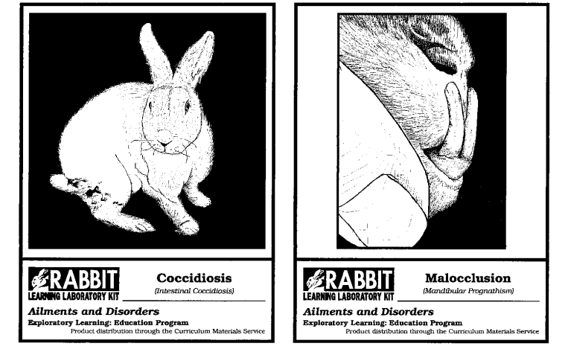

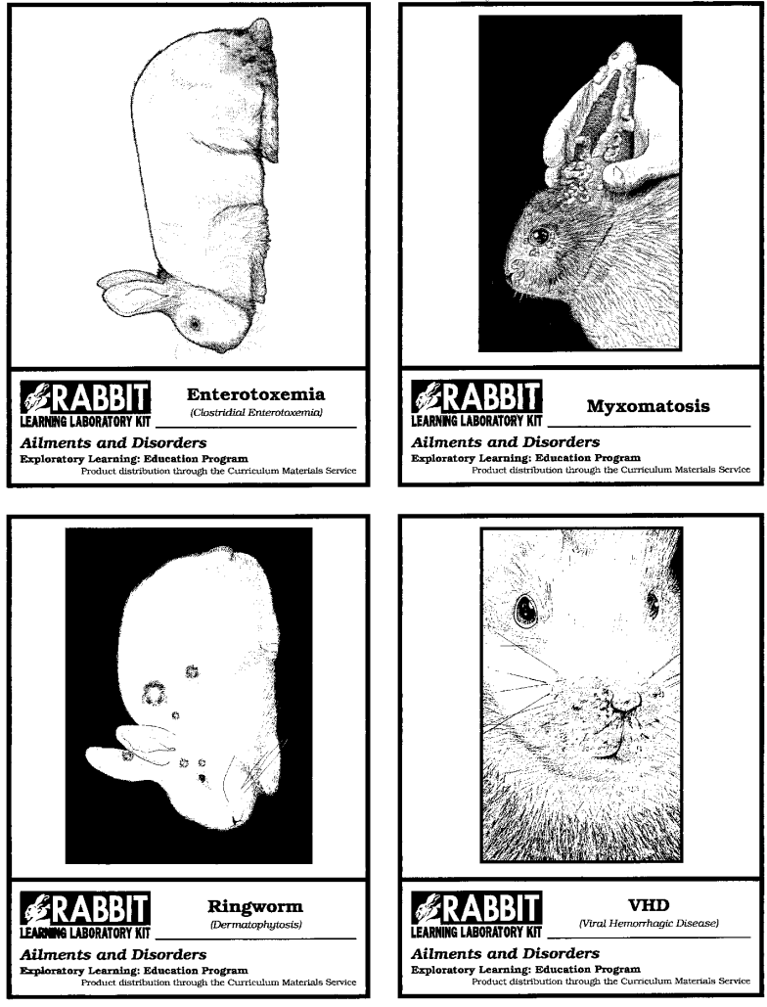

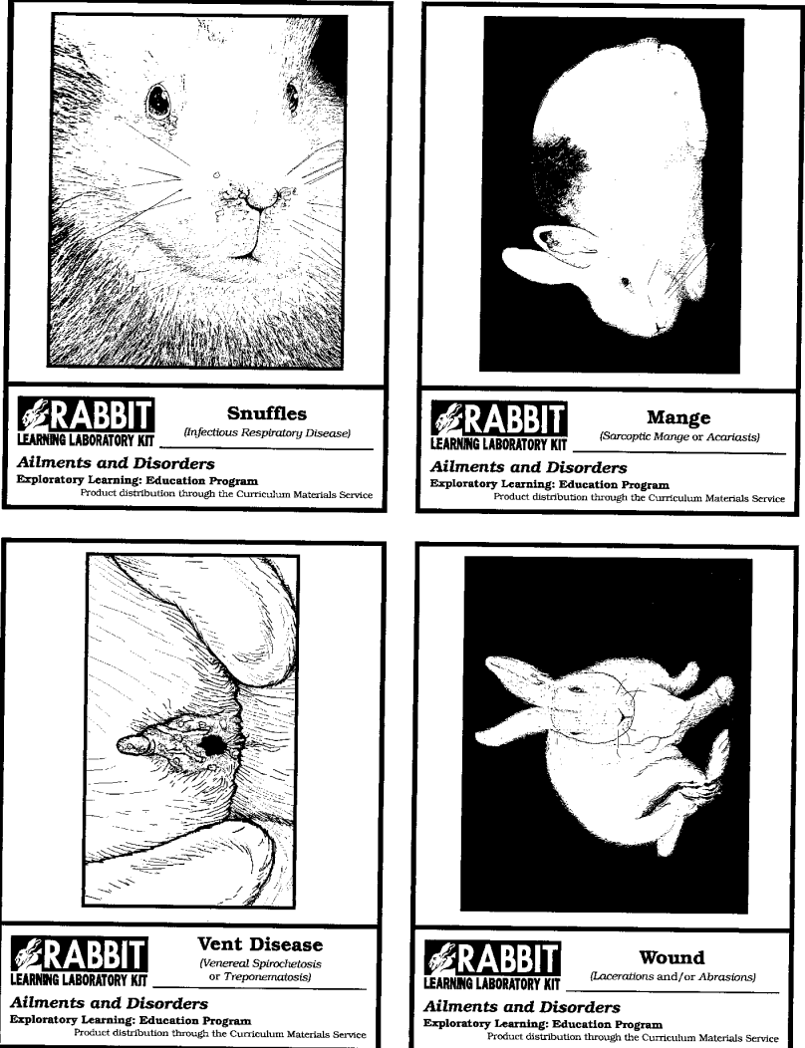

**Handling and Training**

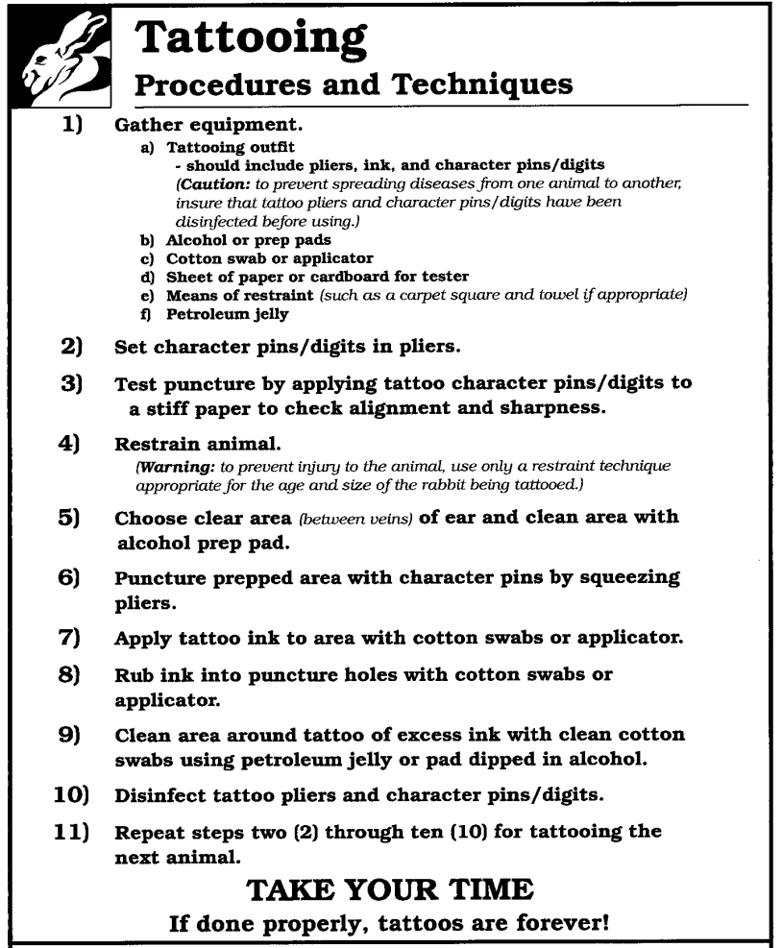For showing, select the best rabbits according to the standards for its breed. Study the show rules, regulations and classifications carefully before taking a rabbit to a show. Shows impose strict requirements on weight, color, size and age of rabbits entered. Although pedigrees are usually not required, good records make good rabbits even more valuable for show and meat production. You can learn a lot about showing rabbits by watching others show them. Some pointers you should know include:

- Select best rabbits for showing. Do this early,

allowing time for conditioning.

- Begin grooming the rabbits you have selected at least 6 weeks before show time. Grooming should be done in the cool part of the day

to prevent your rabbits from getting too hot. A small table covered with a carpet remnant can serve as a grooming place. For the first few

days of grooming, moisten your hands and rub them through the fur until it is damp. Once the fur is good and damp, gently and repeatedly

stroke your rabbit from head to tail to remove loose fur. This may bring about molt, but it's better for the rabbit to molt then instead of at

show time. There will be plenty of time for the fur to grow back. After the first few days of actual grooming, always stroke your rabbits from head to tail. Stroking your rabbits daily this way will make their fur glossy and tight. Do not stroke your rabbits' fur backwards (from tail to head), because this can cause their guard hairs to break. Daily grooming not only improves

the appearance of your rabbits, it also tames them and makes them easier to handle at the show. As you are grooming them, place your rabbits in the preferred position for their breed and encourage them to stay in that position. Because different breeds have different show positions, talk to someone familiar with your breed to find out how best to position your rabbits for show. It's also a good idea to play a radio near your rabbits' hutch. This will help them to get used to voices and to the extra noise they will hear at shows.

-Read all the rules and regulations for the

show. Ear canker, sore hocks and other abnormalities disqualify a rabbit.

- Before the show, have your rabbit tattooed

properly for identification.

- When you arrive at the show, check your entry

with the show superintendent or secretary.

- Be present when your rabbits are being

judged to learn from the judge’s comments.

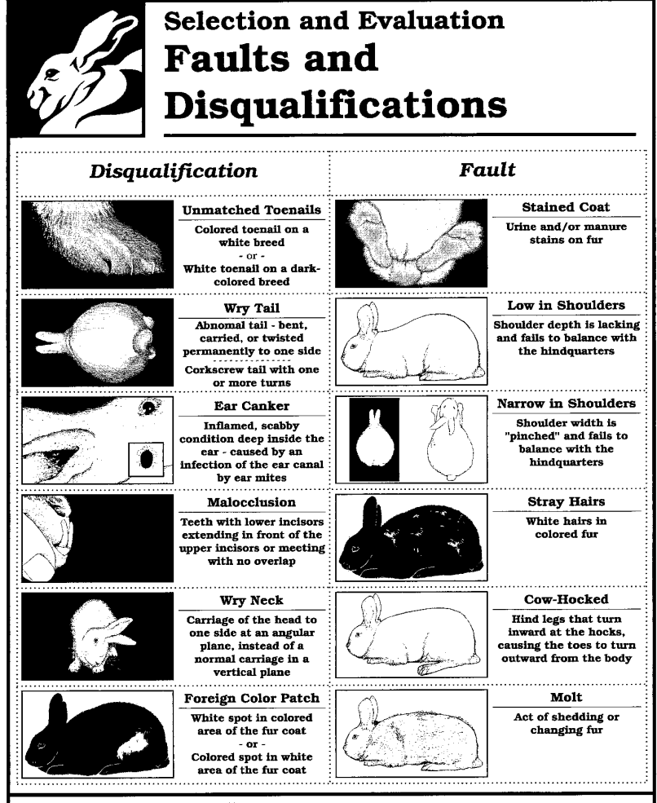**General Faults - All Breeds**

Faults are conditions or characteristics

that are not acceptable. They

will generally result in lowered show

placings. A list of the most common

faults follows.

• Specimen in molt or otherwise out

of condition (but not diseased).

• Hutch stains.

• Broken toe nails.

• Stray white hairs in colored fur.

• Double dewlaps.

• Poor tail carriage, one that is not

set on either side.

• Poor ear carriage.

• Poor eye color.

• Flabby and overfat, or thin and

extremely poor in flesh.

**General Eliminations - All Breeds**

Eliminations are conditions that are

assumed to be temporary in nature

and curable; nevertheless, they are

cause for elimination from competition

in a show and from registration

until the ailment is cured or corrected.

Ear cankers, sore hocks,

and overweight or underweight are

examples of conditions leading to

elimination.

**General Disqualifications – All Breeds**

Disqualifications result from one or

more permanent defects, deformities,

or blemishes which renders an

animal unfit to win an award in

competition or from taking part in

exhibition. Examples are snuffles,

crooked feet or legs, and the wrong

color mixed in fur.

**Show Classifications**  
There are always two classes in each of the categories in a rabbit show: one for bucks and one for does. Two general classes are

provided for all breeds under 9 pounds senior ideal weight. (See the A.R.B.A. "Standards of Perfection" for the ideal weights for each

breed.)

This group is considered "Four Class Rabbits," because there are really four classes: senior

bucks, senior does, junior bucks, and junior does. Following are the requirements for senior and junior rabbits of either sex.

Senior - Rabbits 6 months of age or older or over maximum Juniormweight on day of show.

Junior - Rabbits under 6 months of age and under maximum Junior weight on day of show.

Three classes are provided for all breeds having 9 pounds or over ideal senior weight. This group is considered "Six Class Rabbits," because there are 6 classes:senior bucks, senior does, intermediate bucks, intermediate does,

junior bucks, and junior does.

Senior - Rabbits 8 months of age and older or exceeding maximum Junior weight on day of show.

Intermediate weight on day of show. Intermediate - Rabbits from 6 to 8 months of age or exceeding maximum Junior weight on day of show. (No animal over 8 months is eligible to show in an Intermediate class.)

Junior - Rabbits under 6 months of age and not over maximum Junior weight limit of breed on day of show. (No animal over 6 months of

age is eligible to show as a Junior.) Besides the classes explained above, there are other classes that you will find at some shows.

Meat Pen - Three rabbits of the same breed and same variety weighing up to 5 pounds and not over 10 weeks of age on day of show.

.

Best of Breed {BOB) is awarded to the rabbit that is the best animal in a breed. The Best of Breed can be either a doe or a buck and can be from any age group that is exhibited (senior, intermediate, or junior).

Best of Opposite Sex {BOS) is the best rabbit from any age group not the same sex as the animal that

was named BOB. For instance, if a buck was named BOB, a doe is named BOS.

In breeds with more than one variety (color), each variety is judged separately. For example, the New Zealand breed has three varieties: Black, Red, and White. Each variety is judged separately, and Best of Variety {BOV) is selected from either sex.

A Best of Opposite Sex of Variety {BOSV) is then selected; the BOSV is the opposite sex of the rabbit that was named BOV.

To select BOB in breeds that have varieties, all BOV are compared to each other. When BOS is selected, all animals of the opposite sex,

whether they were awarded BOV or BOSV, are compared to select BOS of that breed.

Best in Show {BIS) is selected from all the BOB animals. BIS is selected by comparing each of the

BOB to the "Standard of Perfection," and the rabbit that adheres closest to its breed standard is awarded BIS.

In shows where Best Four and Best Six class rabbits are selected, the Best Four and Best Six class rabbits are compared to the "Standard of

Perfection" to determine BIS.

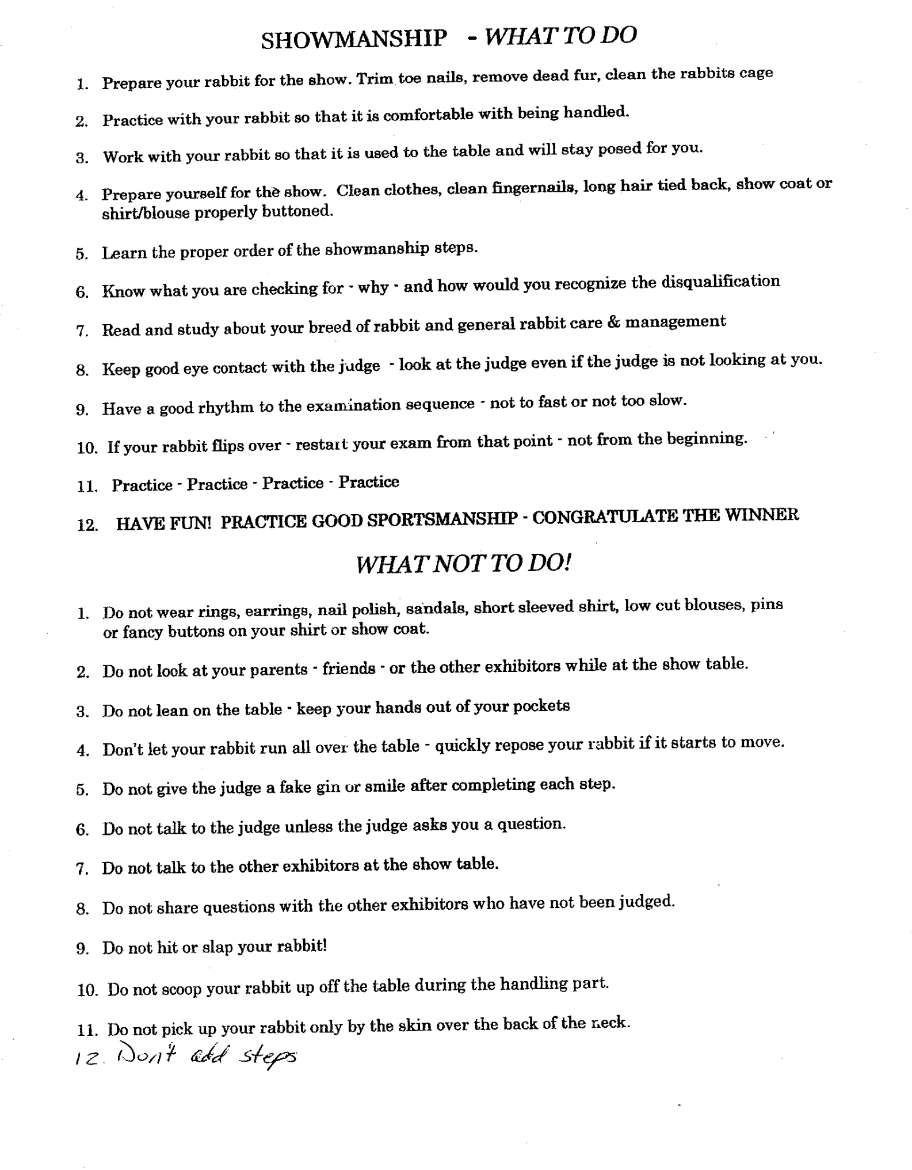

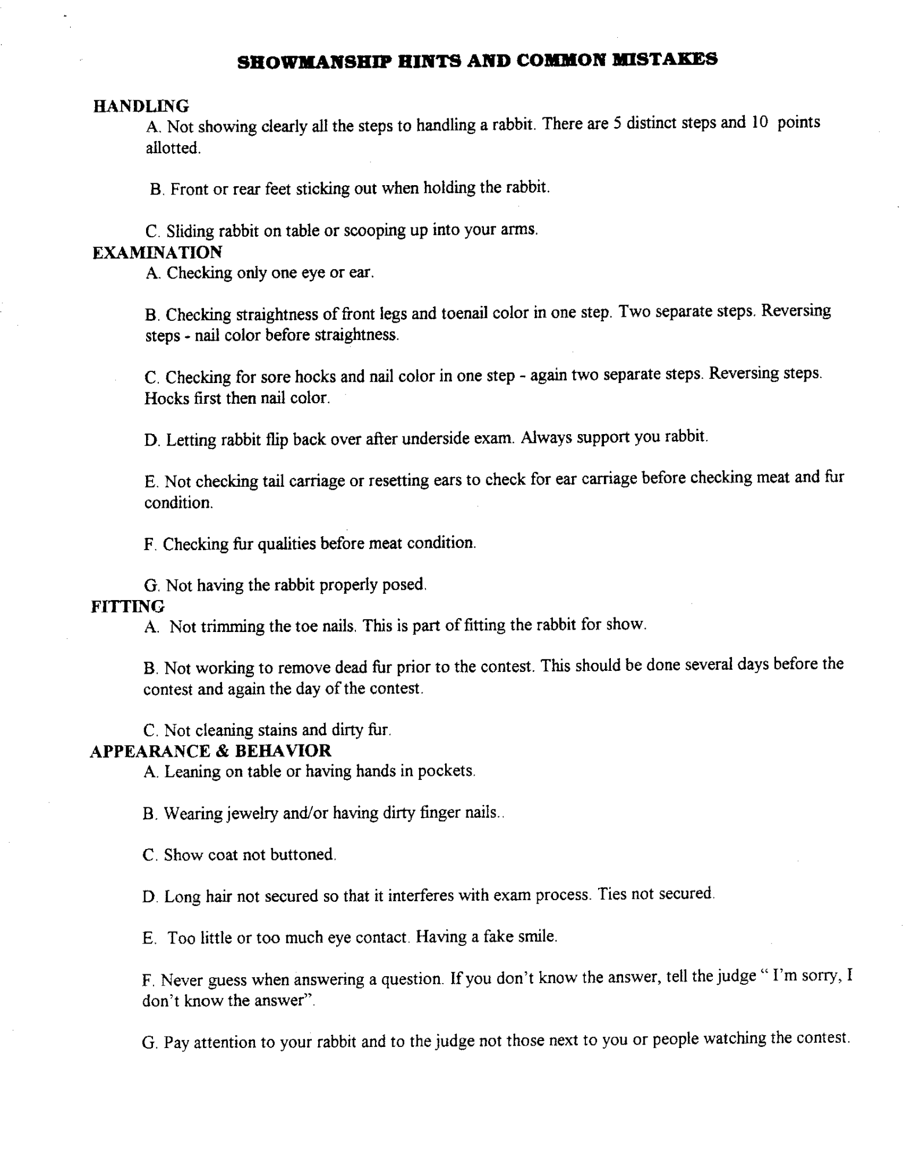

.

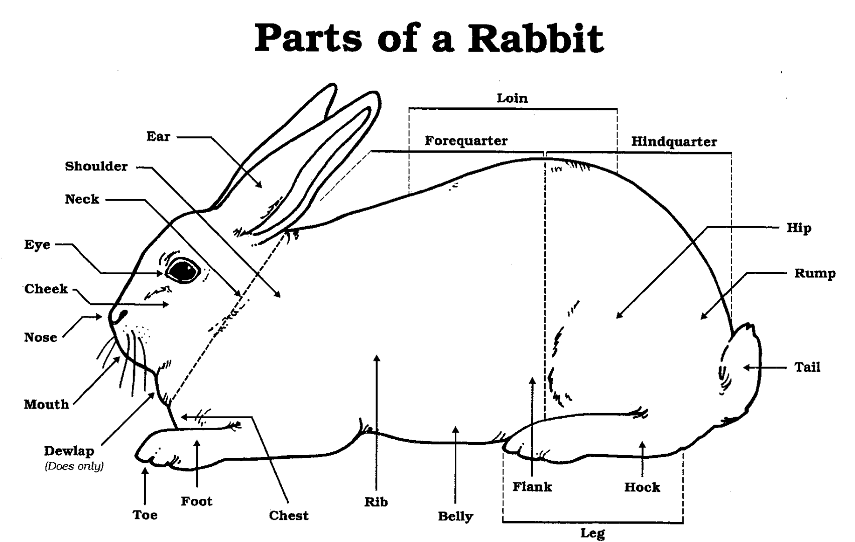

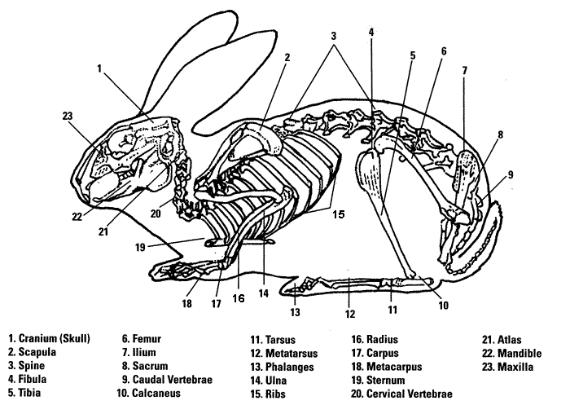

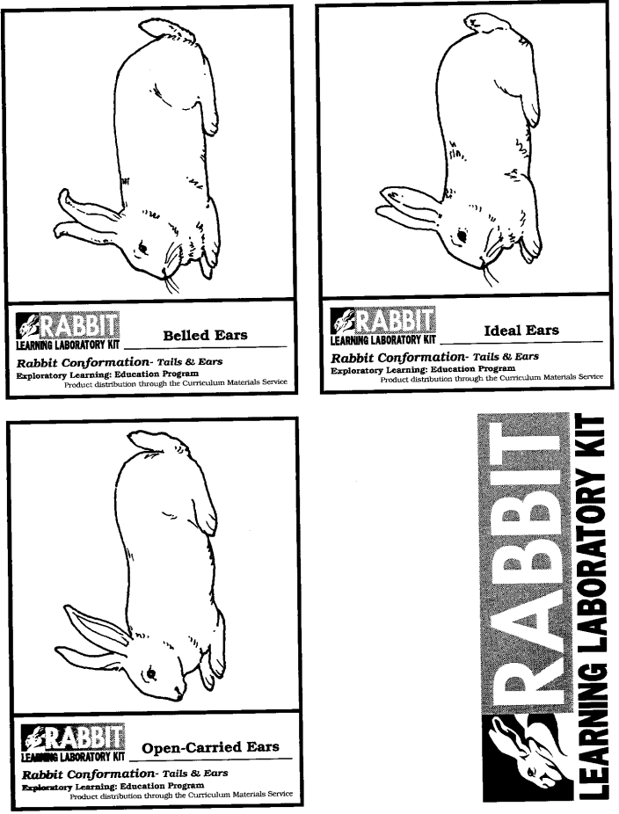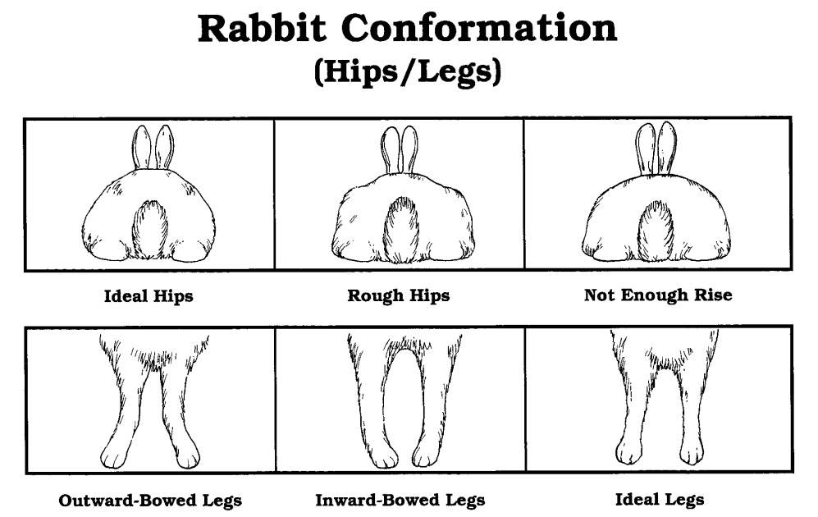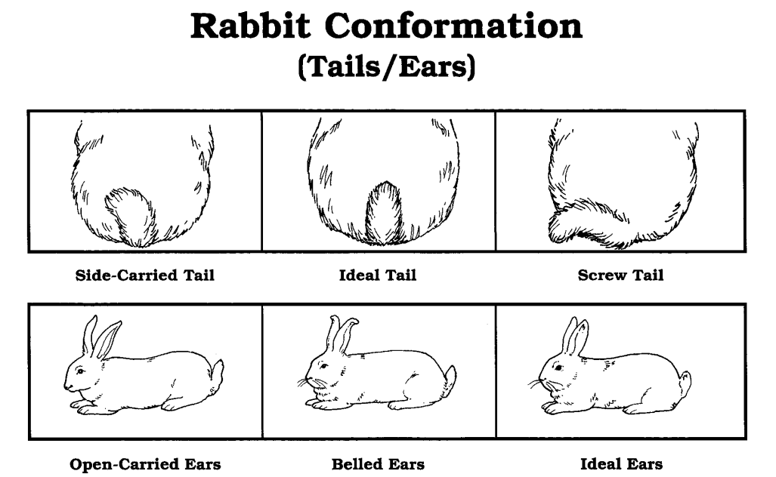

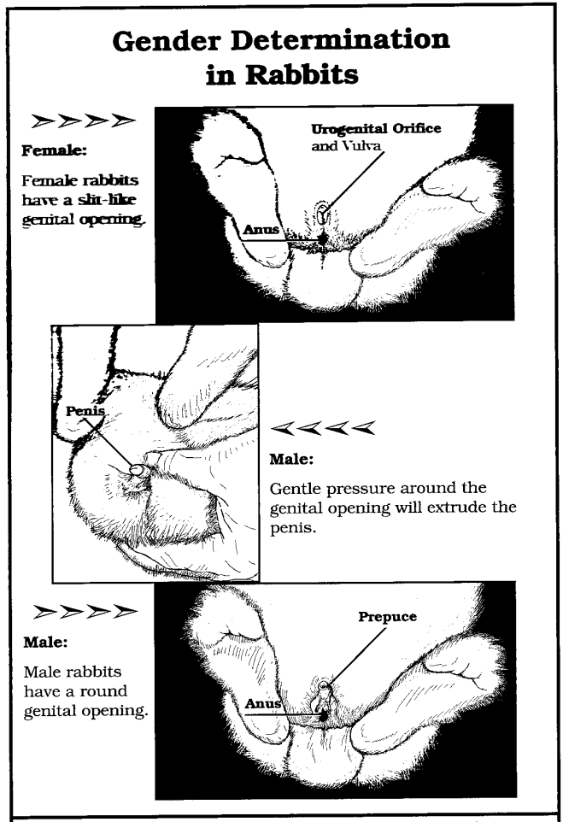

**Meat science**

Rabbit carcasses yield is determined by

dividing the dressed weight by the live

weight.

Dressing percent of rabbits will range from

fifty to fifty-nine percent, which would be

known as the yield.

Fryers are divided into three grades:

Prime, having a 57% yield; Choice, having

55.9% yield; and Commercial, having a

52% yield. At six pounds a rabbit is

considered a roaster, having 55% to 65%

yield.

**MEAT TYPE**

A good meat pen combines the best meat type; type therefore, is the most important factor in judging these pens. The best meat type is found in those fryers that are compact, short, body well filled, rounded, solid flesh, smooth and well

filled hips. (Protruding hip bones, or prominent “razor backs” are serious faults.)

1st - Hindquarter

2nd- Loin

3rd- Forequarter

**CONDITION**

All fryers in a pen must be in prime condition. This reflects the care and management practices of the breeder. The fryers

must be in firs and solid; they must not show any signs of flabbiness, softness, looseness, or pottiness. The pelt must be tight over the body, the animals must be clean and show no sign of neglect or disease.

**UNIFORMITY**

This denotes the ability of the breeder to pick three fryers for each pen. Uniformity must be present in weight, size, appearance, condition and meat type, and should be as similar in all respects as possible. This Uniformity applies also to the fur. The quality of the fur should only be determining factor in of an absolute tie.

**QUALIFICATIONS**

Meat Pens will consist of three (3) rabbits - all the same breed and variety. Eliminated if more than one breed or variety is in the same pen. Weight limit not over 5 pounds for each rabbit. Age limit not over 69 days old (breed Doe 100 days before show date for proper age meat pen).

If any one rabbit in the pen weighs more than the maximum weight, the entire pen is eliminated.

If any one rabbit in the pen is disqualified, the whole pen becomes disqualified.

**POINTS**

Meat Type. . . . . . . . . . . . . . . . . . 40 points

Condition of flesh . . . . . . . . . . . . 25 points

Uniformity in body and weight . . 20 points

Fur . . . . . . . . . . . . . . . . . . . . . . . 15 points

TOTAL ----------------

100 points

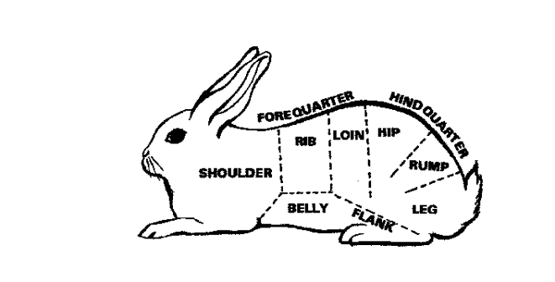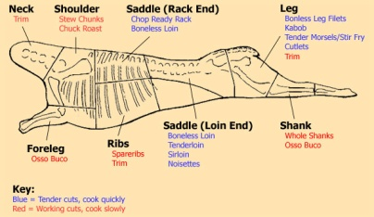

****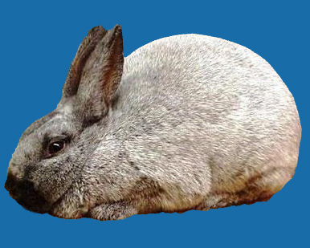

The **Champagne d’Argent**, also known as French Silver, is probably one of the oldest breeds known and has been raised in France for more than 100 years. A well-known commercial breed, its fur is useful in its natural state and is still one of the leading furs used in garment manufacturing throughout Europe. This rabbit is born black. At about 3 to 4 months, it takes on the adult color, a silver or skimmed-milk color with a dark slate blue undercoat. The ideal weight for bucks is 10 pounds; does, 101/2 pounds.

The **Satin** is an American breed that occurred as a mutation in a litter of Havanas. The Satin mutation affects fur structure and sheen, which are determined by a recessive gene. This means

that if you breed a Satin with another breed, the babies will probably have the other breed’s fur structure and sheen. Therefore, it is best not to breed Satins with rabbits that have normal fur. Nine colors are recognized. The breed is popular for two reasons: Its type

and size make it a good commercial breed; its sleek coat with commercial properties, brilliant sheen and rich, vivid colors make it an excellent show rabbit. Mature bucks weigh 9 pounds; does, 91/2 pounds.

The **Californian** breed is another American creation. After experimentation and crossbreeding, this rabbit was produced in 1923. It was bred as a meat rabbit to have broad shoulders, meaty back and hips and a good dressing percentage (percentage of edible meat). This rabbit is white except for ears, nose, feet and tail, which are a dark gray or black. The ideal weight for bucks is 9 pounds; does, 91/2 pounds.

There are 47 breeds recognized by the American Rabbit Breeders Association (A.R.B.A.) We have highlighted a few common breeds and included a photo of all of the breeds.

**White New Zealand**, an American creation that appeared after the Red New Zealand, is one of the best all-around commercial breeds. It is an all-white rabbit whose fur can be dyed many colors for use as garment trims. The ideal weight of bucks is 10 pounds; does, 11 pounds.



**Angora**-Variety of sizes and colors   
English angora: 5-7 lbs (2.3-3.2 kgs), long silky hair.   
French angora: 7.5-10.5 lbs (3.4-4.8 kg)   
Giant Angora: 8.5 lbs (3.9 kg) and up, soft fine undercoat (wool), straight stiff guard hairs, and a wavy fluff with a guard tip in between.   
Satin Angora: 6.5-9.5 lbs (3-4.3 kg), very fine wool.

The **Rex**, meaning king, was named for its short hair by M. Amedee Gillet of Coulange, France. Rex have medium-length bodies with good depth, well-rounded hips and a well-filled loin. They come in several varieties and have excellent meat-producing qualities. The ideal weight for bucks is 8 pounds and does, 9 pounds.

The **Mini Lop** originated in Germany as the “Kleine Widder” but the exact origin is unknown. It has a massive, thick-set body and good depth and width from the shoulders to the hindquarters, which are slightly heavier. The body color may either be patched or have blanketed

markings. The ideal weight for bucks is 51/2 pounds and for does, 6 pounds.

The **Dutch**, said to have originated in Holland, was improved and developed for exhibition purposes in England. One of the most fancy

popular breeds, it rates tops with rabbit fanciers. This breed has six varieties: black, blue, chocolate, tortoise, steel gray and gray. Because

it is a small rabbit, weighing from 31/2 to 51/2 pounds, the Dutch is ideal for fanciers with limited space. The Dutch is cobby and compact with

a well-rounded body, smooth in every respect. Markings of the Dutch, sometimes difficult to achieve, should be clean cut, clear and sharp.

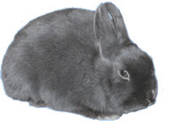[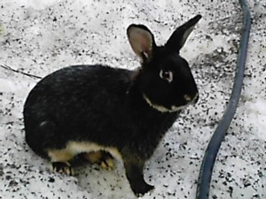](http://www.rabbitbreedsguide.com/wp-content/uploads/2012/05/SilverMartenBlack_640px.jpg)****

**Polish** is a neat, cobby (stout or stocky), sprightly rabbit with well-furred, short ears. The first Polish were all white with ruby-colored eyes. Although their origin is unknown, they probably were bred from Dutch or Himalayan stock.

Polish are recognized in four colors: ruby eyed white, blue-eyed white, black and chocolate. Polish fur is short, dense and soft, resembling the Himalayan. For this reason, it was known in Germany as the Ermine rabbit, because its coat is white like that of the ermine, a member of the weasel family. Polish have become so popular in this country that in most shows they rank among the top

10 breeds in numbers exhibited. They are nicknamed “The Little Aristocrat.” 4-H members can have lots of fun exhibiting this toy rabbit, which weighs 21/2 to 31/2 pounds.

The **Himalayan** rabbit came from the Himalayan Mountains in Asia, but has long been known as an inhabitant of countries north and

south of the Himalayan range. One of the oldest breeds, it is distributed more widely throughout the world than any other rabbit. Thousands of these rabbits are sacrificed annually in China to the gods of crops and fruits of the earth. The Himalayan characteristics are distinctive: a trim, well-built body covered with short, sleek white fur, ears erect and black, a black, egg-shaped nose with the small end coming well up between the eyes, black front and hind feet, a black tail and ruby red eyes. One peculiar characteristic of the Himalayan is that it weaves its head from side to side when sitting at ease. Mature animals weigh up to 3 ½ pounds.

**Silver Marten** fanciers have a choice of four colors: black (the most popular variety), blue, chocolate and sable. Choose a compact animal with a well-filled back and shoulders to bring out the desired type of the breed. Never stray

from proper body shape. The basic color is as jet black as possible. Blue is a medium shade. A dark chocolate color is the standard, while the sable blends into various shades. All colors should be free from white hair, molt (shed fur) or stained fur. Proper color contrasts vividly with the silver-tipped guard hair, which adds much to this breed’s beauty. Silver-tipped guard hair should be evenly distributed along the sides and rump. In weight, bucks range from 61/2 to 81/2 pounds; does from 71/2 to 91/2 pounds.

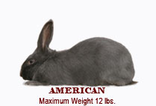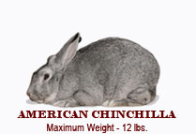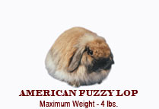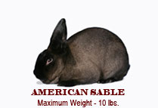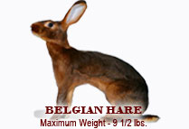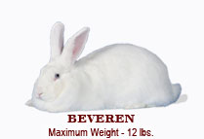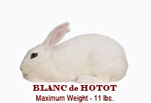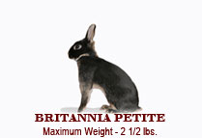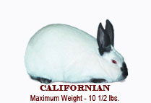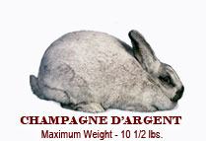

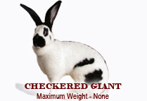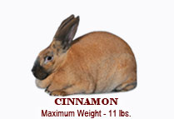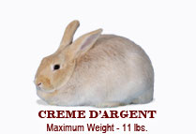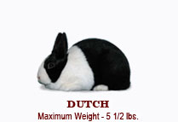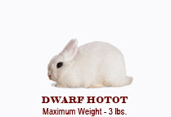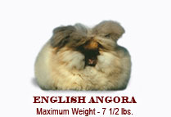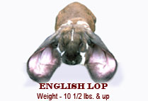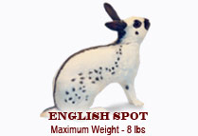

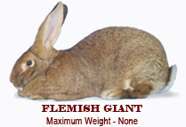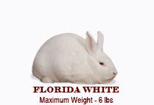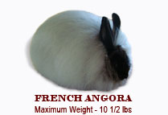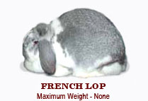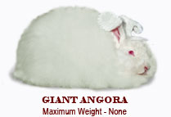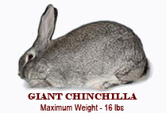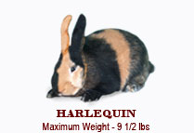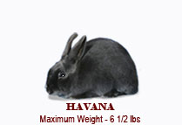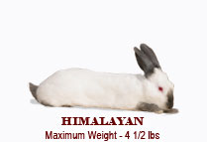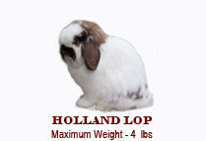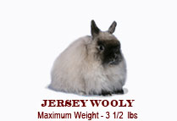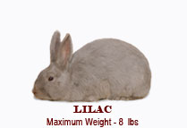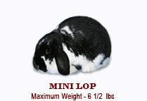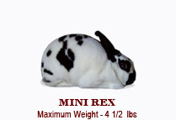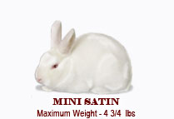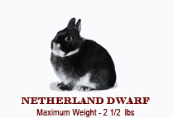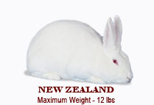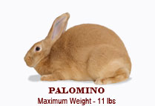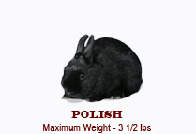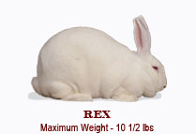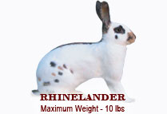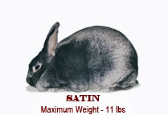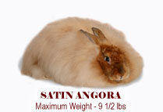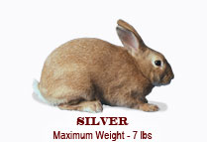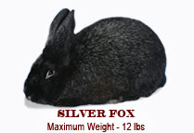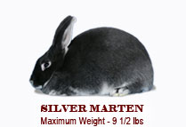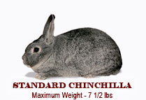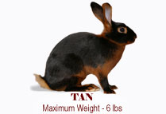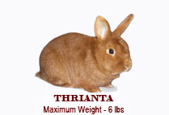

**Glossary of Terms**

**Abcess** -A hard swelling or isolated

collection of pus or purulent matter occurring in the rabbit's skin. Accompanied by localized fever

and heat.

**Adult** - See Senior.

**Agouti color pattern** - A hair shaft that has three or more bands of color with a definite break between each color. Usually dark slate at the

base, with two or more alternating light and dark bands or rings interspersed with black guard hairs. The head, ears, and feet usually

have ticking; the belly color is much lighter and does not carry ticking. Examples: steel or gray Flemish, Chinchilla, and Belgian Hares.

**BIS** - Best in Show.

**BOB**- Best of Breed. .

**BOS-** Best of Opposite Sex.

**BOSV** - Best of Opposite Sex of Variety.

**BOV -** Best of Variety.

**Back** - The entire top portion of the rabbit, extending from neck to tail.

**Bell Ears** - Ears that have large tips with a distinct fall or lop.

**Belly** - The lower part of the body containing the intestines. The abdomen. For purposes of defining color area, it is the underbody of the

rabbit from the forelegs to the crotch area.

**Belt** - The line where the colored portion of the body meets the white portion just behind the shoulders. Example: Dutch breed.

**Blaze** - A white area on the head and nose running up between the eyes on rabbits with multi-colored fur.

**Boils** - See Abcess.

**Bowed Legs** - Legs bent like a bow or curved outwardly in the middle, applied to both fore and hindlegs.

**Breed** - A race or special class of domestic rabbits that reproduce distinctive characteristics of fur markings, fur texture, shape, size,

and growth. A breed may be subdivided into varieties. Example: Black, Blue, and Tortoise varieties of the Dutch breed.

**Breeder** - A person who raises a special breed/variety or varieties of rabbits in conformity with the accepted standards of perfection.

**Breeding Certificate** - A written certificate by the owner of a stud buck, showing its pedigree and the date of breeding to a particular doe.

Given to prove the ancestry of the young.

**Broken Coat** - Guard hairs broken or missing in spots, exposing the undercoat. Areas where the coat is affected by molt, exposing the

undercoat.

**Broken Ear** - A distinct break in the cartilage which prevents erect ear carriage.

**Broken Tail**- A tail that is or has been broken and is out of line. This is a disqualification.

**Buck** - A normal male rabbit.

**Buck Teeth**- See Wolf Teeth.

**Buff** - A rich golden orange color with a creamy cast.

**Bull Dog** - A short, broad, bold head of pronounced masculine appearance.

**Butterfly** - A dark-colored area on the rabbit's nose. Examples: Checkered Giant and English Spot breeds.

**Carcass Weight** - The weight of the rabbit after it has been processed.

**Carriage** - The way a rabbit carries itself; the style or characteristic pose of a rabbit.

**Charlie** - A term meaning insufficient markings for the breed.

**Cheek** - The sides of the face beneath the eyes.

**Chest** - The front portion of the body between the forelegs and neck.

**Choppy (or Chopped Off)-** A condition in which a rabbit is not well filled out and rounded in the loin and rump area.

**Cobby** - A term meaning stout and stocky; short legged. Condition - The physical state of a rabbit in reference to health, cleanliness, texture and molt of fur, and grooming.

**Cow Hocks** - Hocks that turn or bend inward, causing the foot portion to turn outward.

**Creamy** - A term meaning light colored. The color of cream.

**Culling** - The process of selecting only the best rabbits from a litter for future breeding and show stock by selling or slaughtering the least desirable specimens from a litter.

**Density** - The property or quality of a thick coat.

**Dewlap** - A pendulous fold or folds of loose skin hanging from the throat.

**Disqualification** - One or more permanent defects, deformities, or blemishes that make a rabbit unfit to win an award in competition or to

take part in an exhibition. (Disqualified rabbits are not eligible for registration by the A.R.B.A.)

**Doe** - A normal female rabbit.

**Dressing**- See Processing.

**Ear Lacing** - A black or darkcolored line of fur outlining the sides and tips of the ear.

**Elimination** - One or more defects presumed to be temporary and curable. Cause for elimination in a show or from registration until cured or corrected.

**Embryo** - A kit in the early stages of development inside the doe.

**Eye Circle** - Even marking of color

around both eyes. Example: Checkered Giant.

**Eye Color** - The color of the iris. The circle of color surrounding the pupil.

**Faults** - Imperfections. Conditions

or characteristics that are unacceptable

and will result in lower show placing but not disqualification. Examples: broken toenails, cheek spots too large, and poor tail carriage.

**Fine Coat** - The condition of a coat that is too fine in texture and lacking body. Guard hairs are too weak and thin in structure, similar to hairs

making up the undercoat.

**Flabby** - The condition of a rabbit when the flesh or fur hangs loosely. Not trim and shapely.

**Flank** - The sides of the rabbit between the ribs and hips and above the belly.

**Flat Coat** - The condition of a coat that lies flat or close to the body, lacking spring or body. Fine coat coupled with lack of density.

**Fly Back** - The property of fur that causes it to return quickly to its normal position when stroked toward the head of the rabbit.

**Flying Coat** - The condition of a coat that is loose and fluffy, caused by undue length and thinness of under wool and weak guard hairs.

**Foot** - The part of the leg on which the rabbit stands. On the foreleg, that portion below the ankle or pattern. On the rear leg, that portion

below the hock joint.

**Forehead** - The front part of the head between the eyes and the base of the ears.

**Foreign Color** - Any color of fur, eyes, or nails that is different from the prescribed standard of perfection for the breed or variety.

**Four Class Rabbits** - Rabbit show category for all breeds having ideal adult weight under 9 pounds. There are four show classes for these

rabbits: senior bucks, senior does, junior bucks, and junior does.

**Genotype** -The genetically inherited

characteristics and potenial of the rabbit stock.

Gestation - The period of time that a doe carries young in its uterus.Pregnancy. Normal length is 28-32 days.

**Glossy** - The reflection of luster or brightness from naturally healthy fur in rabbits. Improved by grooming.

**Guard Hair** - The longer coarser hair of the coat, offering protection to the undercoat and providing wearing quality and sheen to the

coat.

**Hairline** - A narrow white line running between the ears, connecting the blaze and collar on the

Dutch.

**Hindquarters** - The after-portion or posterior section of the body, made up of loins, hips, hind legs and rump.

**Hip**- The thigh joint and large, muscular first joint of the hind leg.

Hock - The middle joint or section of the hind leg between the foot and hip.

**Hog Fat** - The condition of a rabbit obviously over-fattened and, as a result, out of proportion to the true type of the breed.

**Hump Back** - The condition of having a hump or protrusion on the back, marring a gracefully arched outline.

**Inbreeding** - A breeding program involving the mating of closely related rabbit stock, such as brother and sister.

**Inherited** - The degree to which a trait or characteristic is passed on from a parent to offspring.

**Inner Ear-** The concave (curved inward) portion of the ear.

**Intermediate** - A show class term referring to rabbits that are at least 6 months old and no older than 8 months and that fulfill the weight

requirements of the breed.

**Inventory** - A list of everything on hand that is necessary to the project. A beginning inventory is taken at the start of a project year. An ending inventory is taken at the close of a project year.

**Junior** -A show class term referring to rabbits that are under 6 months of age and that fulfill the weight requirements of the breed.

**Kindling** - The process of giving birth to kits.

**Kit** - Baby rabbit.

**Knee** - The second joint of the leg, connecting the thigh and leg. In animals, more properly called the "hock." The second joint of the foreleg is the elbow.

**Knock Kneed** - See Cow Hocks.

**Lapin** - French word for rabbit. Also, in the fur trade, it is dyed rabbit fur.

**Lazy Tail** - A tail that is slow to assume its normal position when it is moved.

**Linebreeding**- A breeding program involving the mating of rabbits that are both descended from the same animal but are related several generations back. For example: mating first cousins, uncle to niece, or aunt to nephew.

Litter- Young rabbits of a doe born at the same time.

**Live Weight** - The weight of a rabbit before it is dressed for market.

**Loin** - The part of the back on either side of the spine and between the lower rib and hip joint.

**Loose Coat** - The condition of fur lacking density in the undercoat, coupled usually with fine guard hairs and resulting in lack of texture. Does not indicate a slipping coat.

**Lopped Ear**- Pendulous ear. Not carried erect. Falling to the side or front.

**Luster** - Brightness and brilliance of fur.

**Malocclusion**- An inherited defect where the upper and lower jaws do not let the teeth meet, resulting in long, uneven teeth extending out of

the rabbit's mouth.

**Mandolin** - The body of the rabbit is pear shaped, having the appearance of a mandolin laid face down. Back and saddle arch toward loins to make noticeably large, broad

hindquarters.

**Marked** - A rabbit's fur usually white, which is broken up by an orderly placement of another color. Also refers to rabbits that carry the

pattern of the Tan variety.

**Massive** - A term meaning bulky and heavy. Ponderous or large.

**Meaty** - The quality of being able to carry a large proportion of meat for the size and type of rabbit. A noticeable meatiness at the forequarters,

back, saddle, loins, and haunches.

**Molt (Moult)** -The process of shedding or changing the fur twice each year. The baby or nest fur is molted at two months. The first

natural coat of fur is fully developed at 4 to 6 months.

**Muzzle** - The projecting portion of the head surrounding the mouth, nose, and lower jaw.

**Neck** • That part of the rabbit connecting

the head and body.

**Nest Box** - A kindling box inside the hutch or cage hole where the kits are born and live for the first 18 to 21 days.

**Off-Colored** - Applied to several hairs or patches of fur foreign to the standard color of the rabbit.

**Open Coat** - See Loose Coat.

Outbreeding - A breeding program involving the mating of unrelated rabbits of the same breed.

**Pair** - A male and a female rabbit.

Palpation - A method of examining by touch used to determine if a doe is pregnant and will bear young.

**Patches** - Small sections of fur with a color foreign to the standard of the rabbit.

**Paunch** - The prominent portion of the abdomen of the rabbit.

**Pedigree** - A written chart of the male and female ancestors of a rabbit, showing the date of birth and the parents, grandparents, and

great grandparents of the rabbit.

**Pelage**- The fur coat or covering.

**Pepper and Salt** - A flat, unattractive

appearance of black and white ticking.

**Phenotype** - The appearance of the individual rabbit.

**Poor Coat** - A term describing fur that *is* not in good condition through molting, rust, poor grooming, or ill health of the rabbit.

**Processing** - The process of killing and preparing a rabbit for market.

**Rabbit** -A domesticated rodent of the genus Orctolagus Cuniculus.

**Rabbitry** -A rabbit-raising enterprise or a place where domestic rabbits are kept.

**Racy** - A term meaning slim, trim, slender in body and legs, harelike, alert, and active.

**Registration** - The process of certifying that a rabbit meets the qualifications established by the

A.R.B.A. for that breed and has a three-generation pedigree (see above). Requires examination by a licensed registrar.

**Ribs** - The curved portions of the sides immediately back of the shoulders and above the belly.

**Rump** - The hind portion of the back and bones.

**Rust -** A reddish-brown coloration of fur, usually appearing on the side, flanks, or feet of rabbits,

having the appearance of iron rust and being foreign to the standard color. Rust usually appears in American Blues, Black Havanas,

and Lilacs. May be caused by fading through over-exposure to the sunlight, dirty hutches, or dead hair about to molt.

**Saddle** -The rounded, intermediate portion of the back between the shoulder and loin.

**Sandy** - The color of sand, as in sand-gray Flemish Giants. Gray with reddish brown cast interspersed with dark guard hairs.

**Screw Tail**- A tail that is twisted. A corkscrew tail has more than one turn and is a disqualification.

**Self or Self-Colored**-The condition of having the same-colored fur over the entire head, legs, body, and tail. Not having ticking, agouti hair

pattern, or shadings.

**Senior-** A show class term referring to rabbits that fulfill the weight requirements of the breed and that are 1) 6 months of age and older in

those breeds having two show classes (Junior and Senior) or 2) 8 months of age and older in

those breeds having three show classes (Junior, Intermediate, and Senior).

**Service** - The mating act of the buck with the doe.

**Shadow Bars** - Weakness of self color in the fur of both fore and hind feet, appearing in the form of white or lighter colored bars running across the feet. Acts as a severe cut or penalty in scoring. Occurs more often in the agouti breeds

than in selfs.

**Shoulder-** The uppermost joint of the foreleg, connecting it with the body.

**Silvered** - A term describing an abundance of silver-white or silver tipped guard hairs interspersed through the fur that produces a

lustrous silvery appearance.

**Six Class Rabbits** - Rabbit show category for all breeds having ideal senior weight of 9 pounds and over. There are six show classes for

these rabbits: senior bucks, senior does, intermediate bucks, intermediate does, junior bucks, and junior does.

**Slipping Coat** - A coat that is shedding or molting a profusion of hairs.

**Slobbers** - Excessive salivation creating wet or extremely moist and unsightly fur around the mouth and lower jaw and forelegs.

**Smut** - A term describing slate grey fur that is foreign to the standard color for the breed. Example: Creme D'Argent.

**Snaky** - A term describing the slender, narrow body that is typical of the Himalayan.

**Snipey** - A term describing a narrow and elongated head, with an appearance of undue leanness.

**Solid-Colored** - The condition of having the same color uniformity over the entire animal, not mixed with any color. Having no markings

or shadings.

**Sport** - A rabbit not true to the characteristic markings of its breed. Examples: English Spots, Rhinelanders, or Checkered Giants

lacking white color.

**Spraddled Legs** - A term describing forefeet bowed outward when viewed from the front. **Knock kneed**.-Hind feet not set parallel with the body. Turned outward from the hock joint.

**Stocky** - A term meaning compact, stout, and cabby.

**Stops** - In the Dutch, the white part of the hind foot extending upward from toes and ending abruptly about one third of the way to the

hocks.

**Strain** - A race or stock of rabbits in any standard breed of the same family blood, having the quality of reproducing marked racial characteristics.

**Stringy** - The quality of having a ropy or sinewy finish, noticeable in the larger breeds of rabbits if not properly fattened for market.

**Sway Back** - The condition of having a distinct fall or scoop in that portion of the back between the shoulders and hindquarters, as distinguished from a gradually arching back.

**Sweep** - An unbroken flow of designated markings. There should be no gaps or congested areas.

**Symmetry** - A harmonious proportion of head, ears, legs, and body structure conforming to the standard type of the breed represented.

**Tail Carriage** - The way in which a rabbit carries its tail. A tail being carried to one side or the other has poor tail carriage.

**Tattoo** - A code punched in the ear as a permanent method of identification.

**Texture** - The character of fur as determined by feel or touch, such as "fine" or "coarse" texture.

**Ticking** - A wavy distribution of longer guard hair throughout the fur. Ticking is usually produced by black-tipped guard hairs and adds to the beauty of the fur. Examples: Chinchillas, Flemish Giants, and Belgian Hares.

**Trio** - One buck and two does.

**Tucked Up** - The trim appearance of a Belgian Hare, with rounded body and breast and belly gathered in closely to form an arch when the

rabbit is sitting.

**Type** - A term used to denote body conformation of a rabbit or shape of a particular part of a rabbit, as in "head type." The general description

of the physical makeup of the rabbit.

**Typical** - A term describing an ideal representative of any given breed or variety as applied to type, color, or fur quality.

Under Color - The base of the fur shaft. Shaft next to the skin. Not the belly fur of the rabbit.

**Uterus** - Organ in the doe in which developing kits are contained and nourished before birth. Also called the womb.

**Variety** - A subdivision of any recognized standard breed, distinct in color of fur from other subdivisions.

**Wall Eyes (Moon Eyes}-** The condition of having a milky film over the cornea or appearance similar to a moonstone. Colored eyes having an extremely light iris, giving the

eye a glazed appearance.

**Weaning** - The process by which young rabbits become independent of the doe for their nourishment. A young rabbit is weaned when it is between 4 and 8 weeks old, depending on the breeding schedule used and the breed of rabbit.

**Wolf Teeth** - Protruding or elongated teeth in the upper and lower jaw caused by improper alignment of the upper and lower front teeth

preventing normal eating action.

**Wool** - A term describing the fur of Angora rabbits. The guard hairs and under-fur being 2 1/2 to 5 inches long and resembling fine wool in texture.

**Wry Tail** - Abnormally bent, curled, or twisted tail. Permanently held to one side. A disqualification for a rabbit.

Resources

<http://texas4-h.tamu.edu/files/2011/12/publications_projects_rabbit_project_reference_manual.pdf>

H/projects/docs/rabbit-feed.pdf

<http://www.lsuagcenter.com/NR/rdonlyres/0B600B5F-ACC7-4012-9780-4A536432644F/32255/RABBITSHOWMANSHIPSTUDYGUIDE.pdf>

<http://www.extension.iastate.edu/4h/sites/www.extension.iastate.edu/files/4h/Publications/4H662rabbitsrabbitsrabbits.pdf>

<http://4h.missouri.edu/projects/skillathons/docs/rabbitbreeds.pdf>

<http://agrilifecdn.tamu.edu/montgomery4h/files/2010/07/Rabbit-Project-Reference-Manual.pdf>

https://www.arba.net/breeds.htm