**Sheep**

**Respiration……………** 12-20 breathes per min **Temperature…………..** 103.8 (100.9- 104 F) **Pulse rate……………….** 70-80 beats per min **Gestation Period…….....**between 147-153 days **Male……………………….**Ram **Female………………….…**Ewe **Offspring………………....**Lamb

**Ovine…………………..….**pertaining to sheep

**All sheep moved within Michigan shall be identified with official USDA scrapie program identification tags prior to movement off the farm. Official ID is:**

**a, A USDA approved scrapie tag.**

**b. The premises ID, obtained by calling the above number, and a unique alpha-numeric individual animal ID, legibly tattooed in the ear (right ear-premises ID; left ear-individual ID) or flank. Tattoos in the tail web are permissible in earless sheep.**

**c. A tattoo of the registration number from an approved breed registry, only if the number is printed on the registration certificate, and the registration certificate is with the animal. USDA must be contacted to link the registration preface with the premises ID.**

**d. Electronic ID implants only in registered animals from an approved breed registry where the ID number is printed on the registration certificate. The owner must present the registration certificate and have a reader present with the animal.**

**Do not remove tags prior to weigh-in or showing. It is illegal to remove official USDA individual animal identification.**

**Selecting your animal**

Lambs may be purchased by private treaty at a producer’s ranch or through sales. During the late spring and summer, there are usually one or more sales every week throughout the state. It is your responsibility, as a potential exhibitor, to read the general rules and regulations, as well as special rules governing the shows you will attend. This information will tell you the number of lambs you may enter, the type of classification system used, weight limits, ownership dates and entry deadlines. Show dates are extremely important. They determine the age and size

or weight of the lambs to be entered and at what time of year the lambs should be purchased. Lamb shows also have weight limit requirements that must be met. Under normal conditions, lambs will gain approximately 1/2 pound per

day. Not all lambs can be fed to the same final weight because not all lambs have the same size of frame. Large frame lambs may be correctly finished at 140 pounds, while small frame lambs may be correctly finished at 100 pounds. You must learn to look at indicators of frame size (length of head, neck, cannon bone and body) and determine the weight at which a lamb will be correctly finished. If you know the

approximate weight of a lamb at the time of purchase and the length of time until a show, you can calculate the feed requirements (light,

moderate or heavy) needed to enable that lamb to enter the show at its proper show weight.

Remember that size does not make a good lamb. There are good little lambs and good big lambs. Your management program is the key.

**Facilities and Equipment**

One of the major advantages of a club lamb project is that you can feed and manage lambs without elaborate facilities. A barn or shed where lambs can retreat from cold, wet conditions and a small pen with outside exposure are essential. Adequate fencing, a feeder, a water container and an exercise area are required, yet other equipment may be considered optional.

**Barns/sheds**

The shed or barn should have at least 20 square feet of space for each lamb. The outside pen can be any size that is convenient. The facility

should be well drained and should open to the east or south. Barn temperature is critical. Structures should be well ventilated so lambs

will remain cool and continue to grow during the summer. On the other hand, when club lambs are slick shorn for shows, barns should be

altered during the winter to keep lambs as warm as possible. This can be done by closing the front of the barn with a tarp or plastic sheet and

by using heat lamps.

**Fences**

Fence height should be at least 42 inches to discourage lambs from jumping. Fences also should keep out predators.

**Feeders**

Self-feeders are often used in the early stages of feeding club lambs. Self-feeders should be blocked at least 8 inches off the ground. If lambs

are hand fed, use movable troughs that hang on the fence at the appropriate height. A trough should be hung at the same height as the top of the shoulder of the lamb being fed. Movable troughs need to be taken down and cleaned regularly. Hay and mineral feeders also need to be elevated. The use of small, individual feeding stalls is an option that allows you to accurately measure the feed consumption of each lamb.

This requires extra pen space and is time consuming. However, it is an excellent way to properly feed individual lambs.

**Water containers**

Fresh water is the most important ingredient in feeding club lambs. Water troughs should be small so they can be drained and cleaned on a

regular basis. Troughs should be located in the shade to keep water cool. In the hot summer months, some lambs tend to drink too much water and appear “full.” Water should never be totally removed from a lamb, but rationing water prior to a show will help remove the belly from the lamb and improve its appearance in the show ring.

**Exercise**

Exercising lambs is a necessity. One of the best ways to exercise lambs is with the assistance of a dog. If a dog is used to run lambs, a circular or

oval shaped track or a square track with rounded corners should be used. The track path should be 5 to 7 feet wide. If the path is any wider, lambs have a tendency to stop or turn back on the dog. The outside fence should be at least 4 feet tall and constructed of heavy, tightly

stretched net wire. The inside fence should be 4 feet tall and made of net wire that has some elasticity and is not tightly stretched. It is important to remove all rocks or obstacles from the path. Sand, cedar shavings or fresh dirt should be kept in the path to provide a softer running surface. Overall measurements should be no larger than 100 feet by 100 feet and

no smaller than 40 feet by 40 feet. The ideal is approximately 70 feet by 70 feet. This is large enough for lambs to get a good workout, but small enough that you can control or stop your dog in case of an emergency.

If you do not have a dog, you may exercise your lambs using a bicycle or four-wheel, all-terrain vehicle. You may also chase the lambs yourself, however, this is very tiring for you and the lambs probably will not get enough exercise. Walking lambs with a halter does not give them enough exercise, but it is better than no exercise at all.

**Equipment**

To properly feed and exhibit a club lamb, it is necessary to have the following equipment:

• stiff brush to clean water troughs;

• shovel to clean pens;

• trimming table that measures 45 inches long, 20 inches wide and 18 inches tall;

• electric clippers;

• 20- and 23-tooth combs with cutters;

• one small wool card or poodle comb;

• syringes and needles;

• lamb blankets and/or socks;

• rope halters;

• hoof trimmers;

• hand shears;

• bolus gun for giving medication;

• back-pack drench gun;

• small portable feed troughs.

You may want the following optional equipment if you are exhibiting several lambs at major shows:

• small animal clippers;

• hair head for electric clippers;

• show box to hold equipment;

• hot air blower or dryer;

• portable livestock scales;

• electric water heater;

• electric sharpener or grinder for combs and cutters;

• extension cords;

• muzzles;

• electric fans.

**Selection**

The selection of a lamb for a project is one of the most important decisions you must make. The type of lamb you select will have a major

influence on the project’s results. However, remember that a winning lamb is a combination of good selection, good nutritional management,

a good exercise program and outstanding showmanship. People differ in their ability to select animals. Some have a natural eye for selecting young animals of high caliber, while others may never develop this ability. Do not hesitate to ask for help from someone with

these skills. It may be your county Extension agent, Future Farmers of America instructor, parent or another leader in your county. Also, many breeders are very willing to assist you in your selection. When selecting a lamb, be aware of wool length and fat thickness. If possible, select your club lamb after shearing. Young lambs that are bloomy and fat always look good, while young lambs that are thin do not. Learn to look past fat and recognize muscle so that you pick a lamb that is genetically superior. When purchasing a lamb, it is important to know something about the lamb producer. Do not hesitate to ask questions about the lamb’s

bloodlines and the age of the lamb. Consider the following when selecting a lamb: classification, muscle, structural correctness, style and balance, and growth potential.

**Muscle**

Proper lamb selection also depends on muscling. Select a lamb that feels firm or hard muscled. The lamb should have a good expression of muscle from the shoulder to the rump. It should have a long, level, square rump with good width at the pin bones (dock). Other good indicators of muscling are the forearm and leg muscles. The widest part of the leg, when viewed from behind, should be through the middle of the leg or the stifle area. Also, a lamb that walks and stands wide is generally going to be more heavily muscled.

**Structural correctness**

Structural correctness refers to the skeletal system or bone structure of an animal. A lamb should hold its head erect and the neck should

extend out of the top of the shoulder. A lamb should travel and stand wide and straight on both its front and rear legs and the legs should be placed squarely under the body. A lamb should have a strong top and a long, level rump. It should be heavy boned and be strong on its pasterns. Avoid open-shouldered, weak-topped, steep-rumped lambs.

**Style and balance**

Style and balance refer to the way all body parts blend together, how the front end matches the rear end, and how “eye appealing” a lamb is.

When viewed from the side, a lamb should have a clean front, smooth shoulder, level top, level rump, trim middle and straight legs. Because

all club lambs are shorn smooth, it is absolutely necessary that a lamb have a tight hide and be free of wrinkles. A lamb should never be selected in the wool, if possible. A good, smooth, thin-hided lamb has eye appeal and will handle well when properly finished. A lamb that is balanced, smooth, pretty, and holds up its head is the first one you notice when you walk in the pen.

**Growth potential**

The ability of an animal to grow rapidly is very important. Generally, larger framed lambs, as indicated by a long head, neck, cannon bone,

and body, will grow faster, be larger, and be more competitive in the show ring. Lambs that are extremely long in the loin and rump will

have an advantage over others.

**Nutrition and Feeding**

**Nutrition**

There are no magic feeds or rations that make champions. It is the total feeding program, including the feeding schedule, the exercise

program, and the careful observation of the lamb during growing and finishing stages, that makes a champion lamb. To establish a good feeding program, study the lamb and use all of the available information to decide when feed changes should be made. To develop a successful feeding program for a particular lamb, it helps to know how lambs from similar genetic backgrounds usually develop, and it helps to carefully observe the lamb during the feeding period. **There are five basic nutrients required by all livestock. They are water, protein, carbohydrates and fats (or energy), minerals and vitamins.**

**Water**

Lean tissue consists of more than 70 percent water. Clean, fresh water is required on a daily basis to provide the necessary fluids to keep the

body functioning at optimum levels. If water is limited, feed consumption will decline. This can aid feeders at certain periods during the program by reducing the size of the rumen and making the lamb look trimmer.

**Protein**

The primary constituent of the animal body is protein. Dietary protein maintains protein in body tissues, provides for carriers of other nutrients, and is a major component of various products such as meat, milk and fiber. Protein requirements for lambs vary according to their

size, age and maturity. Young, fast growing lambs need rations that contain 16 to 18 percent protein to allow them to grow and develop their

muscle potential. Lambs can be fed lower protein diets during the fattening stage and during the hotter summer months, when feeding

high protein diets may tend to cause heat stress. Older lambs can be fattened on rations containing 11 to 12 percent protein. Remember that lambs have a daily requirement for protein. If fed more than is required, lambs use excess protein for energy production. Using protein as an energy source is very expensive. Also, during

periods when total feed intake is reduced, protein supplementation maybe necessary to provide the adequate daily requirement for lambs.

**Carbohydrates and fats**

The most common limiting nutrients in lamb rations are energy producing carbohydrates and fats. Inadequate energy intake will reduce growth and cause weight loss. An adequate supply of energy is necessary for efficient nutrient utilization. Grain and protein supplements are high in energy. Hay contains less carbohydrates and fats. In lamb rations, too much energy intake can be just as detrimental as not enough.

**Minerals**

Important minerals in lamb rations are salt (sodium and chlorine), calcium and phosphorus. It is recommended that loose salt and a loose

trace mineral for ruminants be fed free choice at all times. Calcium and phosphorus are necessary for proper growth and development. They should be fed in a ratio of approximately 2.5 parts calcium to 1 part phosphorus. Feed rations that contain high levels of phosphorus in relation to calcium may cause urinary calculi, the formation of stones that block the passage of urine. The addition of ammonium chloride at the rate of 10 pounds per ton of feed will prevent

urinary calculi. Roughages are generally high in calcium and low in phosphorus. Grains are generally low in calcium and moderate in phosphorus. Most protein supplements are high in phosphorus and moderate in calcium.

High energy lamb rations usually need calcium supplementation, such as calcium carbonate, to bring the calcium:phosphorus ratio to 2.5:1.

**Vitamins**

Vitamins are essential for proper body function, but lambs require very small amounts. Only vitamin A is likely to be deficient. If lambs are

receiving alfalfa hay or dehydrated alfalfa hay pellets in the ration, then vitamin A deficiency should not be a problem. It is a good practice to

inoculate lambs with vitamin B complex to enhance their well-being.  
**Copper Toxicity**  
Sheep are unique in that they accumulate copper in the liver more readily than other farm animals. As a result, they are very susceptible to Cu toxicity (poisoning). Mature ewes of British breed origin appear to be the most vulnerable and there is evidence to suggest that Finn Sheep and Texels also have a tendency to accumulate more Cu in the liver than other breeds. Copper is essential for life. It is required for normal iron metabolism, synthesis of elastin and collagen, melanin production and integrity of the central nervous system. It is essential in keratin (wool) production. More recently, it has been shown that copper is one of the key trace minerals required for an effective immune response. Signs of deficiency include anemia, brittle or fragile bones, loss of hair or wool pigmentation and poor wool growth. In sheep, stringy wool and "swayback" are commonly reported. Affected sheep are lethargic and anemic. They may grind their teeth incessantly and experience extreme thirst. Membranes are very pale and may appear yellow, as jaundice sets in. Urine is a bloody color. Death usually occurs 1 to 2 days after the onset of clinical symptoms. At post-mortem, tissues are pale to dark yellow and the kidneys are a very dark color. In contrast, cattle require about 10 ppm of Cu in their diet and can tolerate Cu levels ten times higher than sheep. Non-ruminants, such as pigs and chickens, tolerate even higher levels of Cu. Growing pigs are often fed 100 to 250 ppm to improve performance. According to the Salt Institute, the toxic level of Cu in the diet of chickens ranges from 250 to 800 ppm.

Thus, due to species differences, it is necessary to purchase grain rations or mineral premixes which have been specifically formulated for sheep. It is recommended that sheep NOT be fed poultry litter or other waste products which contain high levels of copper. In addition, there have been instances where high levels of Cu have been traced to the fertilization of pasture with pig manure.

**Management and Feeding**You have a choice of feeding a commercially prepared ration, mixing your own, or feeding a county ration that has been mixed and is sold by the local feed store. If you are raising only one or two lambs, it is not feasible to buy all the ingredients and hand mix the ration. It is difficult to balance the calcium:phosphorus ratio, add the proper amount of ammonium chloride and properly mix the feed. There are many complete commercial rations available that will do a satisfactory job. Remember that there is no such thing as a “magic” ration. Find a balanced ration, learn how to feed it and learn how your lambs respond to it. At the time of purchase, many young lambs, especially range lambs, will not know how to eat feed from a feeder. These lambs should be started on good, leafy alfalfa hay that is top dressed with a preconditioning pellet. After 2 or 3 days, slowly change these lambs to the concentrate that you have chosen. Hay can be fed during the first part of the feeding program, but should be eliminated at the later stages to prevent lambs from getting a large stomach. Breed differences also play a major role in the feeding program. The greater the finewool influence in a lamb, the more timid and wild it will be and the less likely it will be to eat when people are present. Because of these differences, finewools, crossbreds, medium wools and Southdowns should be fed separately. When all of your lambs are eating well and are comfortable with their surroundings, you should separate them based on condition and feed them accordingly. Initially, lambs may be self fed with excellent results. Self-feeders allow the timid, smaller lambs an opportunity to eat. Once the lamb begins to mature and fatten, a hand-feeding program should be implemented. Feeding lambs individually allows you to know how much each lamb eats each day.

Fat deposition must be closely monitored throughout the feeding program. The feeding schedule can be adjusted to modify gain and body composition, but you must check the lambs’ progress so that changes in the feeding program may be made as necessary. Rations that are not producing enough finish can be bolstered by adding a high energy feed during the late stages of the feeding program. This will reduce the overall protein content of the ration and provide the extra energy needed during cold weather. Never make abrupt changes in the feeding program. Gradual changes are more desirable so lambs stay on feed and continue to develop. The feeding program will dictate how your lambs develop and mature. A good program cannot make up for a lack of superior genetics, but it will allow your lambs to reach their genetic potential. A poor feeding program can cause a lamb with great genetic potential to be wasted. Feeding is a daily responsibility and the program should be changed as needed to maximize results. To monitor your results, weigh lambs on a regular basis. Know whether your lambs are gaining or losing weight and know how much. Feeding and exercise go hand in hand. Exercise is an excellent way to condition and tone your lambs, and help control fat deposition. Lambs should be exercised extremely hard and fast for short distances of 350 to 450 yards. In an exercise program, your goal is to run the lambs just long enough to get adrenalin running through their bodies. This helps develop muscle. If you exercise the lambs too long, you will pass this point and start to tear down muscle rather than develop it. Exercise programs should begin 2 to 3 months before the show, depending upon the ration fed and the condition of the lambs. Do not make the mistake of exercising lambs before they are properly conditioned.

**General Health Management Health**

The key to a healthy lamb is the development of a preventive health program. It is a good practice to assume that the lamb you have purchased has had no treatments. Therefore, the health program should include vaccinations or treatments for a number of potential problems.

**Internal parasites**

Internal parasites are a continual problem. New lambs should be drenched for internal parasites immediately. A second drenching should follow about 3 weeks later. Consult your veterinarian for recommended practices and information on the most effective drenches.

**Ringworm**

Ringworm can become a serious problem because it is contagious and can be transmitted from lamb to lamb, from lamb to human, or from

infected equipment to lamb. A good prevention program is necessary. The following products have been used with varying results:

• Fulvicin® powder — as a bolus or used to top dress feed;

• Novasan® — 3 ounces per gallon of water sprayed on lambs, equipment and premises;

• Bleach — 10 percent solution sprayed on lambs, equipment and premises.

**Other care considerations**

Tail docking, hoof trimming and daily observation are also necessary to a good health management program. Hooves need to be trimmed every 4 to 6 weeks. Always trim hooves 1 to 2 weeks before a show in case you accidently cut into the quick. This will give the lamb time to heal before the show. Careful daily observation of lambs also is a good preventive measure. Lambs that do not feel well generally do not eat as quickly and may not clean up their feed. It is a good idea to routinely check the manure of the lambs in the pen. Lambs with diarrhea generally have had their feed changed too quickly, have consumed too much high-energy feed, or may have an internal parasite problem. Check the lambs to see how they

walk and get a good impression of their overall thriftiness. Lambs with their ears hanging down and walking abnormally do not feel well.

Daily observations also will help you detect lambs suffering from urinary calculi or water belly. An affected animal will stand with its

back arched and will strain to pass urine, may kick at its belly and show extreme discomfort. It is normal for most lambs to urinate after they

stand up and move about for a few minutes. Watch your lambs closely to make sure they are urinating without problems. Heat stress also can be a problem for lambs. Heat stressed lambs tend to stand very straight on their hind legs and appear to have the shakes or tremors in their rear quarters. To reduce stress, shear the lambs and provide a quiet, cool place for rest.

## **Disease Prevention**

## Common Diseases or Problems

### Abortion

**Campylobacter** or **vibrio** may cause 10 to 60% of the abortions in a flock. The ewe usually is not sick. The fetus and placenta are aborted during the last three to four weeks of gestation. The placenta is thickened and brown. Some ewes infected with vibrio may not abort but will produce weak lambs, most of which die.

The vibrio organism is taken in orally. It is not a venereal disease. Too high concentrations of sheep and feeding contaminated feeds increase the chance of an outbreak. New sheep that carry the organism will bring it to your flock.

Vaccinate with killed vaccine at breeding and mid-gestation if abortion has been a problem. The second year, use a booster at mid-gestation. Vaccination cost is 40 cents per ewe per year.

If ewes have not been vaccinated and an abortion outbreak occurs, feeding 250–400 mg tetracycline (Aureomycin or Terramycin) per ewe daily for 30 days usually is an effective preventive measure.

**Chlamydia**, or **enzootic abortion**, affects two–five percent of ewes. This disease has become more prevalent in the Midwest since 1970. The ewe usually is sick and won't eat for two or three days. The placenta is retained and is brown in color. The ewe usually has a vaginal discharge. Abortion occurs during the last four weeks of gestation. There is now a vaccine (killed bacterin) that costs about $1 per ewe. In case of an outbreak, antibiotics help, but the low incidence lessens its practicability.

**Toxoplasmosis** is caused by the protozoan parasite *Toxoplasma gondi*, which occurs in humans, several other mammals, and birds. In sheep it causes abortion, encephalitis, and pneumonitis. It was first isolated in sheep in 1942 and has become the most frequently diagnosed cause of abortion in sheep since then. Abortion occurs during the last month of gestation, although some infected ewes produce dead or weak lambs at term. Excrement on hay and grain from cats is a major source of infection.

Since the protozoa that causes toxoplasmosis has some similarities to coccidiosis, Rumensin (not approved for sheep but available through a veterinarian's prescription) and Bovatec have been fed to ewes during late gestation to successfully control the disease. The dosage is Rumensin, 15–20 mg or 35–40 mg of Bovatec/ewe daily. If a nonpregnant ewe becomes infected with toxoplasmosis and builds up an immunity against the disease before becoming pregnant, abortion is normally avoided.

Idiopathic abortions are abortions for which there is no explanation. The majority of abortions are idiopathic.

### Ovine Progressive Pneumonia (OPP, Mpedi or Lunger disease)

This disease was once restricted to the western states, but is now very prevalent in the Midwest. It's usually a disease of older sheep. Lung infection causes sheep to waste away. In younger sheep it may express itself as mastitis and hard meaty udders that produce little or no milk. Since it can be passed from sheep to sheep by contact and via colostrum, culling of infected sheep is recommended.

### Pregnancy Disease

Pregnancy disease is an upset or interference in the metabolism cycle of carbohydrates; it is not related in any way to the amount of exercise the ewe gets. In converting fatty acids and particularly body fat to glucose, ketones accumulate in the bloodstream and blood glucose levels decline. The ketones are very toxic to the ewe, resulting in death within two–five days.

Pregnancy disease occurs only among ewes carrying multiple fetuses and usually only during the last four–five weeks of gestation. The ewe stops eating, which reduces her source of carbohydrate. She separates from the flock, often wanders aimlessly, and may press her head against the barn or feed bunk.

Unless a ewe is treated very soon after the first signs are noticed, little can be done. Separate her from the flock, drench her with ½ pint propylene glycol twice a day until she eats, and offer her grain and hay. Drenching with glucose, honey, or molasses or injecting 40–50 cc of 5–10% glucose under the skin also may be used with reasonable success. If the ewe is not treated the first day, however, the prognosis is poor. To prevent pregnancy disease, keep ewes gaining weight during the last four weeks of gestation. Increase the energy intake by feeding, in addition to hay, .5–1.0 pound grain per ewe daily. **Fat ewes may be more susceptible**, because they have difficulty increasing in weight, have limited feed capacity in relation to their size, and have an abundant amount of fat to convert to energy.

### Caseous Lymphadenitis

Caseous lymphadenitis, which is caused by *Corynebacterium pseudotuberculosis*, is a widely spread disease of mature sheep and a major reason for condemnation of ewe carcasses. The abscesses occur in the lymph nodes and may affect the lungs, liver, kidneys, and spleen. Shearing wounds are the major cause and means of spreading the disease. To minimize spreading the disease, shear lambs first and disinfect shearing clippers.

### Entropion

Entropion, or turned under eyelids, occurs most frequently in and is most damaging to lambs. It is an inherited condition and appears in most breeds. One treatment is to remove a small section of the skin about 3/8 inch below the bottom eyelid, which will draw down the eyelid when the skin heals. The eyelid also can be clipped or drawn down with thread. Failure to correct the condition will lead to an unthrifty lamb that may remain blind.

### Polyarthritis

Polyarthritis is arthritis involving one or more leg joints. It may or may not produce pus about the joint. Bacteria causing it are *Corynebacterium pseudotuberculosis* (the same bacteria that cause caseous lymphadenitis in ewes) and *Erysipelothrix insidiosa* (swine erysipelas). The organism enters the body through the umbilicus or through docking or castrating wounds. To prevent polyarthritis, disinfect the navel cord and docking and castrating wounds. Treatment with antibiotics is only moderately successful.

### Feedlot Rectal Prolapse

Feedlot rectal prolapse occurs in 0–10% of sheep. The condition is caused by high grain rations, high feed intake, overweight, coughing, or a short dock. There is no particularly effective cure. Procedures usually include suturing the rectum partially shut or inserting a plastic tube or short piece of hose and clamping off the protruding position of the rectum with an elastrator ring.

### Urinary Calculi

Urinary calculi occurs in feedlot wether lambs and rams on high grain rations and in creep-fed wether lambs. Mortality is 80–90% of those affected. The usual cause is an improper calcium: phosphorus ratio. High grain rations result in a Ca:P ratio of 1:2 or 1:3. The ratio of Ca:P should be 1.5:1 or 2:1; thus, you must add limestone (not Dical) to fattening lamb rations. The addition of .5% ammonium chloride to the grain ration also is an effective preventive measure.

### Mastitis

Mastitis (acute pasteurella) is the major reason producers cull ewes. Mastitis is associated with lambs with sore mouth and incorrect "drying up" of the ewe at weaning. Minimize reinfection by isolating the infected ewe and her lambs. Palpate udders in the fall and cull ewes with indications of scar tissue. Mark infected ewes at lambing time. Avoid udder injury, and cull ewes with pendulous udders. Treatment includes giving sulfamethazine at one grain per pound of body weight (two bolus), intramammary infusion of the udder (by a teat tube), or intramuscular injection of 8–10 cc of tetracycline.

### Ewe Prolapse

Prolapse is a major cause of ewe mortality. Ewes, and especially ewe lambs, that are fat and aren't getting exercise seem prone. Moldy feed that contains estrogen may upset hormone balance sufficiently to cause expulsion of the vagina or uterus.

**Vaginal prolapse** occurs before lambing and may be inherited. It may be due to too bulky feed, natural estrogens in the feed or those produced by molds, short tail dock, or injury. To correct it, clean the protruding tissue, elevate the rear quarters of the ewe, and reinsert the tissue. To keep the tissue in, you can suture the vulva partially, insert a plastic ewe retainer, or fasten a rope hitch around the ewe in a manner that permits tying three knots over the vulva. Use an antibiotic to arrest infection and cull the ewe.

**Uterine prolapse** occurs after lambing and may be due to a parturition accident. It may never occur again. If uterine infection develops, treat it with sulfa bolus or an antibiotic. Use a ewe retainer, feed a low roughage diet, elevate the ewe's rear quarters, and use a rope hitch as described above.

### Foot rot

Foot rot is a grievous disease that almost defies curing. For a small flock of grade ewes, selling out and starting over is the wisest decision.

Foot rot is caused by two bacteria–*Fusobacterium necrophorum* and *Bacteroides nodosus*–that act synergistically. *F. necrophorum* is common in most manure; it is very hardy and can live for years in manure. It contributes to foot rot in cattle and causes thrush in horses. *B. nodosus* apparently lives only in sheep hooves. It dies out in soil in two weeks.

It grows very slowly, so the incubation period may be long. Foot abscesses may be caused by B. nodosus, but foot rot requires the presence of both *B. nodosus* and *F. necrophorum*. Moist soil conditions contribute greatly to the cause and spread of foot rot.

To control and treat foot rot:

* Trim the hoof wall to the quick in all sheep.
* Soak affected hooves for five minutes in a foot bath containing 90% water and 10% formalin (37% formaldehyde) or 10% zinc sulfate. Zinc sulfate is as effective as formalin and is safer to use.
* Isolate limpers and repeat one week later. Turn apparently cured sheep into an uncontaminated area. Doing so does create a problem, however, because some sheep thought to be clean actually still are infected. With time and moist conditions, they will reinfect other sheep.
* Reexamine **all** sheep and remove any limpers you initially thought were clean. Force sheep to move through a 10% zinc sulfate solution daily for 30 days. This has become the most successful treatment scheme.
* Sell persistent limpers.
* If you sell **all** sheep, wait three weeks before bringing in new sheep.

Sore Mouth  
Sore mouth (contagious ecthyma) is caused by a virus. Herpes ulcers develop on the lip and tongue of the lamb and on the udder of the ewe. An abrasion on the lips seems to contribute to its incidence. It is more prevalent in lambs raised on rubber nipples. Vaccinate if you have infected sheep running with susceptible sheep (young lambs). If you show sheep, vaccination is a must. For most sheep it is of little concern. Other than with baby lambs, let it run its course. It is a virus, so antibiotics are ineffective. Vaccinate at two–three days **if** you have had previous problems and have brought in unexposed sheep.   
Scrapie  
Scrapie is a fatal degenerative disease of the central nervous system of sheep and goats. Although Scrapie doesn't cross species, it is a member of the family of diseases known as Transmissible Spongiform Encephalopathies (TSE's) that includes "Mad Cow Disease" in cattle and Chronic Wasting Disease in deer and elk. Over a period of years, infected and/or susceptible herds become economically unviable as younger and younger animals succumb to the disease. Animals sold from infected herds spread this incurable illness. The existence of Scrapie in the United States prevents the export of breeding stock, semen, and embryos to other countries from herds with known or suspected exposure to scrapie. Scrapie has a two–five year incubation period. Suffolk and North Country Cheviot appear to be most susceptible. An infected sheep rubs its head and rump against buildings or fences, becomes nervous, and develops muscular tremors and convulsions that result in death. Pinkeye  
About 15% of flock owners surveyed reported pinkeye as a problem. Use tender loving care that includes darkening loafing areas to minimize eye stress, and let it run its course. In two or three weeks it usually cures itself.

### Lamb Starvation

Lamb starvation, the **number one killer of lambs**, often is associated with lack of shepherding. Contributing causes are:

The lamb doesn't get started (gets no colostrum). Seventy-five percent of lambs that don't get colostrum die for one reason or another.

* The ewe won't claim the lamb.
* Mastitis.
* The teat is too big or is too near the ground and the lamb doesn't find it.
* Sore mouth.
* The ewe can't feed two lambs (mastitis, too little feed, etc.).
* Joint injury or illness.
* Pneumonia, which often is associated with lambs that received no colostrum and thereby lack immune bodies.
* Difficult parturition.
* A "genetic will to die." Actually, the majority of lambs die for no apparent reason. A genetically caused lack of vitality may well be the cause.

### Pneumonia

Pneumonia, the number one lamb disease, occurs because of a lack of colostrum, because of "mastitis milk," or because ewes are heavily infected with pasteurella (99% are infected, so the organism is always present). A lamb contracts pneumonia because it can't stand such stresses as too little milk, draft, dampness, and ammonia off a manure pack.

Diagnosis of sick, unthrifty young lambs is relatively simple, because 90% of the time they are either starving or have pneumonia. Strive for early detection and start antibiotic treatment before the lungs have been permanently damaged.

Treatment for pneumonia is to inject the lamb with antibiotics (tetracycline, penicillin, or streptomycin) plus one grain sulfamethazine per pound of body weight. Adequate selenium and vitamin E help the lamb withstand pneumonia. Keep the lamb strong!

### Baby Lamb Scours

Scours are due to one of many bacteria. To minimize the problem, an adequate intake of colostrum (eight to 12 ounces of either ewe or cow colostrum) is absolutely essential. Scours may hit the lamb the first day of life. The lamb succumbs due to added stress (draft, ammonia, poor ventilation). *Clostridium perfringens* type C may be the cause of baby lamb scours. Vaccinate the ewe four weeks prelambing to prevent it.

Treat scours with a 250 mg tetracycline capsule orally, injection of 1 cc penicillin or tetracycline (IM). *E. coli salmonella* often is the cause.

### Coccidiosis

Coccidiosis usually occurs in lambs four weeks or older. It is caused by protozoa. Treat it with amprolin or sulfamethazine (one grain per pound of body weight). Rumensin, 15 grams/ton, in feed prevents it. Rumensin is approved for cattle but not sheep.) Bovatec, 40 g/ton of feed, is also effective. Electrolyte-baking soda or consomme soup are supportive treatments. Lambs usually show blackish, blood-tinged diarrhea and are reluctant to eat.

### White Muscle Disease

The cause of white muscle disease (muscular dystrophy) is a lack of selenium or vitamin E or both. Signs are lambs born dead or weak, or lambs that are unable to rise or walk or that do so stiffly. It may affect six- to eight-week-old lambs. Very often the fastest gaining lambs are affected.

To prevent white muscle disease, feed salt containing 90 ppm selenium, feed salt fortified with 100,000 I.U. vitamin E per 100 pounds salt, or inject young lambs with selenium and vitamin E on day 1 and day 10.

### Enterotoxemia

Enterotoxemia can kill sheep of all ages but usually kills only those that consume high levels of carbohydrates. Feedlot mortality for vaccinated lambs is .5%; for unvaccinated lambs it is 5–10%. Vaccination costs about 15 cents per lamb.

*Clostridium perfringens* type D, one type of bacteria that causes enterotoxemia, is most prevalent in feedlot or in creep-fed lambs. Symptoms are sudden death, occasional pushing and staggering, and apparent blindness.

For an **outbreak**, vaccinate with type D toxoid on day 1 and again 12–14 days later, de-worm, and reduce grain until the vaccine takes effect.

*C. perfringens* type C causes a type of enterotoxemia that usually is accompanied by bloody scours. Mortality may be high. It usually occurs among fast gaining lambs during the first three weeks. Ewes vaccinated three-four weeks prelambing provide antibody protection in their milk. Normally, vaccine won't "take" on young (3- to 10-day) lambs that are nursing.

*Acidosis* High grain intake lowers the rumen pH from about 7.2 to 5.2–5.8 causing lambs to discontinue eating, pain and if sufficiently severe, death. Purging with mineral oil or a bicarbonate drench is effective.

### Neurological Diseases

1. **Bacterial meningitis:** The lamb can't stand and its rear quarter is weak. The brain is infected. Antibiotics may help but the **prognosis is guarded**.
2. **Polioencephalomalacia:** The disease occurs in feedlot lambs on high grain rations and is caused by a bacteria in the rumen that deprives the lamb of thiamine. In contrast to enterotoxemia, the lamb lives one–three days. Infected lambs flex back their heads and peddle their legs. Thiamine **injection** may produce a dramatic response if lambs are treated early.
3. **Listerosis:** An aerobic bacteria, listeria, which frequently occurs in silage, causes this disease. The sheep circle around. Antibiotic treatment may save a small percentage of infected sheep. Feeding high quality, mold-free silage will not cause the disease.
4. **Rabies:** Skunks transmit rabies to sheep.

**Tetanus:** Tetanus is caused by *Clostridium tetani*, which persists in the soil of most farms. Next to horses, sheep are the most susceptible farm animal. The bacteria are anaerobic, so wounds in which air contact is limited are most susceptible to tetanus. Docking and castrating with rubber rings increase the incidence of infection. Disinfecting docking and castrating wounds will minimize it. Infected sheep become stiff, move with a straddled gait, and usually die. Vaccinating with tetanus toxoid and anti-toxin prior to docking is effective.

**Residues**

As livestock producers, we use animal health products, commonly called drugs or medications, often on our animals. They prevent or treat disease, provide for the welfare of the animal, minimize production costs, improve rate of gain and feed efficiency. These products may be injectable, such as penicillin, or feed additives, in some cases already mixed into the feed we are using. Unfortunately, there is always the possibility of misuse of these products. One consequence of misuse of animal health products is residues of the medication in the meat. Many tissue residues in meat are caused by not following the label on medications and feed additives. All medications and feed additives are required by law to state the trade name, active ingredient, lot number, dosage, application method (i.e. intramuscular), expiration date, and any precautions or warnings that may be associated with the use of the drug. Withdrawal times are also included. A **withdrawal time** is the amount of time required for the medication to be metabolized, or

broken down, by the body. The withdrawal time in determined and set by research and governmental regulations and must be followed

to ensure a safe, wholesome product. For example, the withdrawal time of LA-200 (oxytetracycline), is 28 days. If you decide to

treat your animal with this drug the day of the show, and the animal is sold for slaughter a few days later, you have not followed the

withdrawal time. This is not only unethical and illegal, it is potentially dangerous for the consumer of the meat. Many research trials

were necessary to determine a drug’s safety, both for the animal and humans. Keeping complete records of medication use (which

animal was injected with which drug, when, by whom, and even recording withdrawal time) will help prevent both errors and drug residues. There are often situations when a certain medication would be more effective if used in a manner other than what is printed on the label. For instance, it may be more effective if given more often and in a higher dosage than the label states. This is considered **extra label** use and absolutely requires a recommendation by a veterinarian. A producer cannot legally use a drug in any manner except what is written on the label. If a producer does this without a veterinarian’s involvement, it is called “off label” drug use and is illegal. Extra label use of an animal health product requires a good working relationship with your veterinarian. While it may often be difficult to find livestock veterinarians in your immediate area, their direction is absolutely required when using medications in any other

way than what is printed on the label. Examples of extra label drug use include:

• Your veterinarian may change the dosage of the drug (tell you to give it more or less than the label states)

• Your veterinarian may change the frequency of administration (tell you to give it more or less frequently)

• Your veterinarian may change the treatment period (tell you to give the drug longer or stop using the drug sooner than what is printed on the label)

• Your veterinarian may prescribe a treatment for a disease other than what is stated on the label

• Your veterinarian may prescribe a drug for your animal that is not labeled for use in that species. (This is done only if it is a logical choice and if label use of an approved drug is not available)

Altering the label use requires a veterinarian’s guidance because it could change the withdrawal time or safeness of the meat product. Feed medication can ONLY be used as directed by the label. It is illegal for the producer or veterinarian to feed medication other than according to the label directions.

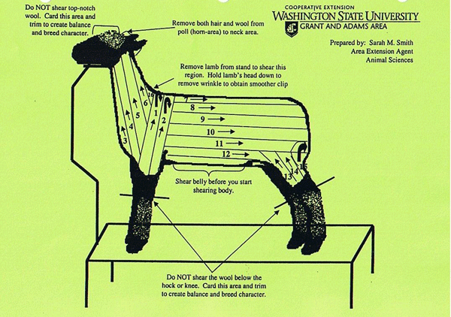Reading labels, keeping good records and paying attention to detail can help you prevent tissue residues. It is EVERY producer’s responsibility to do everything they can to provide a safe, wholesome product for the consumer.

**Handling and Training**

**Fitting**

Fitting lambs for show requires more than simply shearing them. Lambs, regardless of breed, should be washed prior to shearing. The only exception to this is when lambs are in long fleece. A clean fleece is easier to shear and extends the life of clipper blades. Any livestock soap or liquid dish washing soap will work extremely well for washing lambs, but be careful to remove all soap when rinsing. Wash and shear lambs as close to the show day as possible. Most of the major shows do not allow washing after arrival on the show grounds. Lambs that are sheared frequently have a greater tendency to wrinkle or become loose hided. A blow dryer may be used to hasten drying time. A bath towel is adequate for drying short fleeced lambs in warm weather. Lambs that have a tendency to wrinkle should not be dried with a blow dryer. Shearing can be done while the lambs’ wool is still damp. Clippers will perform better in loose, damp wool. A pair of electric clippers fitted with a 20-tooth goat comb and 4-point cutter or a 23-tooth comb and 9-point cutter should be used to ensure smoother, more attractive lambs. Lambs should be sheared smooth. While shearing, the clippers should run parallel to the length of the body rather than vertically. Shearing parallel to the length of the body makes lambs appear balanced and longer bodied. Wool below the knees and hocks should not be shorn. This “boot” can be carded out and blended in with hand shears or electric clippers. Leaving the wool on the legs also improves the balance and “eye appeal” of lambs. Small animal clippers may be needed to clip closely around the eyes, ears or delicate areas. Immediately after shearing, cover each lamb with a lamb sock or blanket and hood. A clean, well-bedded pen should be provided to keep lambs clean and dry. Showing market lambs is an art. Some people have natural abilities to show, but all exhibitors can learn techniques and improve their showmanship skills.

(See this online resource for additional shearing advice.

http://animalag.wsu.edu/Youth%20Producers/SmithFS1008-2003.pdf)

**Preshow preparation**

The amount of time required to train a lamb for show depends on the lamb, the physical size and experience of the exhibitor, and the intensity

of training. Some lambs are easy to gentle and train for show, while other lambs are difficult and nearly impossible to train. Most lambs can

be trained if enough time and effort are spent. Larger, more experienced exhibitors can handle a wilder lamb, while beginners need a gentle,

well-trained lamb. Some exhibitors spend time training throughout the program, while others start an intensified training program just 2 to 3

weeks before the show. Halter breaking is an excellent way to begin the gentling process,

especially if you have several lambs. Lambs should be caught, haltered with a rope halter, and tied to a fence. Do not tie the lambs where they can hurt themselves and do not leave tied lambs unattended. While a lamb is tied, you can place the lamb’s feet properly and get it accustomed to setting up. After the lamb begins to gentle, you can start teaching it to lead.

This is done with one hand under its chin and the other hand on the back of its head. Have someone assist you by patting the lamb on its dock whenever it stops. When you are comfortable leading the lamb, you can learn to position your hands in a way that holds the lamb’s ears forward. This will give the judge the impression that the lamb is long necked and very stylish. Lead with your arm extended and with your body 1 to 2 feet from the lamb.

The next step in the training process is to lead the lamb without a halter and properly set it up. Set the hind legs first, then place the front legs, keeping the body and neck straight and the head in a high, proud position with ears up and forward. You should remain standing at all

times. Do not squat or kneel. After a lamb is trained to lead, set up and remain set up while you move around it, the lamb is ready to be taught to brace or push when pressure is applied to its neck or chest. 

*Bracing:* Train the lamb to brace or push against your knee. When the lamb braces, its muscles flex and tighten up to make the lamb feel firmer. The muscles also appear larger and more defined.

1) To brace a lamb, stand so the inside of your left knee is placed against the lamb’s breastbone. Gently push back on the lamb, encouraging your lamb to push into you. With proper training your lamb will learn to gently push back on your knee causing the leg and loin muscles to flex and be more defined

(2) ALL FOUR FEET SHOULD REMAIN ON THE GROUND AT ALL TIMES.

Never pick the lamb up so that the front feet are off the ground. This is poor showmanship and portrays the show sheep industry in a negative light for the general public watching the show.

A lamb must push or brace itself when the judge is handling it. A constant, steady pressure is desirable because it helps the judge better evaluate the lamb. Keep the lamb’s front feet on the ground when bracing. Do not overpower a lamb when teaching it to brace, or it may develop bad habits such as over driving or kicking its back legs too far back. Be careful and do not practice too much when teaching a lamb how to push. After training is complete, you may wish to practice showing the lamb. You can set up your lamb and show it while someone else handles it, making sure the lamb responds. If the lamb responds properly, return it to the pen and do not overwork it. If it fails to respond, more training is necessary.

Realize that you may have only 5 seconds to actually show a lamb in a major show. If your lamb does not stand and push properly when the judge handles it, you may get overlooked.

**Show ring**

Your planning, selection, feeding, fitting, training and grooming have brought you and your lamb this far — to the show ring. Now, your skill

in exhibiting your lamb — showmanship — cannot be emphasized too strongly! It is often the difference between winning and losing.

You should be mentally and physically ready to enter the show ring for competition. By completing the pre-show activities, you should have confidence that you can do an effective job in showing your lamb. You should be neat in appearance, but not overdressed. Do not wear a hat or cap and do not use a halter in the show ring. Before the show begins, become familiar with the show ring. When the judging begins, watch the judge if possible and see how he works the lambs in the ring. You will feel more comfortable and confident if you know what the judge expects of you. When the appropriate class is called, take your lamb to the show ring.

If the ring stewards do not line up the lambs, find a place where your lamb will look its best. Avoid corners of the ring and leave plenty of space between your lamb and others. Set up your lamb, making sure the legs are set properly, and keep the body, neck and head in a straight line.

Keep the lamb’s head up and alert. Do not cover your lamb with your body or block the judge’s view of your lamb. Have your lamb bracing when the judge begins to handle it. Remember, a constant, steady pressure that keeps the lamb’s front feet on the ground is desirable. After the judge handles your lamb, he will usually step back and look at it. Be sure to keep pressure on the lamb and keep its head up and body, neck and head in a straight line. Keep one eye on the judge and one eye on your lamb. It is your responsibility to watch the judge and not miss a decision. A good showman must be alert and know where the judge is at all times. Always keep your eye on the judge! Remain calm and concentrate on showing. In large classes, it may take 30 minutes before the judge handles your lamb. Be patient and let your lamb relax.

To keep your lamb calm, circle it, scratch it on the ear or rub its stomach. When the lamb is pulled, never back it out of the line. Always move the lamb forward, remembering to keep the lamb between the judge and yourself. If you overpower the lamb and back it out of line, the lamb may stop bracing. If your lamb is not pulled the first time, keep trying. Continue to keep

it set up, remain alert and keep one eye on the judge. If your lamb is pulled, circle it out of line and follow the directions of the ring steward

while keeping an eye on the judge. Move your lamb with style and at a steady, moderate pace.

Remember to keep showing at all times, because a class is not over until the ribbons are distributed. Be courteous to fellow exhibitors. A

good showman will emphasize strong points and minimize weak points in a lamb. Remain standing at all times and always display a pleasant facial expression. Be a good sport, a graceful loser and a humble winner.

**Anatomy**



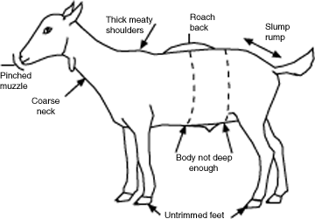

Poor conformation

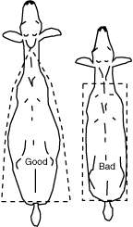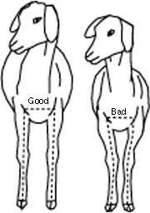

Meat Science  
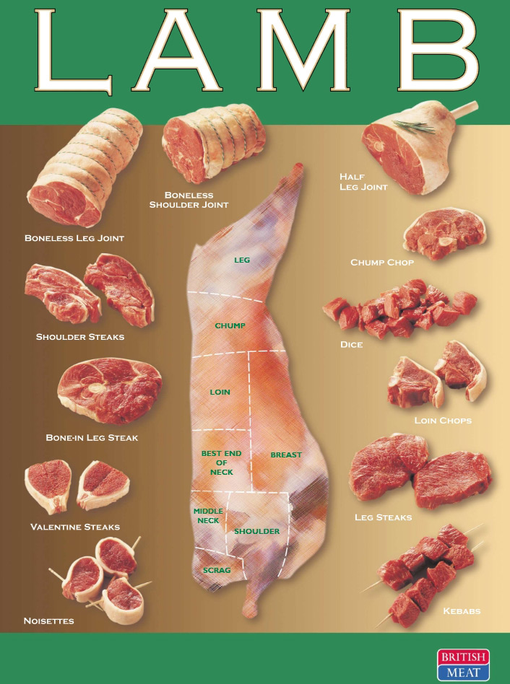

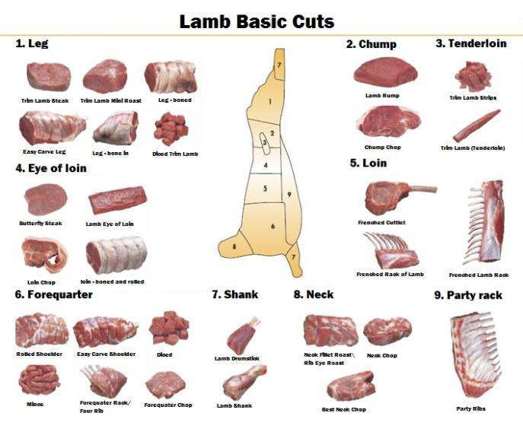

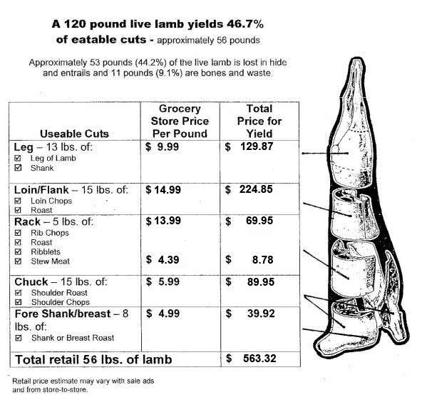

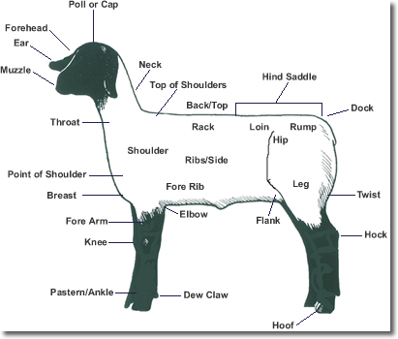

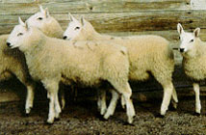**CHEVIOT  
The Cheviot originated in the hill country that borders Scotland and England and was imported into the U.S. in 1838. The Cheviot is small-sized with a white face and bare head and legs. They are moderately prolific, easy lambers, good milkers, posses excellent lamb vigor and produce a desirable carcass at light weights. They are highly adaptable to a variety of climates, thrive on poor forage conditions and produce a high-yielding medium wool.**

**BREEDS**

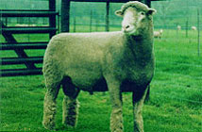 **DORSET**  
Originating in Southern England, the Dorset Horn was imported into the U.S. in 1885. In 1948, a dominant gene for polledness occurred resulting in Polled Dorsets which are now popular in the farm flock states. Dorsets are medium-sized, white-faced, produce medium-wool fleeces free of black fibers and have wool extending down the legs. Dorsets are noted for their aseasonal breeding characteristics and are commonly used in crossbreeding to produce females for out-of-season breeding. Ewes are prolific, heavy milkers, long lived and produce hardy lambs with moderate growth and maturity that yield heavy muscled carcasses.

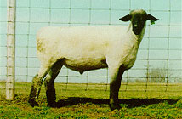**HAMPSHIRES**  
Hampshires were developed in the Hampshire country of Southern England. The Old Hampshire, Berkshire Knot and Wiltshire Horn, with the introduction of Southdown and Cotswold, formed the genetic background of the Hampshire breed. The breed is widely used in the U.S. as a source of terminal sires for commercial lamb production. They are a large, moderately prolific breed with wool caps, black faces and medium-wool fleeces. They also have very good milking ability, growth and carcass cutability.

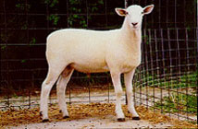**MONTADALE**  
The Montadale was developed in the U.S. from Cheviot x Columbia crosses and is used primarily in the farm flock states. The breed is medium-sized with a white wool covering, bare head and legs, black hooves and nostrils. They are a prolific breed with good maternal instincts, milking ability and produce lambs with lean carcasses. Montadales produce medium wool with good staple length.

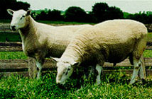**NORTH COUNTRY CHEVIOTS**Originating in Northern Scotland, North Country Cheviots were first imported into North America in 1944. The North Country Cheviot is a large, resourceful hill sheep adapted to rough terrain and adverse conditions of northern hill country climates. They are polled, medium- to large-sized with a white face and bare head and legs and produce medium-wool fleece with good staple length. Ewes are good milkers, easy lambers and are fairly prolific.   
**OXFORD**  
The Oxford originated in England from Hampshire x Cotswold crosses and was imported into the U.S. in 1846. The Oxford is medium to large-sized with a dark brown face and wool on the legs. It is used primarily as a terminal sire breed in the farm flock states. The breed is fairly prolific, possesses good mothering ability and produces desirable carcasses and medium-grade wool.

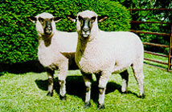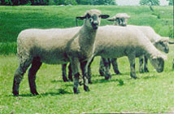 **SHROPSHIRE**The Shropshire originated in England from native sheep and Southdown, Leicester and Cotswold crosses and was imported into the U.S. in 1855. Shropshires are medium to large with a dark face and wool extending down the legs. They are commonly located in farm flocks with emphasis on meat production. They are prolific, possess good milking and mothering abilities and are used as terminal sires in market lamb production. The lambs are hardy, fast-growing and produce lean, well-muscled carcasses. Shropshires produce medium-grade wool.

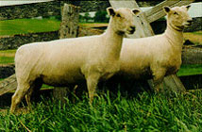**SOUTHDOWN**The Southdown, one of the oldest sheep breeds, originated in England and was imported into the U.S. in 1803. The Southdown is small to medium-sized with a light brown face and wool extending down the legs. The breed is very docile and ideally suited for intensive management. They are early maturing, adaptable to diverse climate conditions, produce muscular, light-weight carcasses and possess excellent longevity. The Southdown is also prolific with good milking ability and lamb survival. They produce a medium-wool fleece.

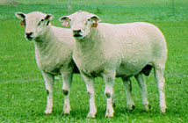**SUFFOLK**  
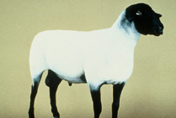The Suffolk originated in England from Southdown x Norfolk crosses and was imported into the U.S. in 1888. This is the largest-sized breed in the U.S. which, along with rapid growth rate, makes it well adapted as a sire breed for production of crossbred slaughter lambs. The Suffolk has a bare and black head and legs, is prolific and a good milker, produces a medium-grade fleece and is raised under a range of climatic conditions. Suffolk lambs grow rapidly and produce high cutability carcasses.

**TEXEL**  
The Texel have been bred in the Netherlands for over 160 years and were first available to U.S. sheep producers in 1990. Texels are hardy, adaptable, medium-sized sheep selected under forage conditions for high muscle-bone and lean-fat ratios. They have a white face with no wool on the head and legs and produce a medium-wool fleece. The breed is considered to have extreme muscling and produce high cutability carcasses.

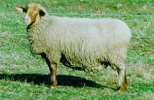**TUNIS**  
The Tunis originated from Tunisia in North Africa and was imported into the U.S. in 1799. The breed was popular in the South until almost eliminated during the Civil War. The Tunis is medium-sized with a red or tan face and legs, pendulous ears, no wool on the head and legs, polled and a medium-sized fat tail. They are fairly prolific, good milkers and mothers and produce a medium-wool fleece.

Questions for Fitting and Showing Competitions: Sheep

Prepared by:

*Dr. Jan R. Busboom, Extension Meat Specialist, Washington State University*

*Revised May 10, 2006*

Junior 4-H Questions

1. What is the sex of your lamb?
2. What do you call the opposite sex?
3. What is the breed of your lamb?
4. Name another breed of sheep?
5. What vaccinations has your lamb received?
6. What wormer has your lamb received and how was it administered?
7. Name body parts of sheep
8. Name wholesale cuts of lamb.
9. What is average daily gain (ADG)?
10. What is the ADG of your lamb?
11. What has your lamb been eating?
12. How much do you feed it per day? (I try to get them to answer in pounds)
13. What percentage protein is in your feed?
14. What is a subcutaneous (s.c., SubQ) injection and where do you give it?
15. What is an intramuscular (IM) injection and where do you give it?
16. What is the meaning of withdrawal time for a drug?

## In the Junior Finals, some Intermediate/Senior 4-H/FFA Questions may be used to break ties

# Intermediate/Senior 4-H/FFA Questions

Any of the Junior 4-H Questions Plus:

1. What do you call an intact male sheep?
2. What are female sheep called?
3. Name 5 key nutrients.
4. What is a normal body temperature for sheep?
5. What is gestation length in sheep?
6. What is the estrus cycle length?
7. How many rams would you need to breed 100 ewes?
8. What is a meat (or ram) breed? Name two.
9. What is a wool (or ewe) breed? Name two.
10. What is a dual-purpose breed? Name two.
11. Why are sheep not fed animal protein by-products?
12. What is scrapie?
13. What is Codon 171?
14. What is T.S.E.?
15. What is B.S.E.?
16. What is entropion?
17. What is a normal birth weight for a lamb?
18. What would be an average life expectancy for a ewe?
19. How many stomachs does a sheep have?
20. Name the stomachs of a sheep?
21. What do you call an animal with four stomachs?
22. Name two grains.
23. Can you safely feed beef feed to your lamb? Why or why not?
24. Can you safely feed swine feed to your lamb? Why or why not?
25. Name one vitamin and one mineral contained in your sheep feed.
26. What do you like or dislike about this lamb?
27. If you could improve your lamb what part or attribute would you change?
28. Define Veterinary-Client-Patient Relationship
29. Name one (or more) sheep disease and tell me what you know about it?
30. What is a prolapse? Symptoms? How to treat? (There is more than one type)
31. What is coccidiosis? Symptoms? How to treat?
32. What is polioencephalomalacia? Symptoms? How to treat?
33. What is ovine ecthyma? Symptoms? How to treat?
34. What is mastitis? Symptoms? How to treat?
35. What is pneumonia? Symptoms? How to treat?
36. What is white muscle disease? Symptoms? How to treat?
37. What is grass tetany? Symptoms? How to treat?
38. What are the USDA Lamb Yield Grades?
39. What does USDA Lamb Yield Grade refer to?
40. What factor(s) is (are) used to determine USDA Yield Grade?
41. What is the USDA Yield Grade of your lamb (or that lamb)?
42. What are the USDA Lamb Quality Grades?
43. What does USDA Lamb Quality Grade refer to?
44. What factor(s) is (are) used to determine USDA Quality Grade?
45. What is the ideal market weight (or Yield Grade, fat thickness or ribeye area)?

**Other Skillathon type questions:**

Protein requirements of lambs of various ages

Identify retail cuts

Roast (Usually at least 2 inches thick) versus steak or slice (usually ¾ to 1 inch thick)

Leg cuts, loin cuts, rib or rack cuts, shoulder cuts, shank, breast, neck, riblets

Identify various parasites such as round worms, tape worms, keds, ticks, lice, flies

Identify feedstuffs such as molasses (smell it), soybean meal, corn, wheat, oats, barley, peas, limestone (its ground up rock with no smell), meat and bone meal (smell it), grass hay versus alfalfa hay versus straw.

Identify sheep equipment

Wool judging

Hay judging

**Resources**

<http://texas4-h.tamu.edu/files/2011/12/publications_projects_sheep_show_lamb_guide.pdf>

<http://animalag.wsu.edu/Youth%20Producers/SmithFS1011-2003.pdf>

<http://animalag.wsu.edu/Youth%20Producers/SmithFS1008-2003.pdf>

<http://www.extension.umn.edu/distribution/livestocksystems/di1877.html>

<http://www.danekeclublambs.com/GeneralSheepKnowledge.html>

<http://ansci.colostate.edu/outreach/youth_livestock_extension.html>

http://www.sheepusa.org/