Senior
Goat Protégé
Workbook

Student: __________________________________________________________________

Teacher: __________________________________________________________________

**Please write and/or draw examples of your protégé experience. You may also include photographs.**
- Name three breeds of goat:

- What is a doe?

- What is a buck?

- What is a kid?

- A goat stomach has how many parts?

- What is the gestation period of a goat?

- Name three things that a goat needs to live:
A.
B.
C.
- What is the proper uniform for showing goats?
- What is disbudding a kid?
- Name a common goat sickness?

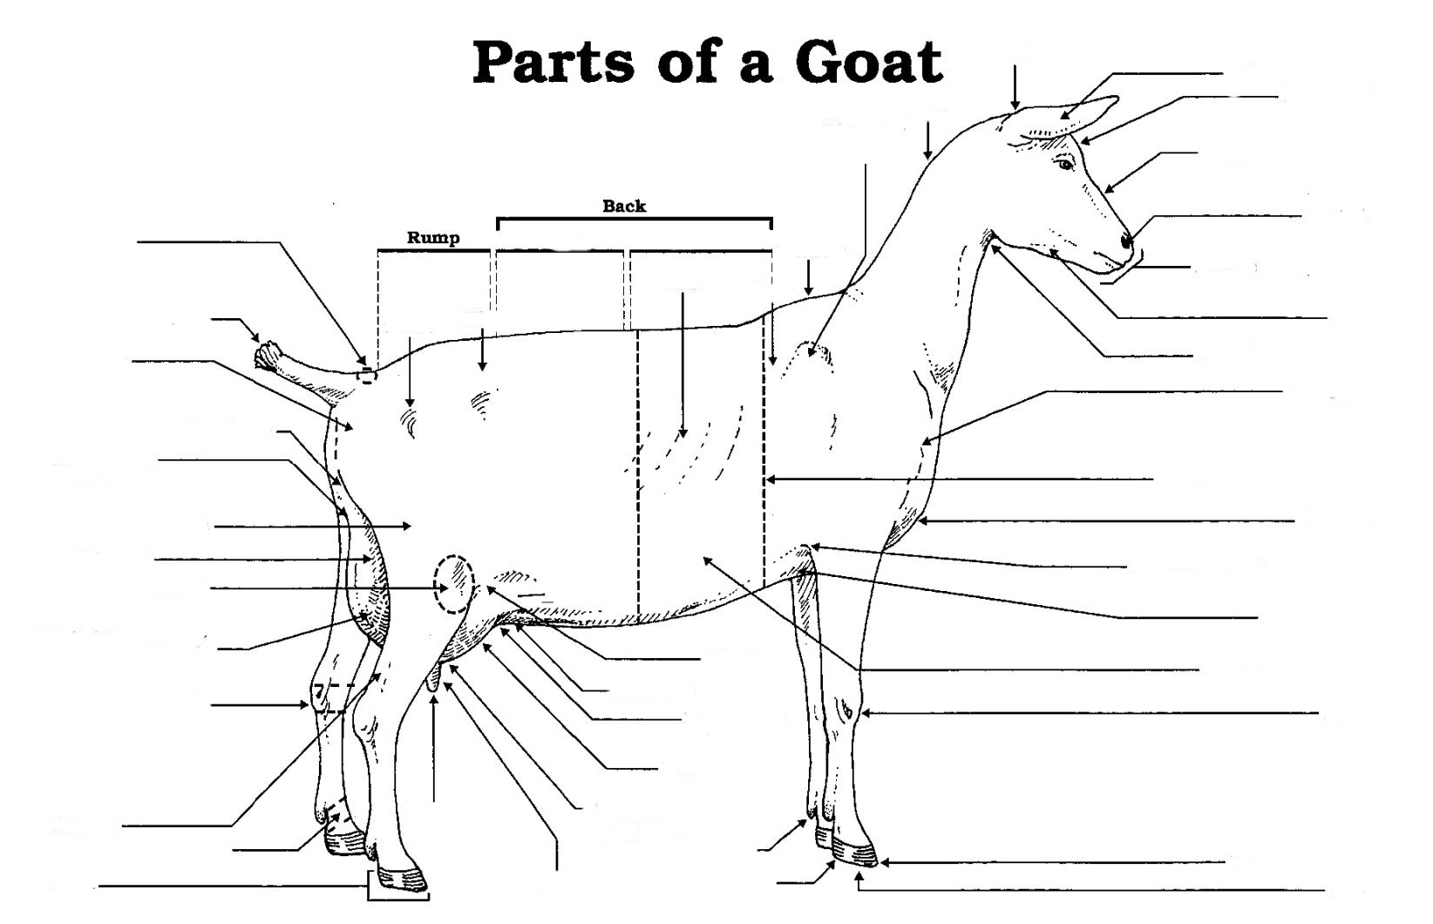
Label 20 parts of your choice

