Senior
Poultry Protégé
Workbook

Student: _________________________________________________________________

Teacher: __________________________________________________________________
**Please write and/or draw examples of your protégé experience. You may also include photographs.**
- Name and describe three breeds of chickens or bantams (main color of feathers, color of earlobes, color of eggs, and comb type):

- What is a hen under the age of one called?

- What is a rooster under the age of one called?

- Name two poultry diseases:

- What color eggs do chickens with red earlobes lay?

- What is the term used when a chicken is shedding?

- What should you feed your poultry project?
- What color eggs do chickens lay other than brown or white?
- What breed of chicken or bantam are you showing?

- What is the proper uniform for showing chickens?

Label the correct body part
Shanks
Vent
Earlobe
Comb
Hocks
Breast
Wattle
Toes
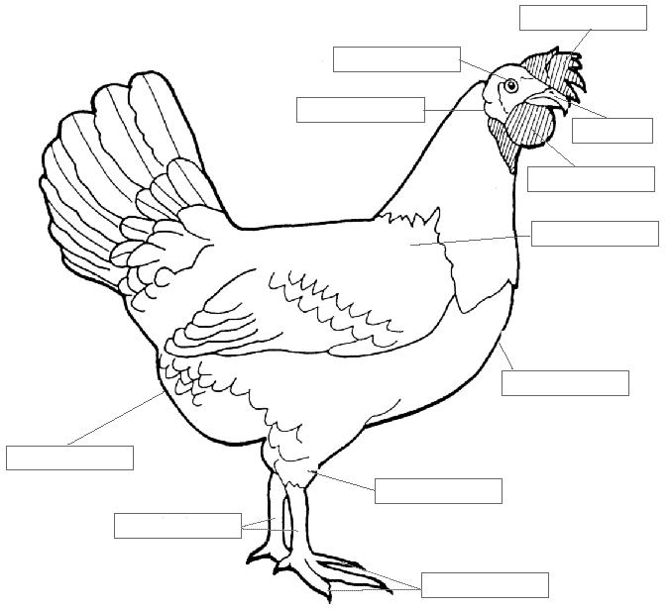
Shoulder
Beak
Eye

